Core Maths Exam Questions by Topic
  - Paper 1

Contents

Fermi Estimation

Specimen - Question 4c

Specimen – Question 7b

June 16 – Question 3a

June 16 – Question 9

June 17 – Question 4

June 17 – Question 10

Payslip calculations

Specimen – Question 3

Specimen – Question 5

June 16 – Question 6

June 16 – Question 8

June 17 – Question 8

Data and Sampling

Specimen – Question 1a

Specimen – Question 7a

June 16 – Question 1

June 16 – Question 4

June 17 – Question 5a

AER and interest rates

Specimen – Question 2

June 16 – Question 2

June 16 – Question 5

June 16 – Question 8

June 17 - Question 5c

June 17 – Question 6c

GCSE Topic Revision

Specimen – Question 5b

June 16 – Question 1

June 16 – Question 2

June 16 – Question 5

June 17 – Question 1

June 17 – Question 2

June 17 – Question 3

June 17 – Question 9a

Graphical presentation of Data

Specimen – Question 4a

Specimen – Question 6

June 16 – Question 1c

June 16 – Question 7

June 17 – Question 7

Spreadsheets

Specimen – Question 5

June 17 – Question 6a

Interpretation/Analysis

Specimen – Question 4b

Specimen – Question 6

June 16 – Question 1d

June 16 – Question 3b

June 16 – Question 7

June 17 – Question 5

June 17 – Question 7b

June 17 – Question 9b, 9d

June 17 – Question 10b

Standard Deviation

June 17 – Question 9c, 9d

Markschemes

Specimen Paper 1

June ’16 Paper 1

June ’17 Paper 1

Questions

Fermi Estimation

Specimen - Question 4 (4c)

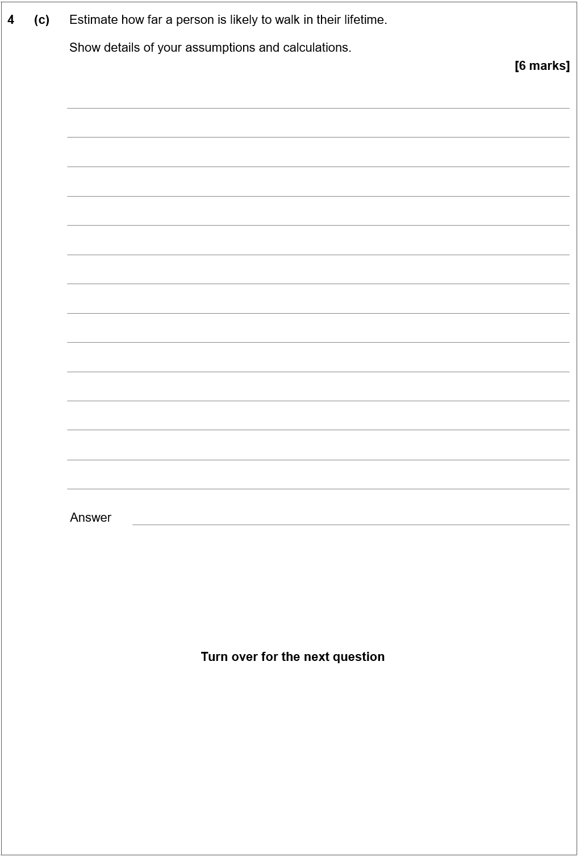

Specimen – Question 7b

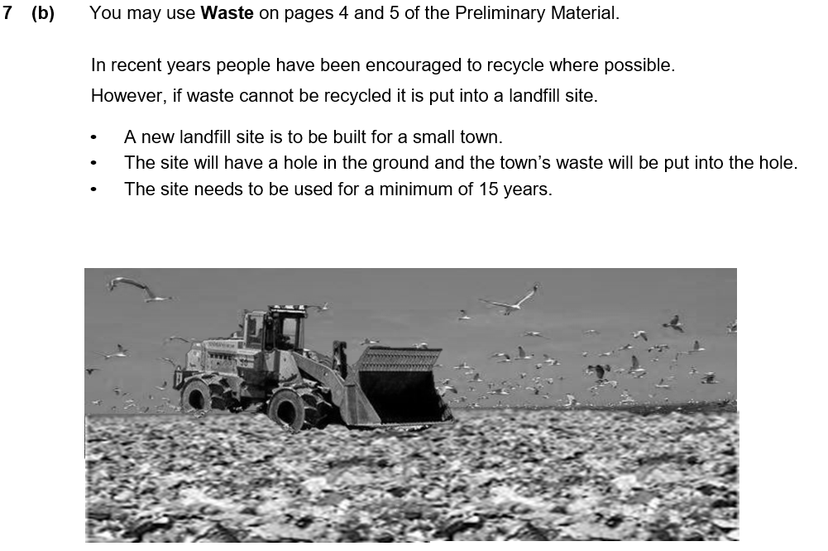
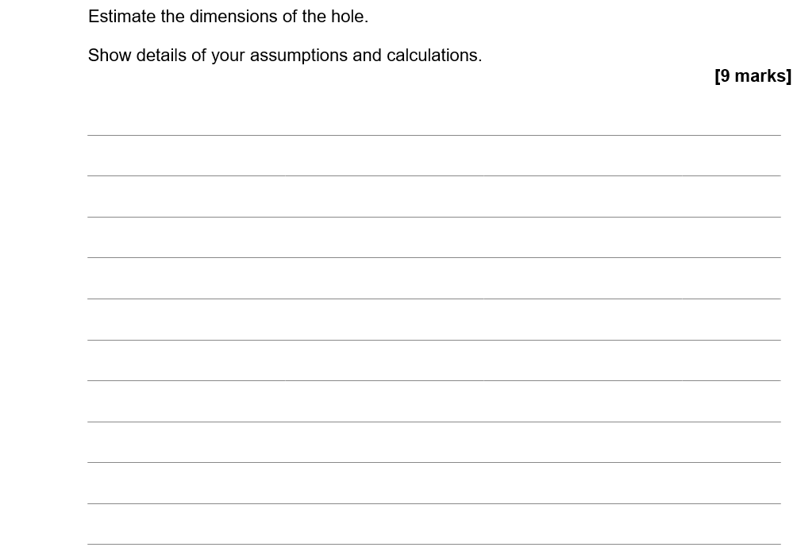
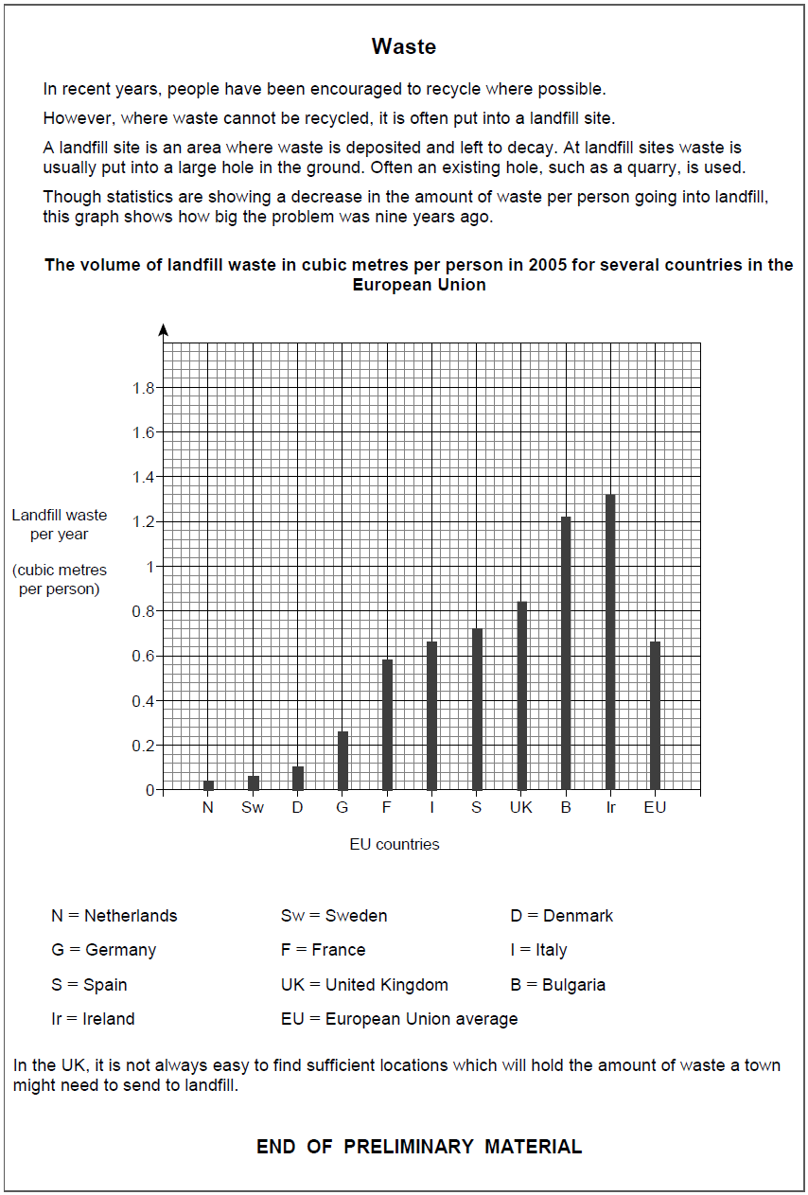

June 16 – Question 3a

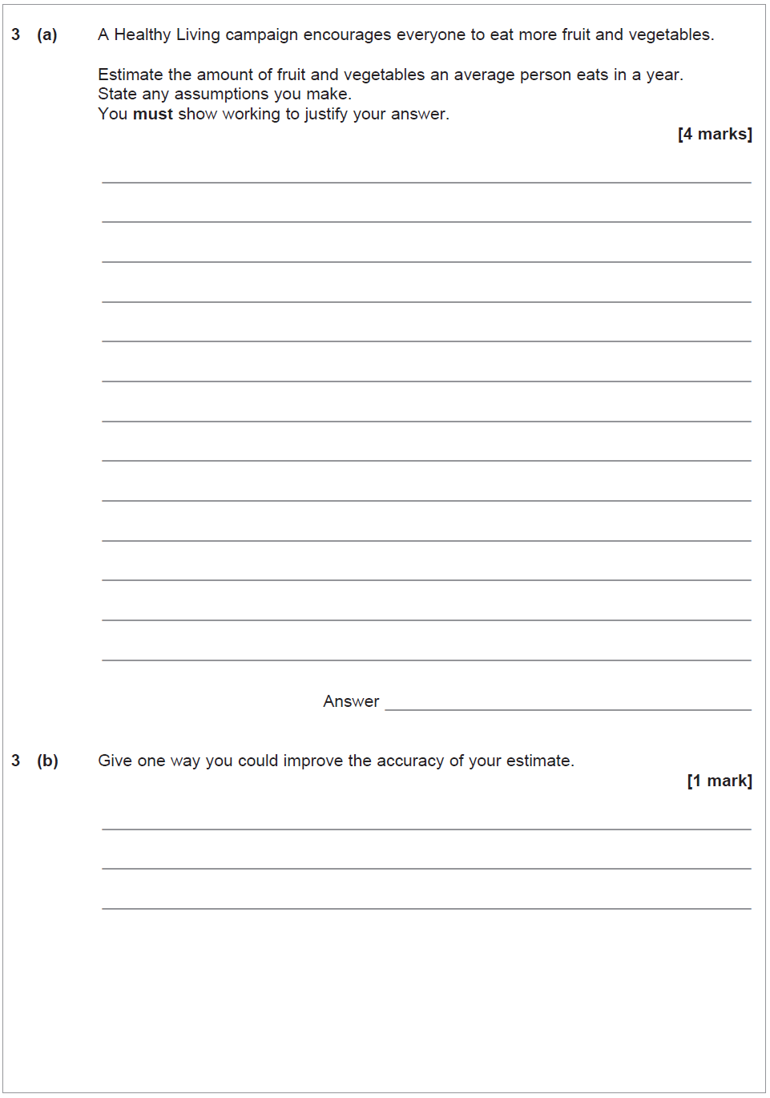

June 16 – Question 9

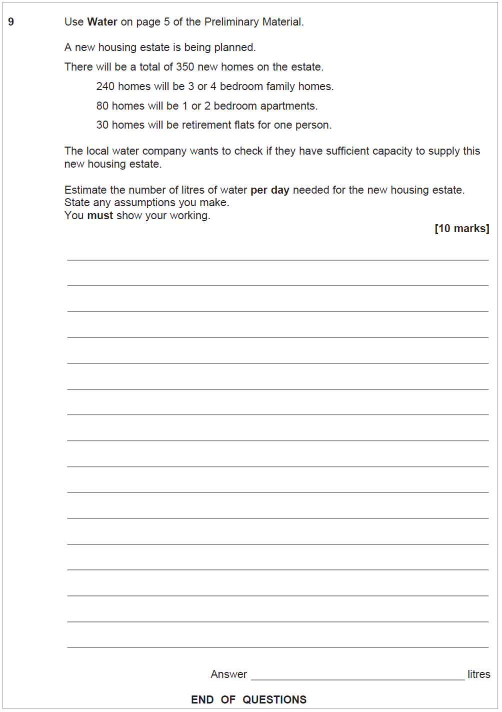

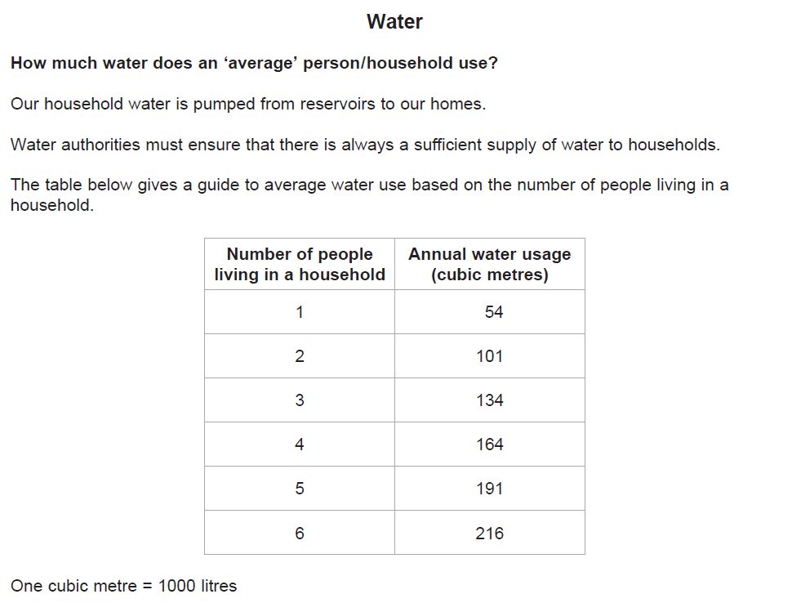

June 17 – Question 4

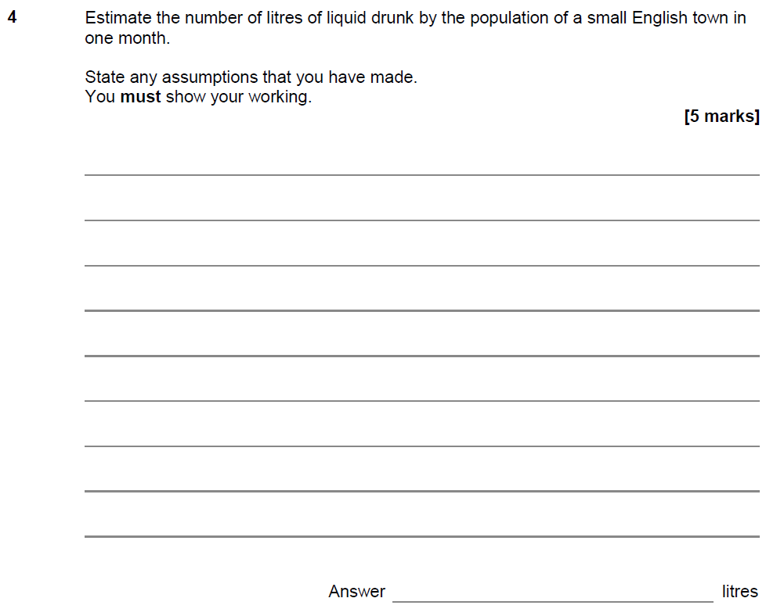

June 17 – Question 10

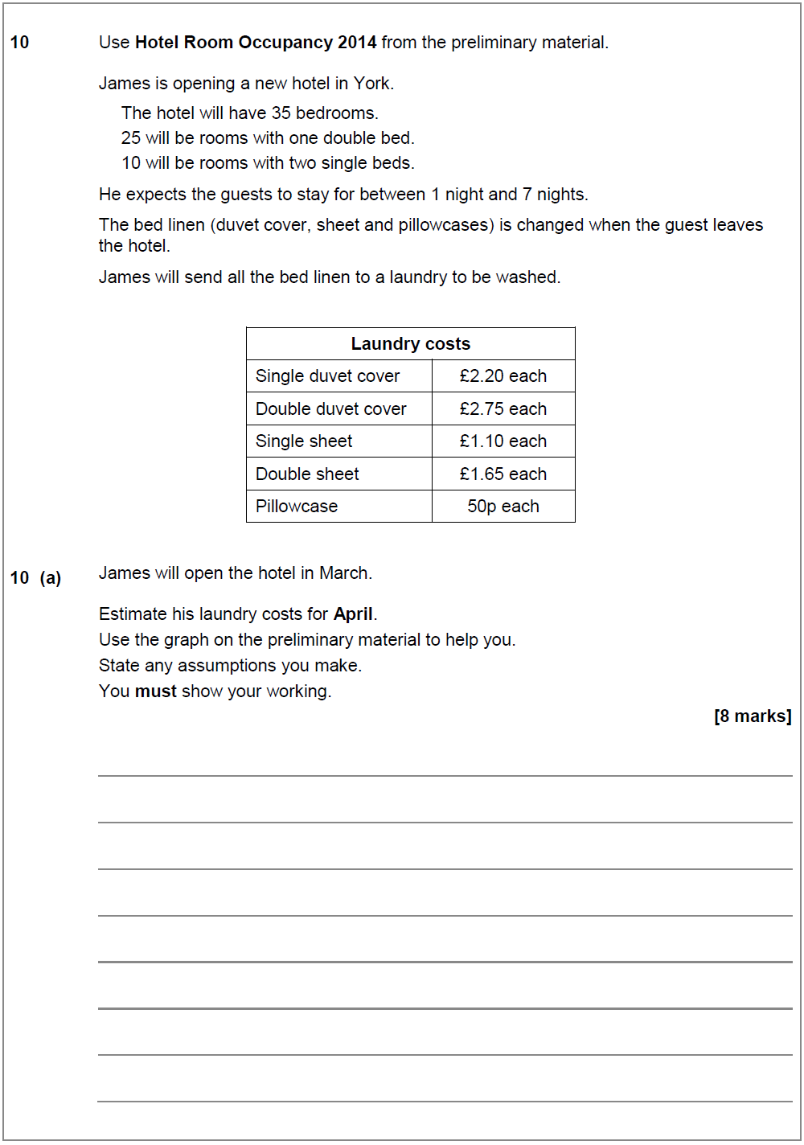

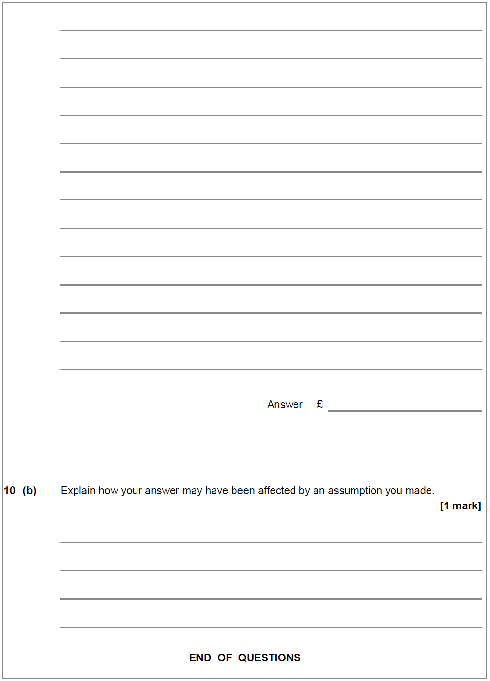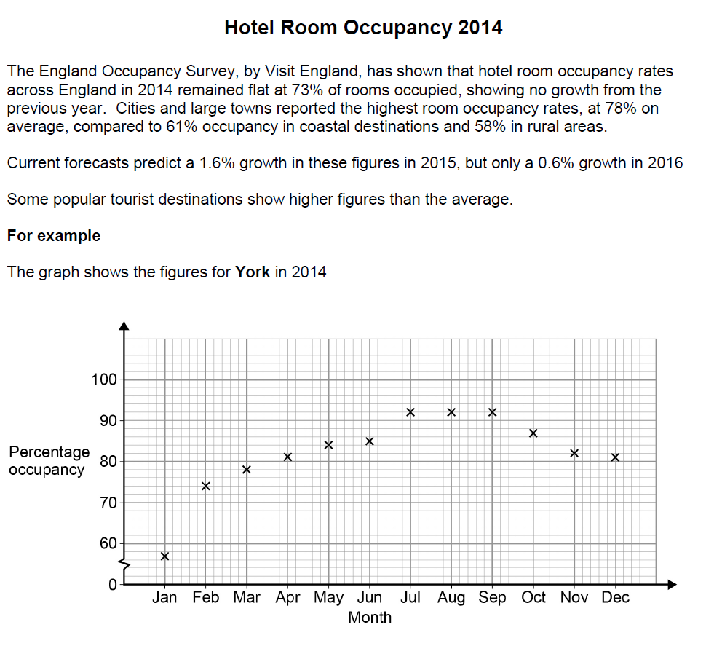

Payslip calculations

Specimen – Question 3

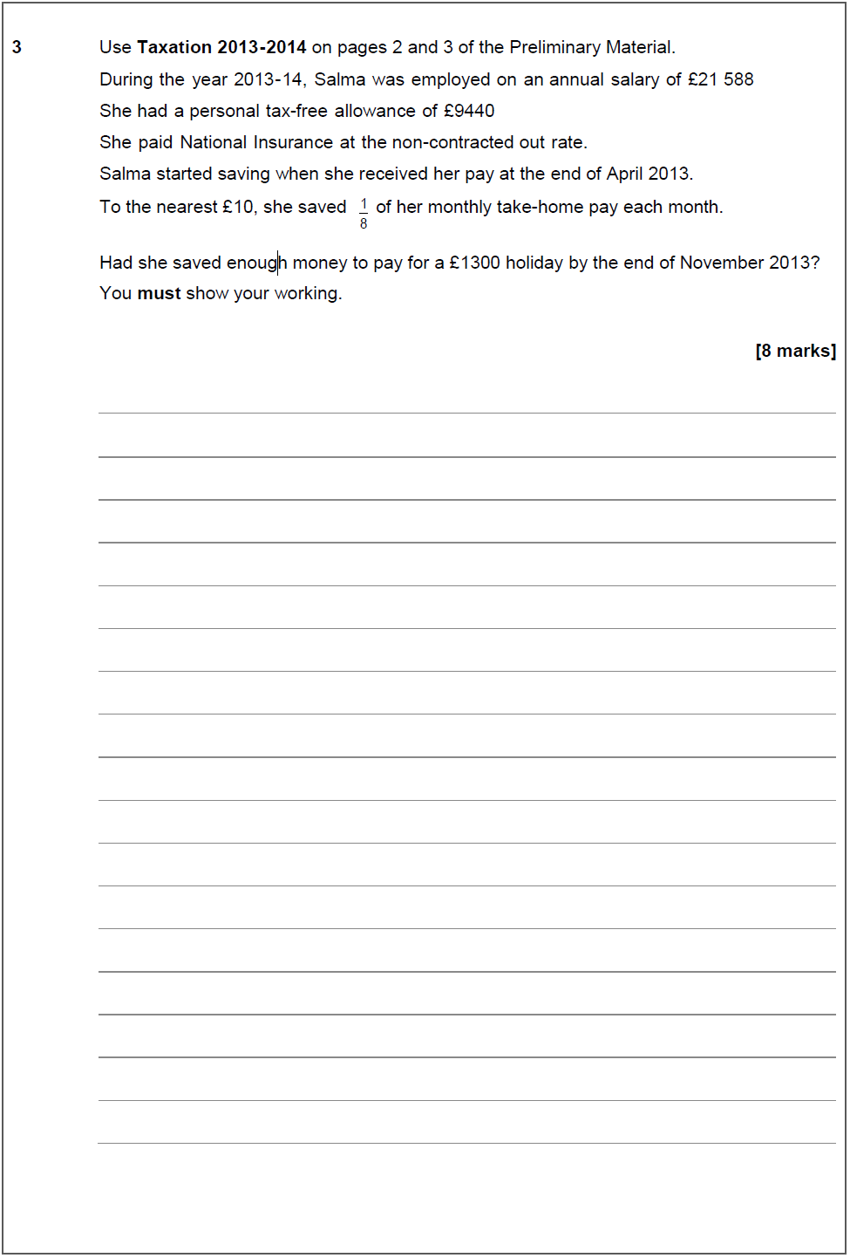
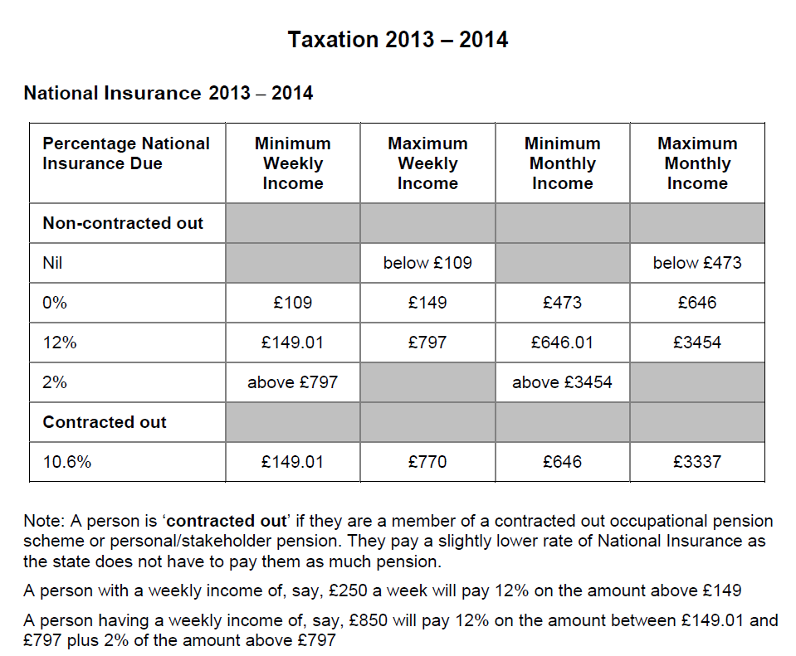

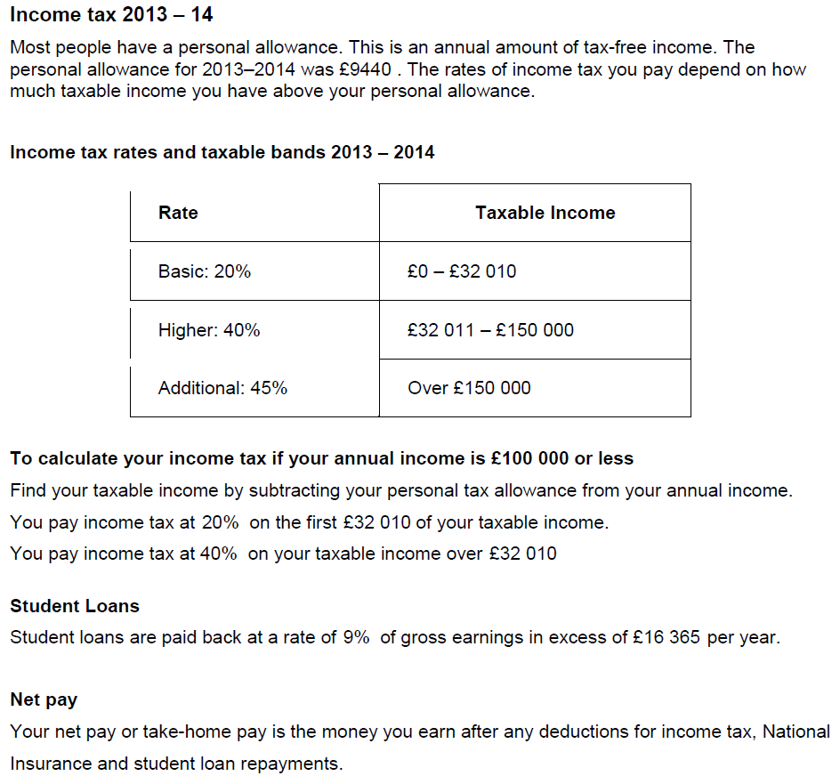

Specimen – Question 5

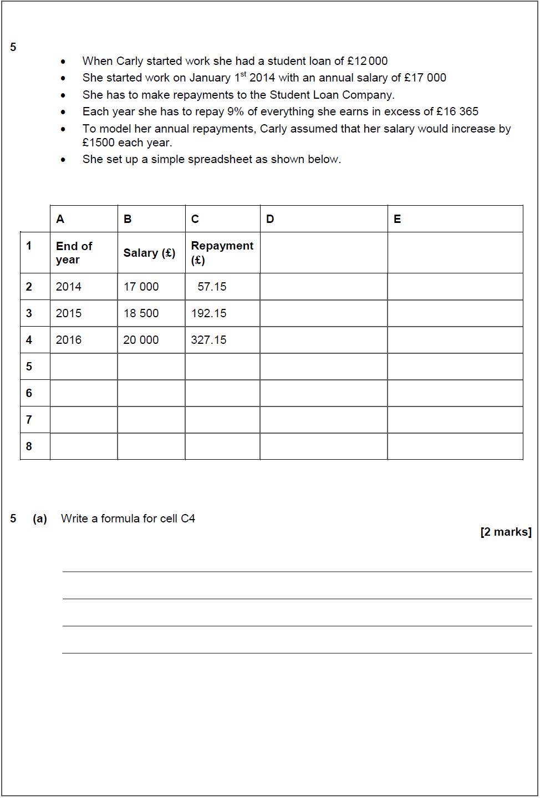

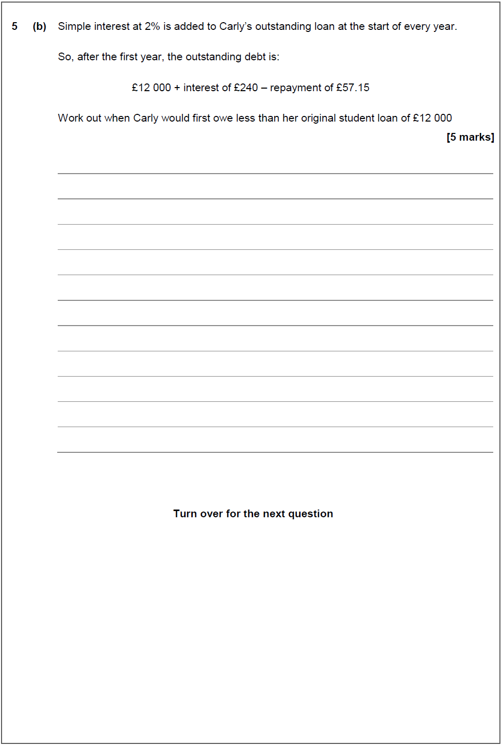

June 16 – Question 6

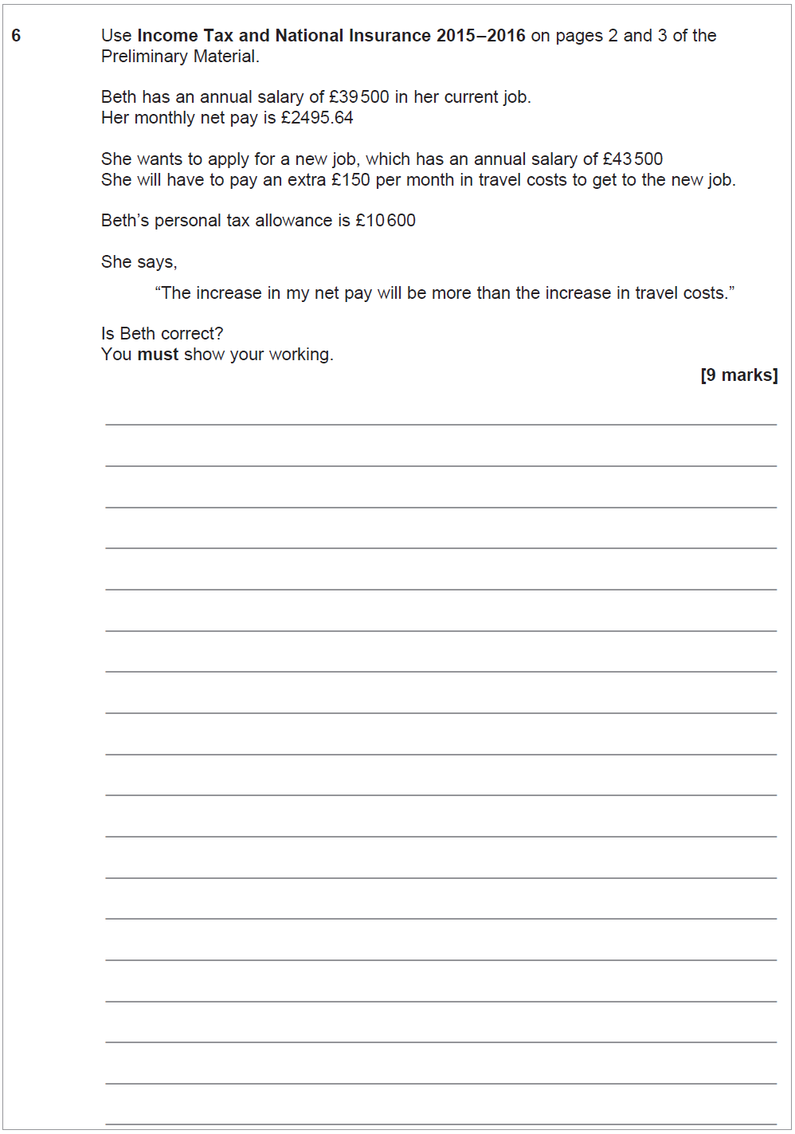
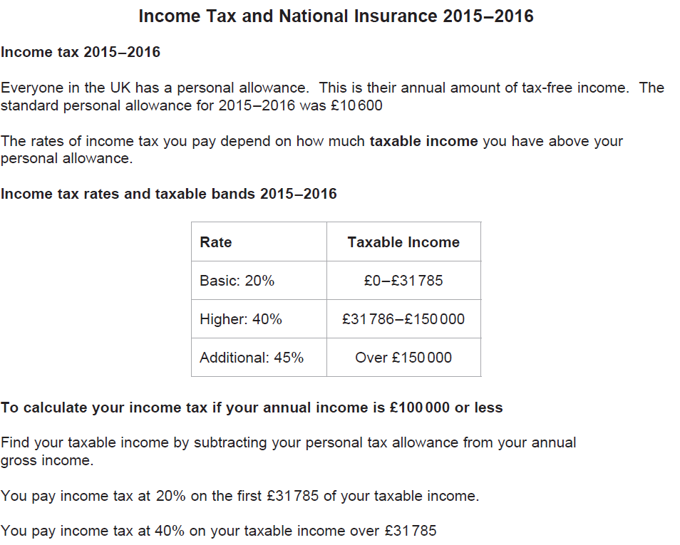

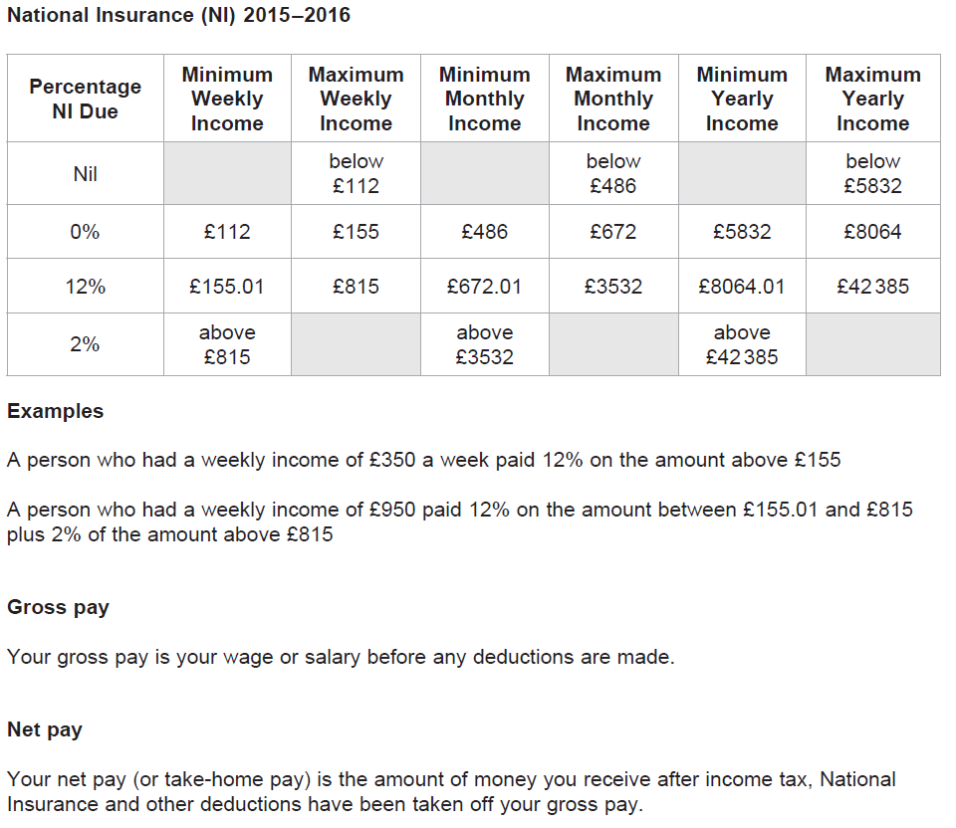

June 16 – Question 8

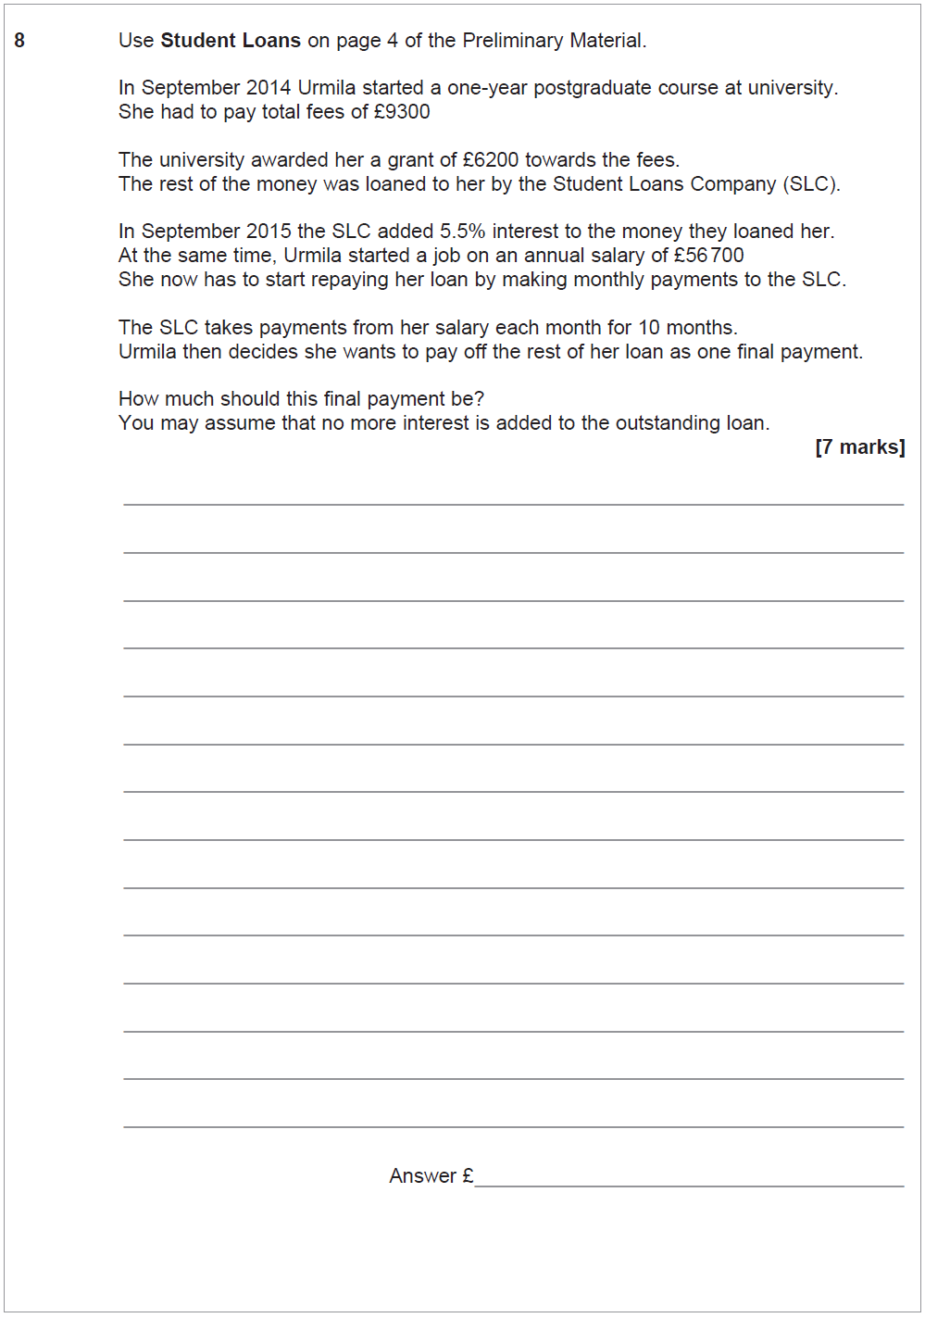
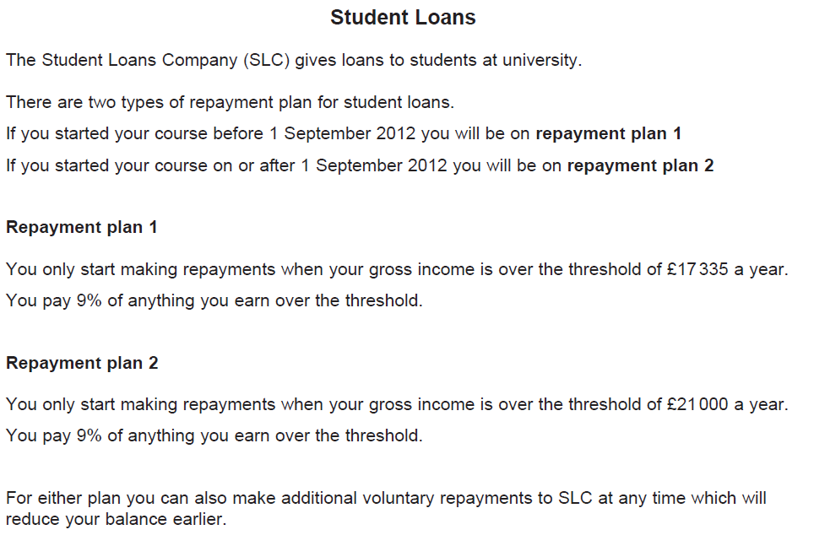

June 17 – Question 8

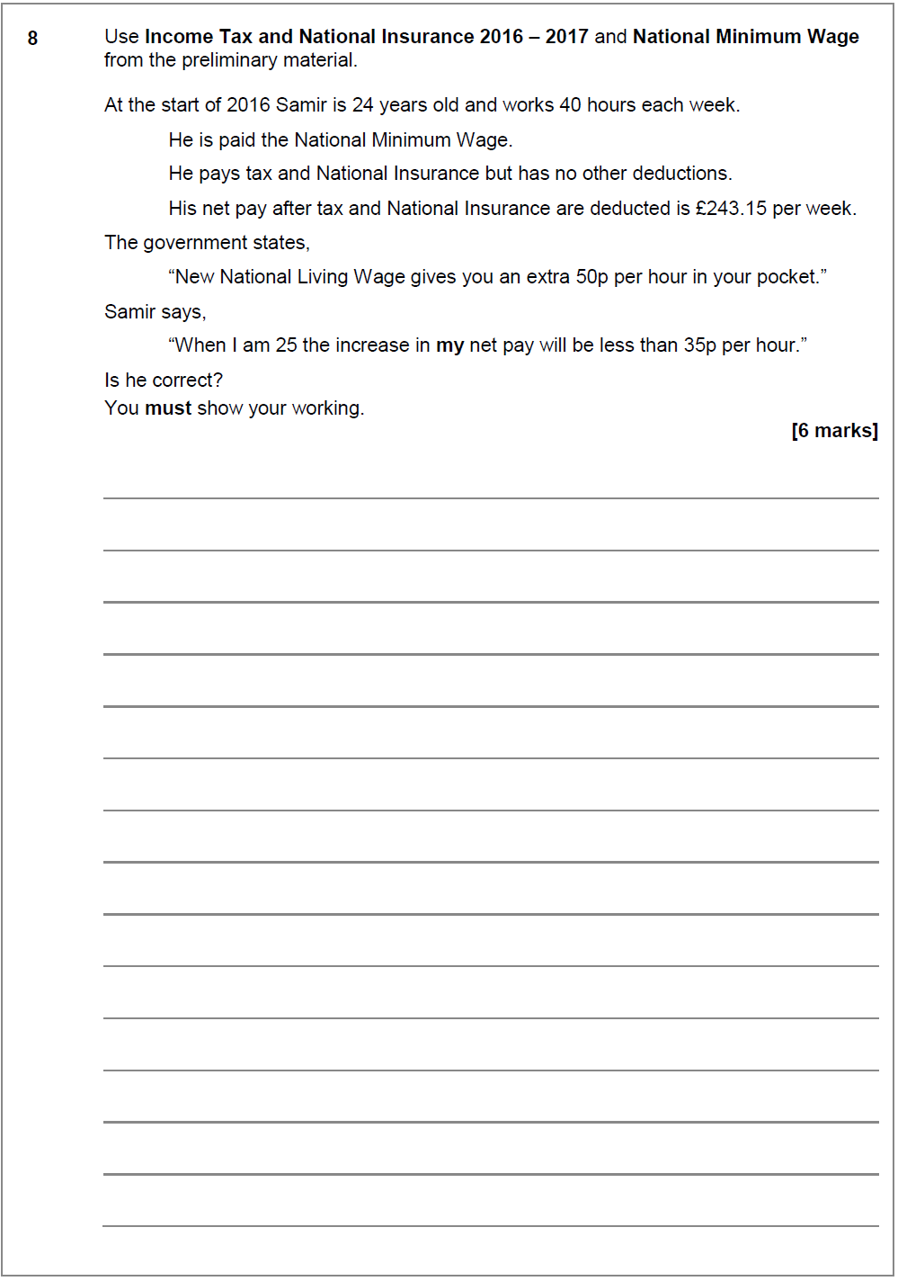

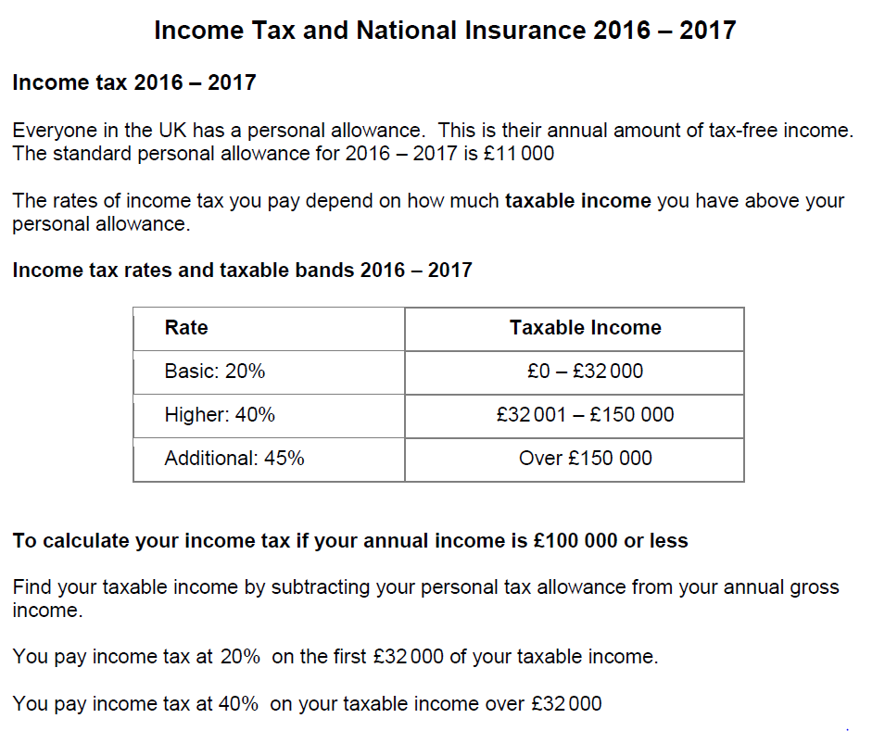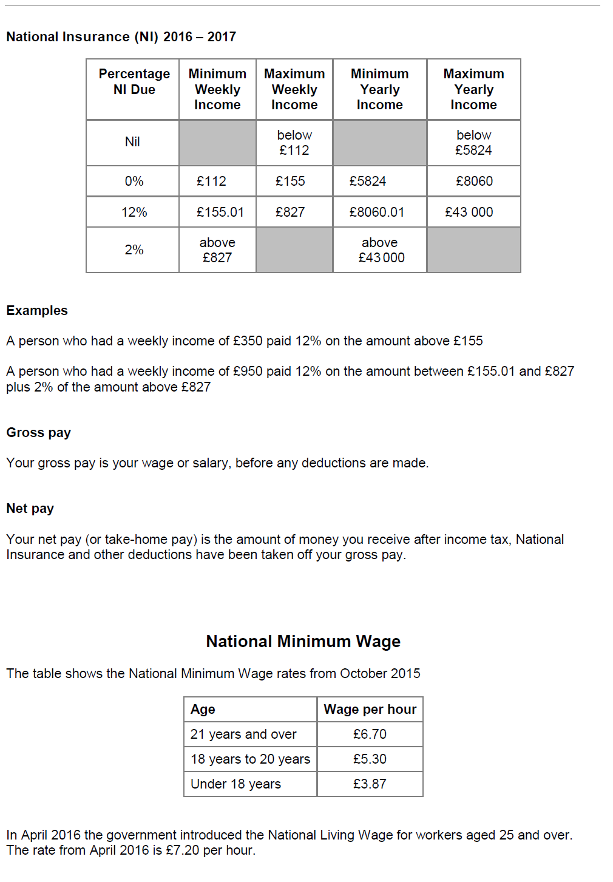

Data and Sampling

Specimen – Question 1

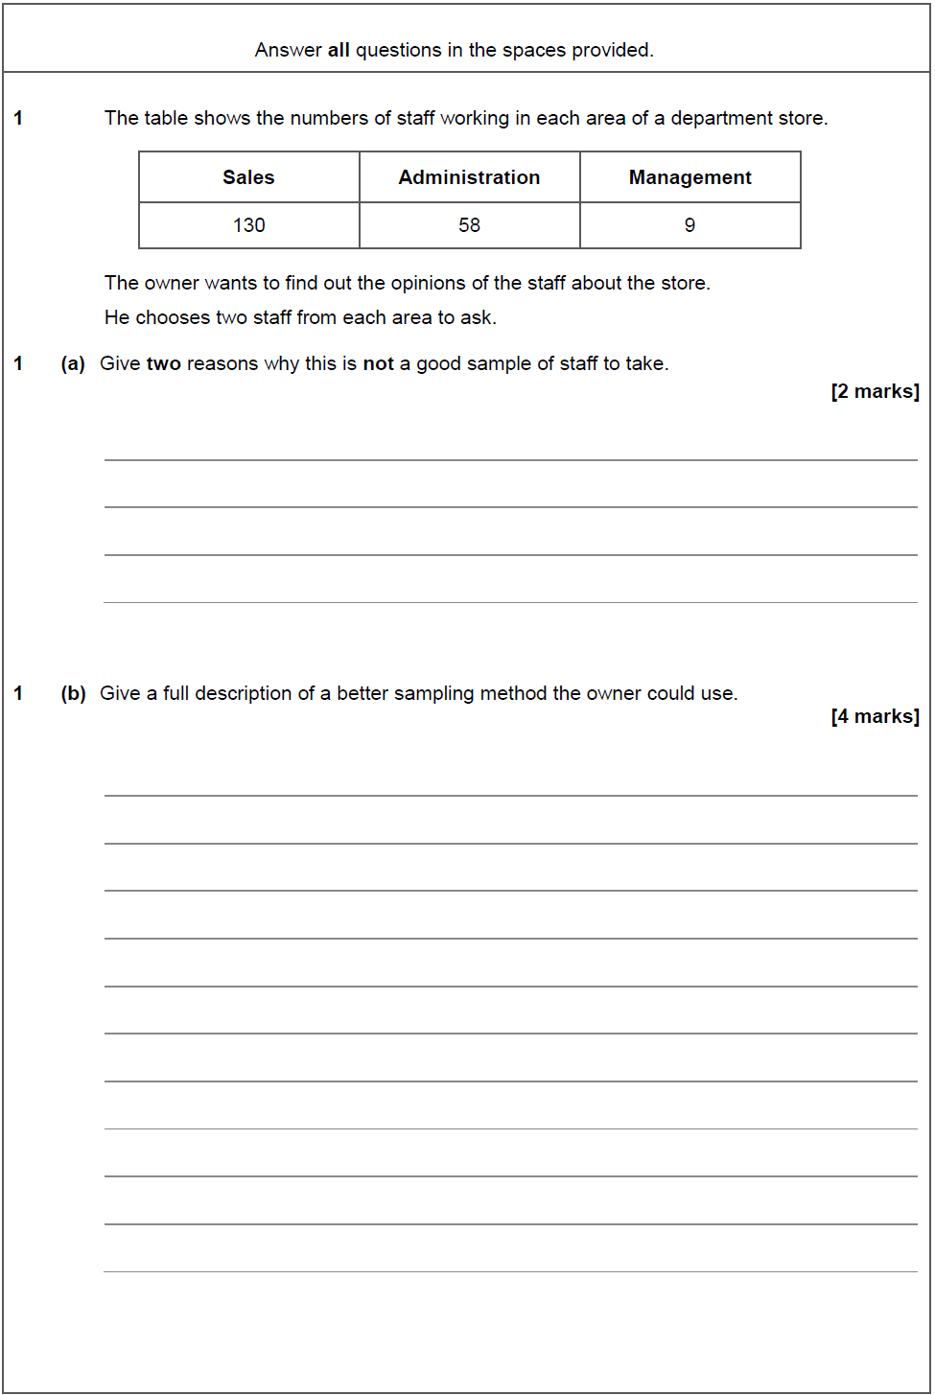

Specimen – Question 7a

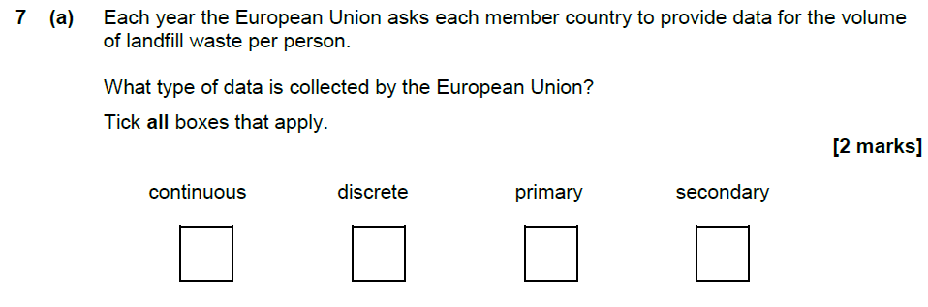

June 16 – Question 1

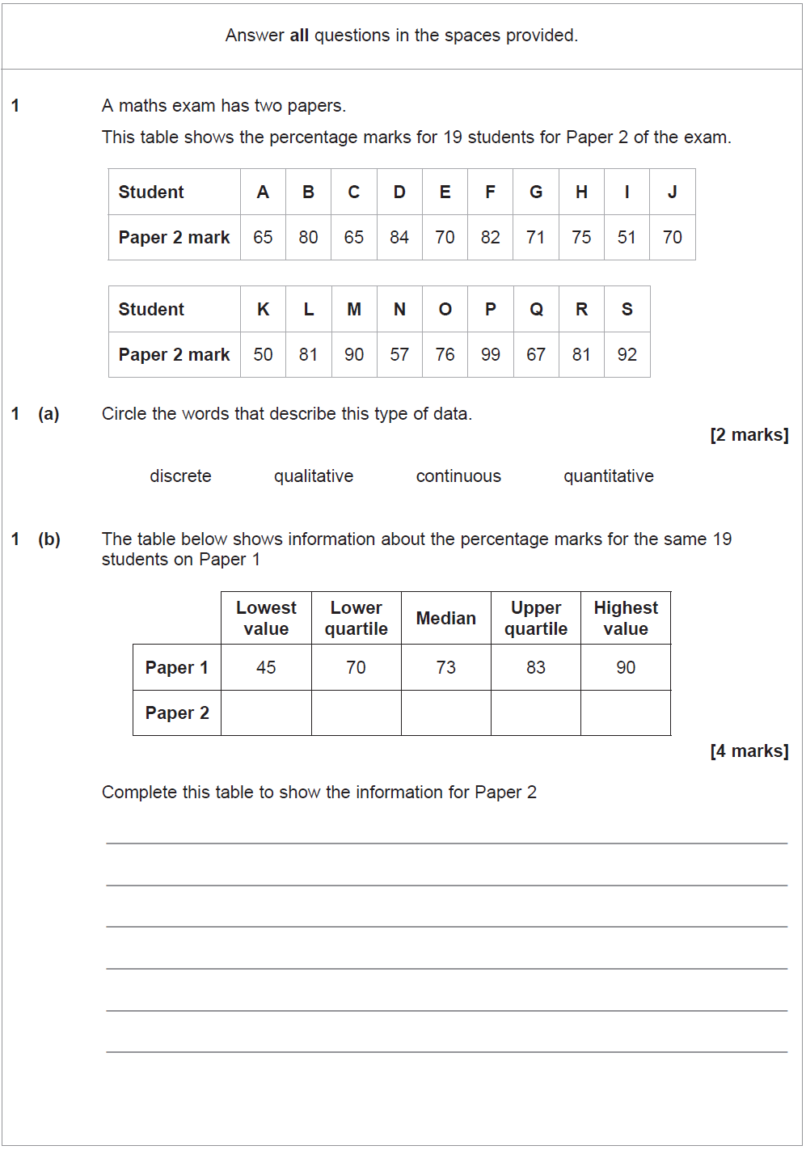

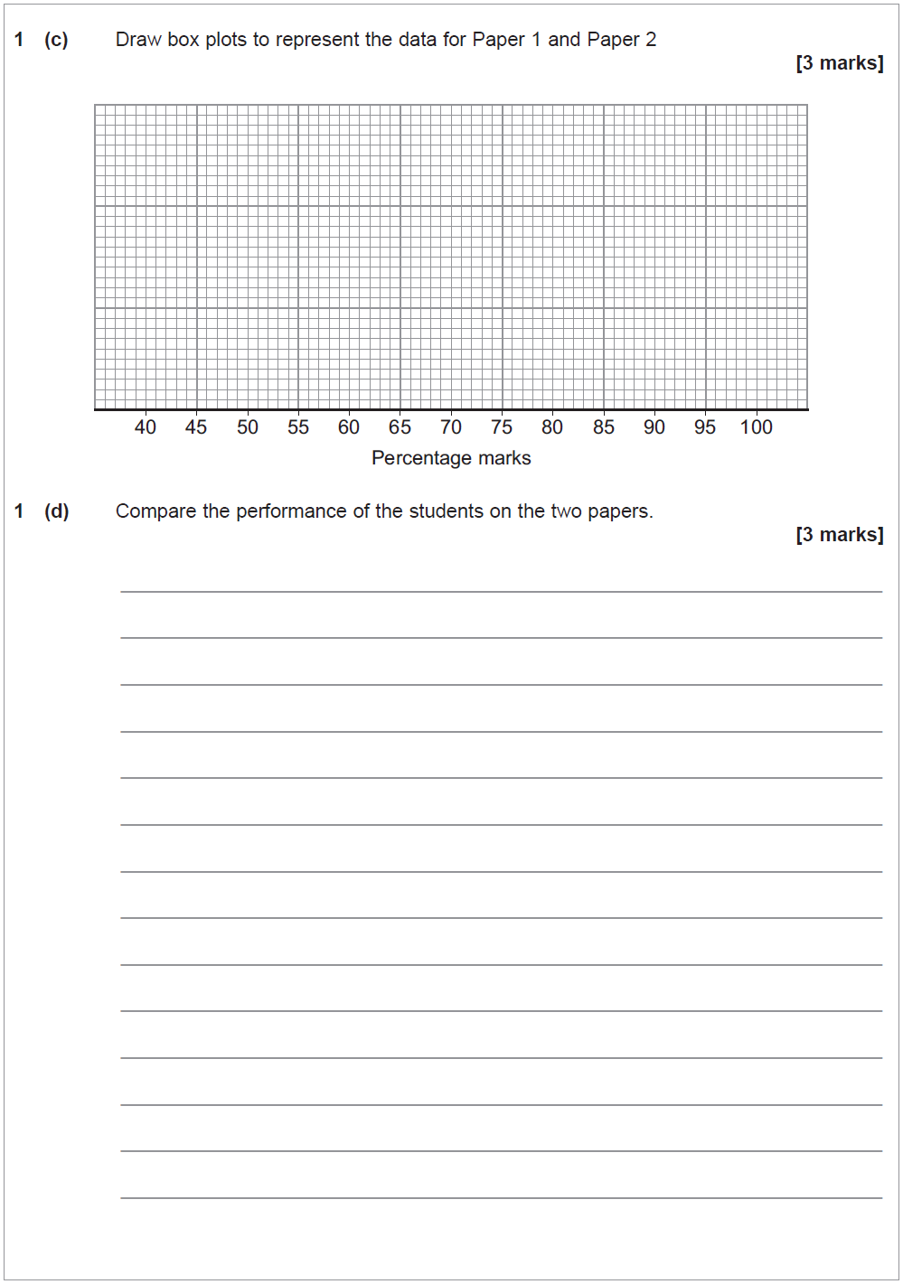

June 16 – Question 4

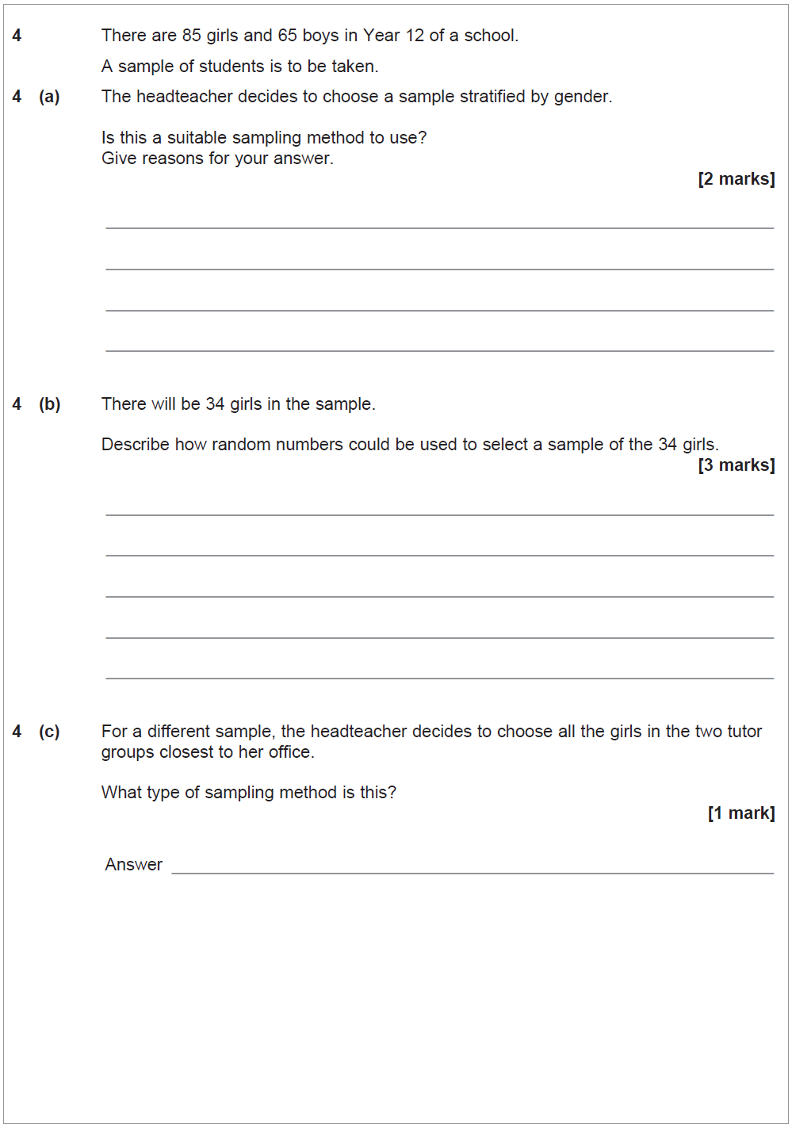

June 17 – Question 5a

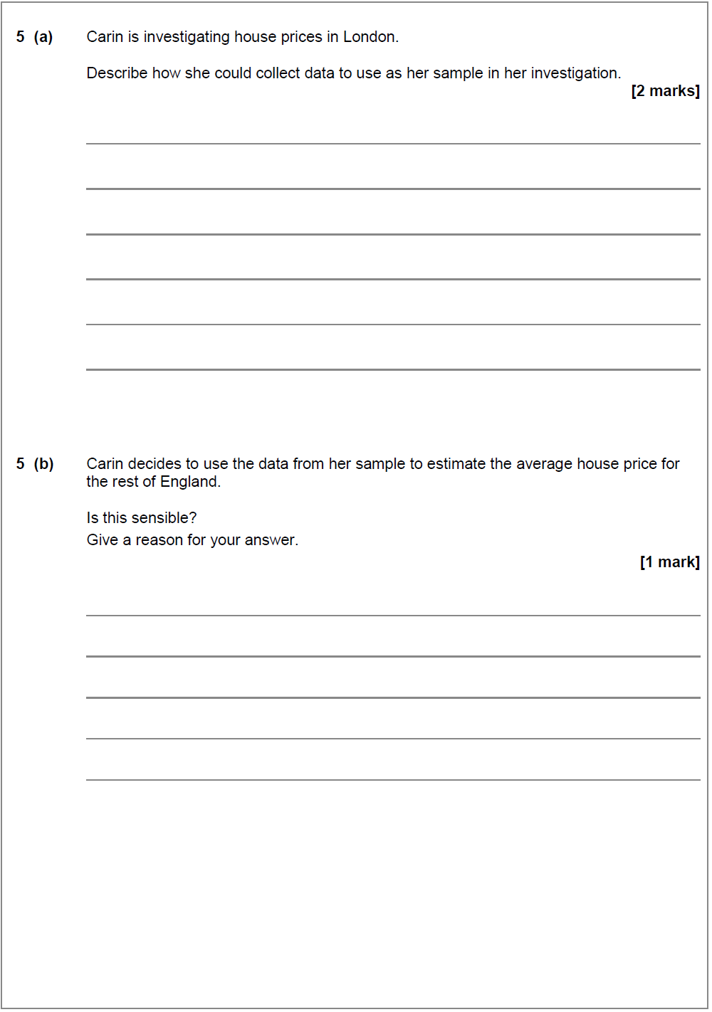
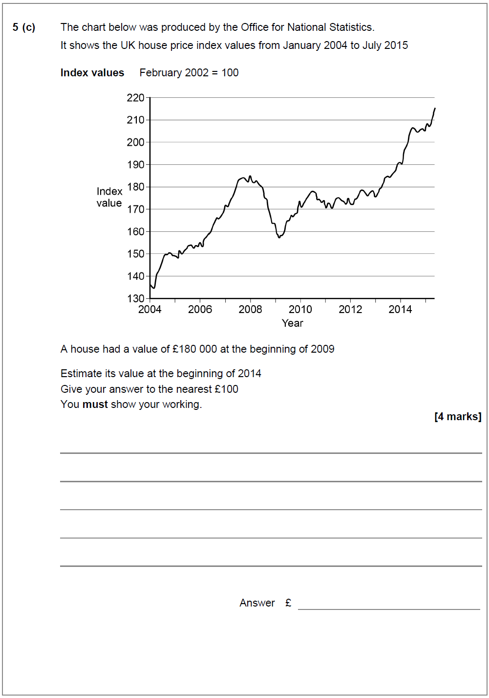

AER and interest rates

Specimen – Question 2

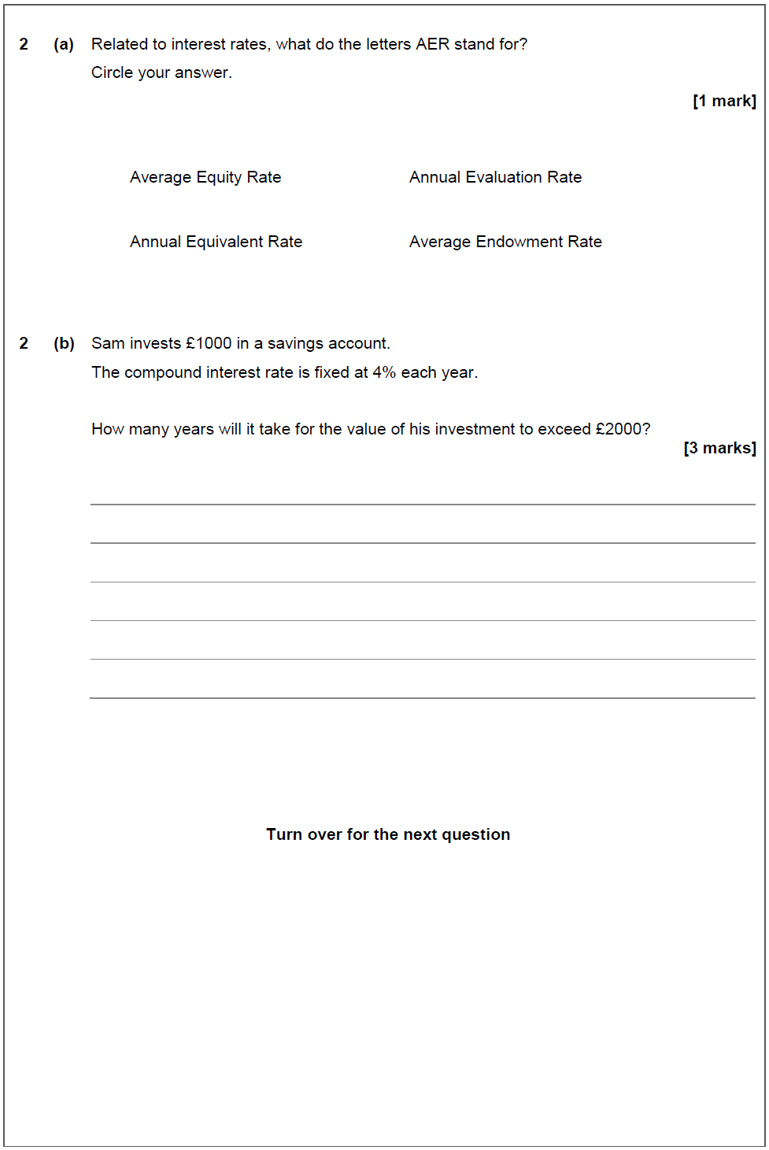

June 16 – Question 2

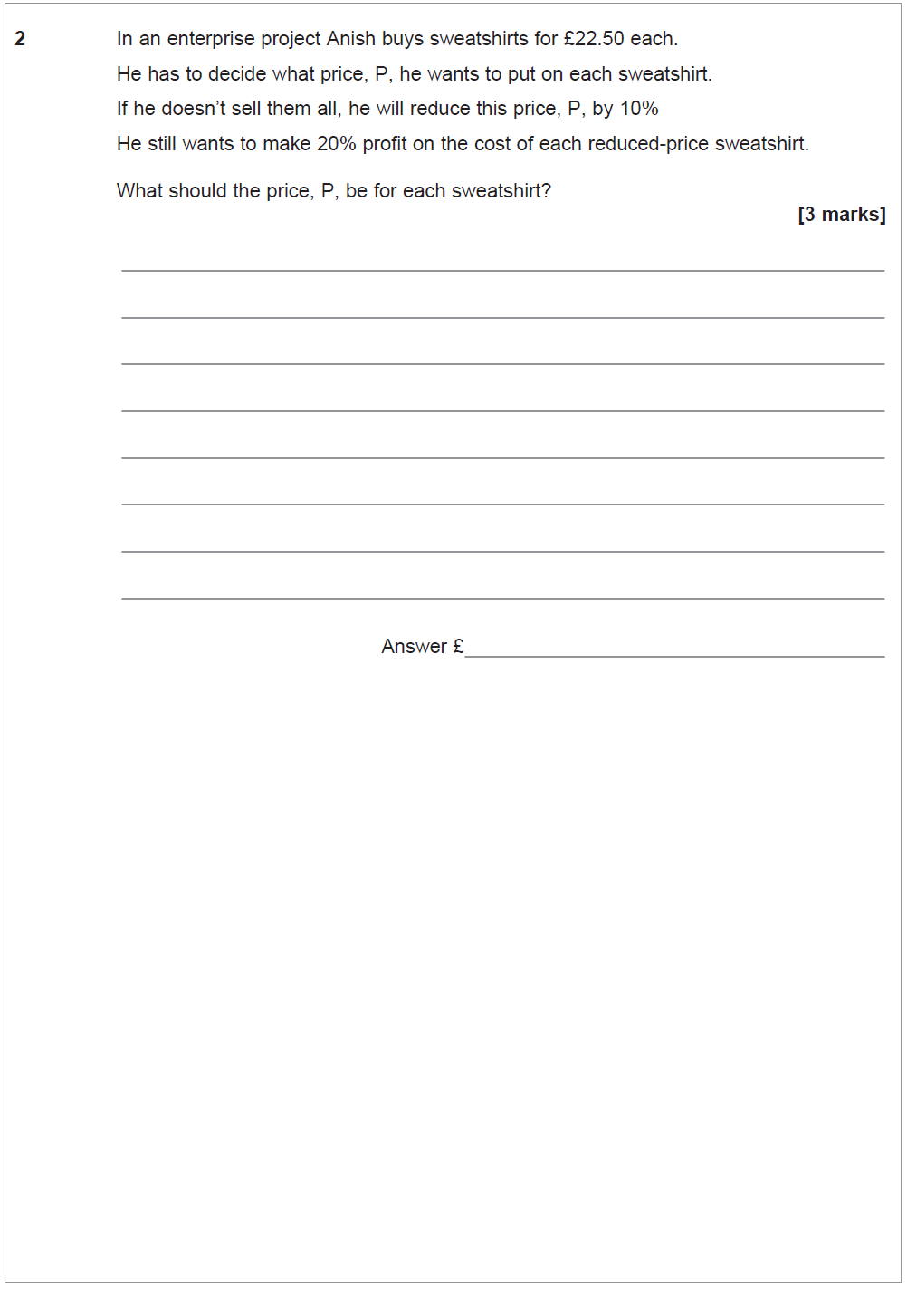

June 16 – Question 5

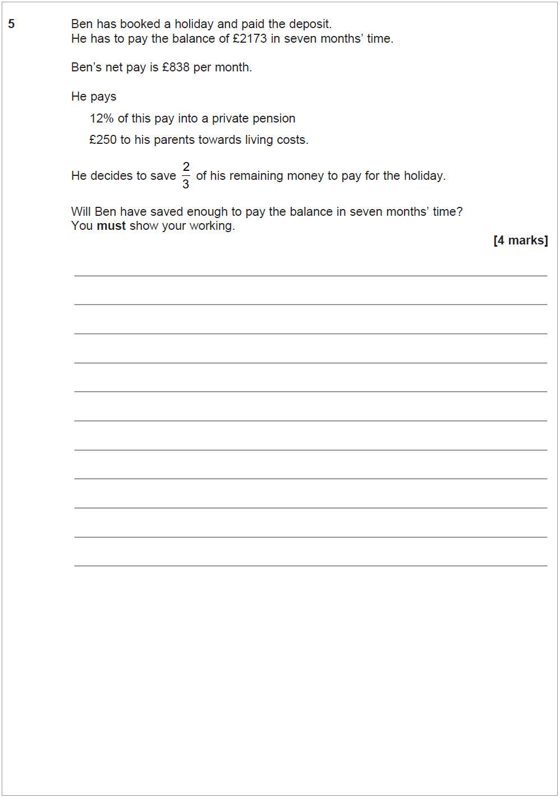

June 16 – Question 8

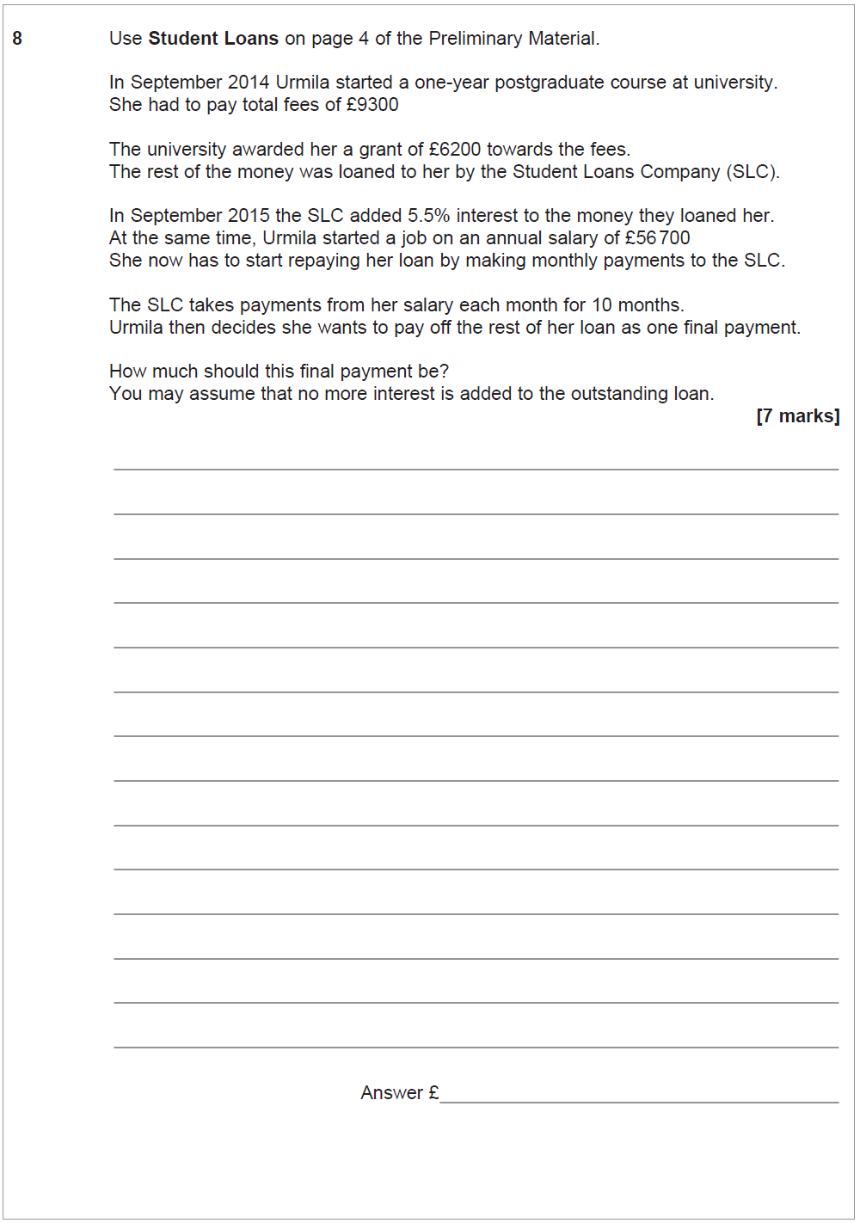

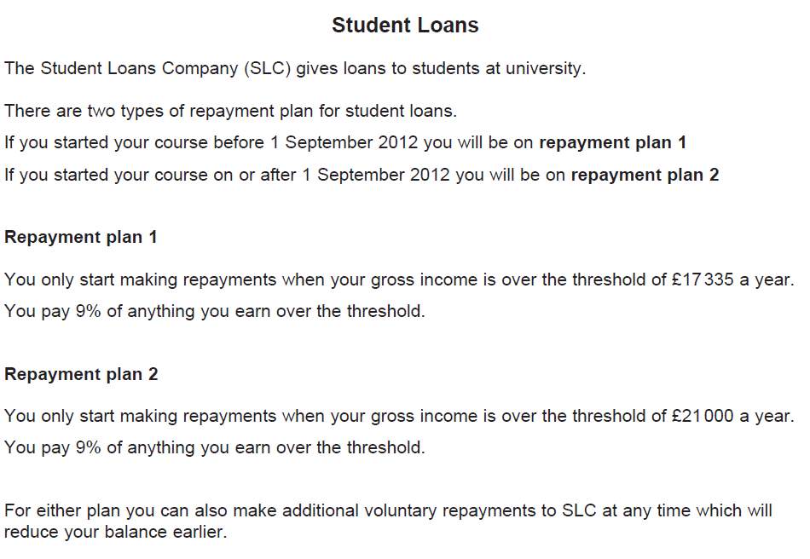

June 17 - Question 5c

June 17 – Question 6c

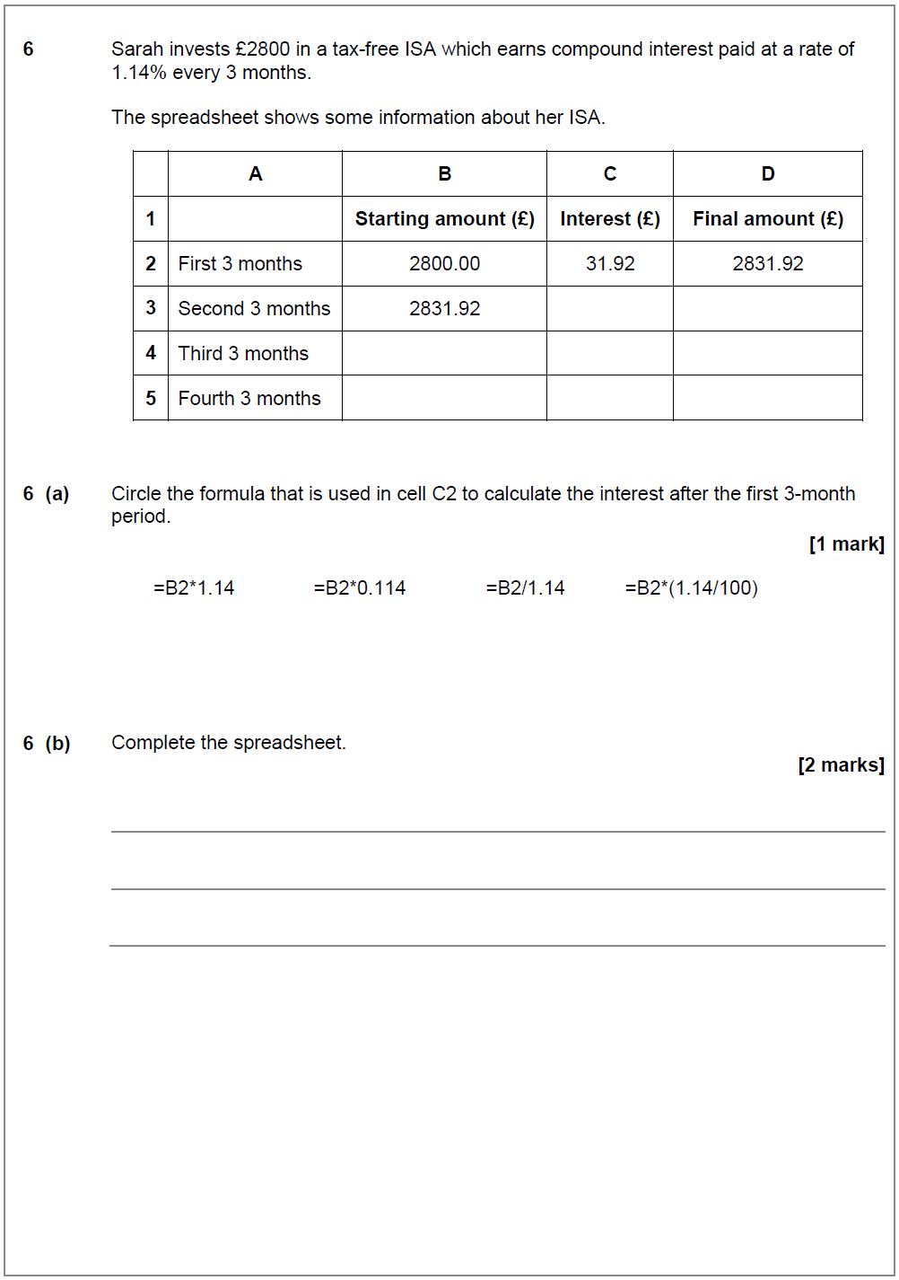
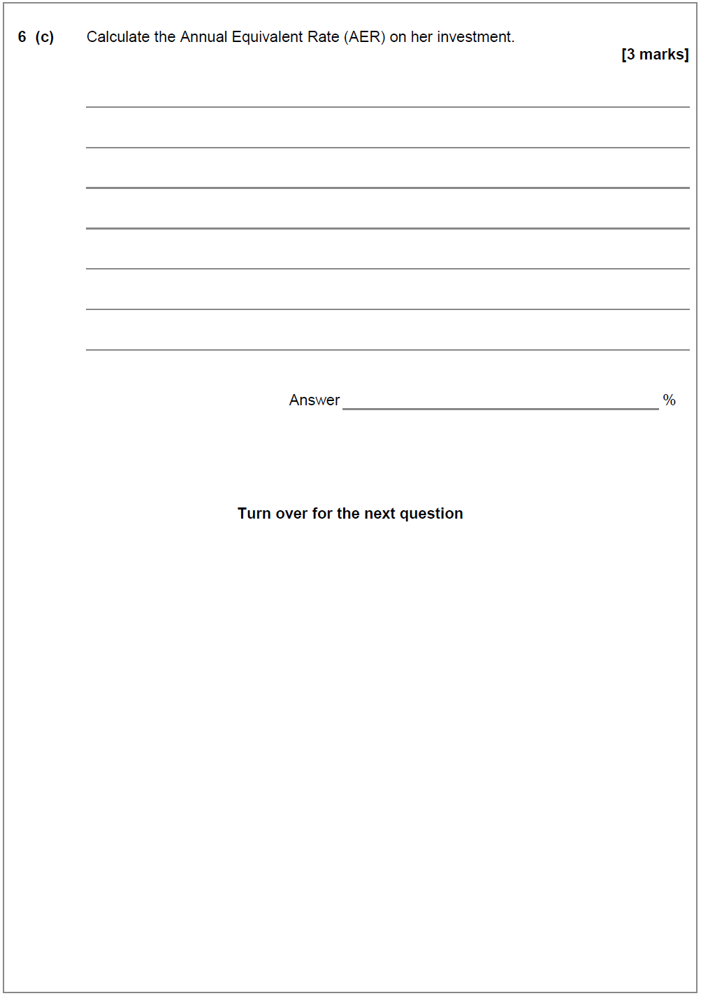

GCSE Topic Revision

Specimen – Question 5b
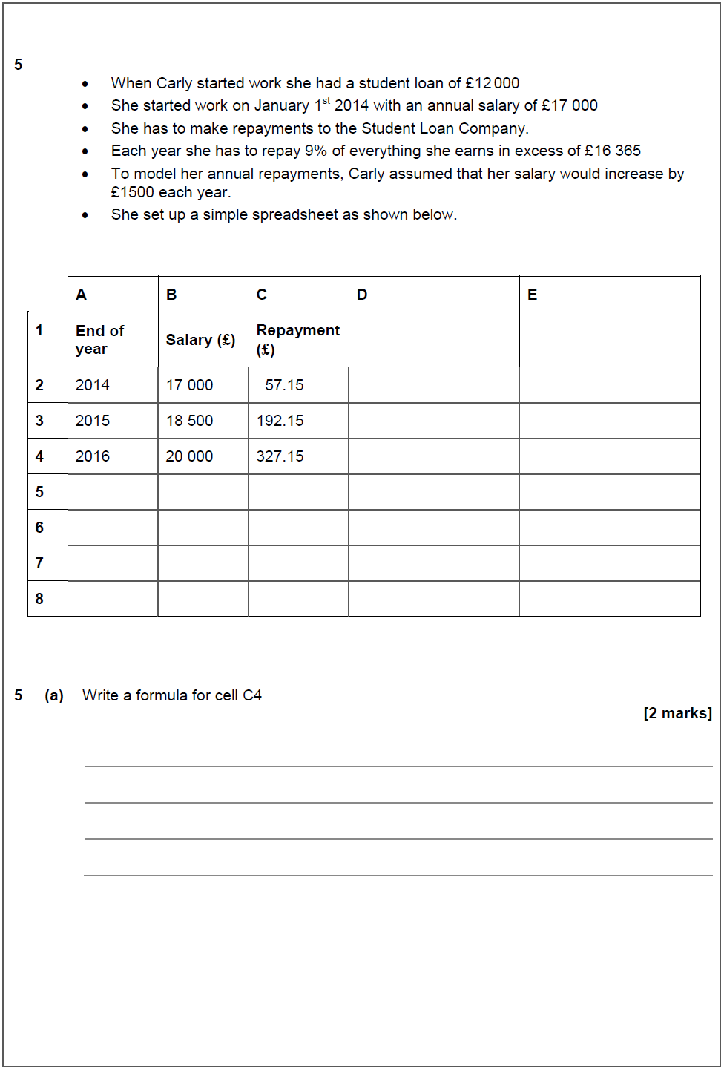

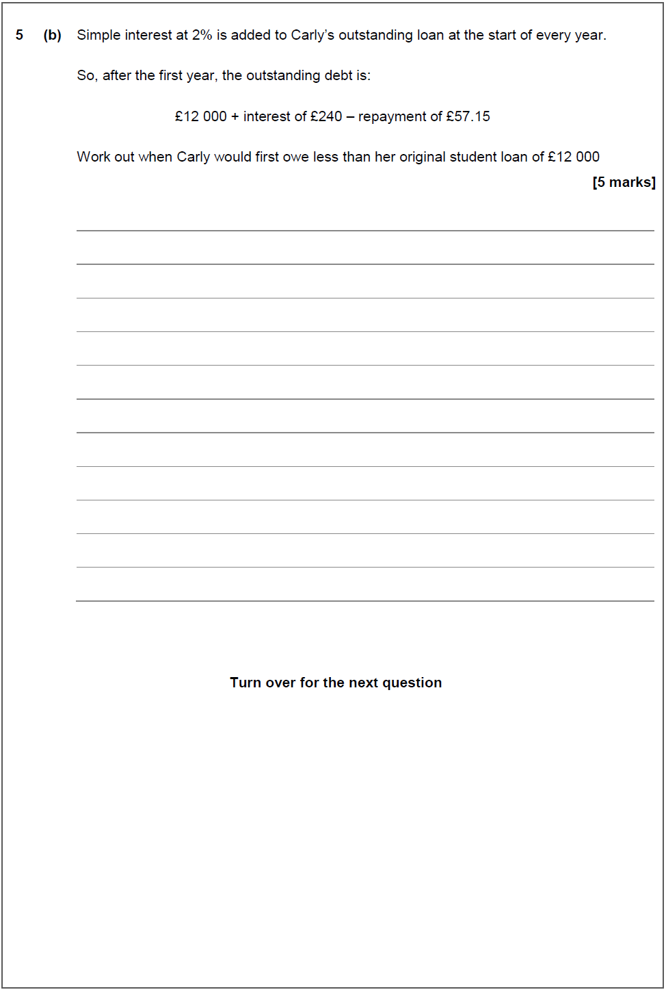

June 16 – Question 1

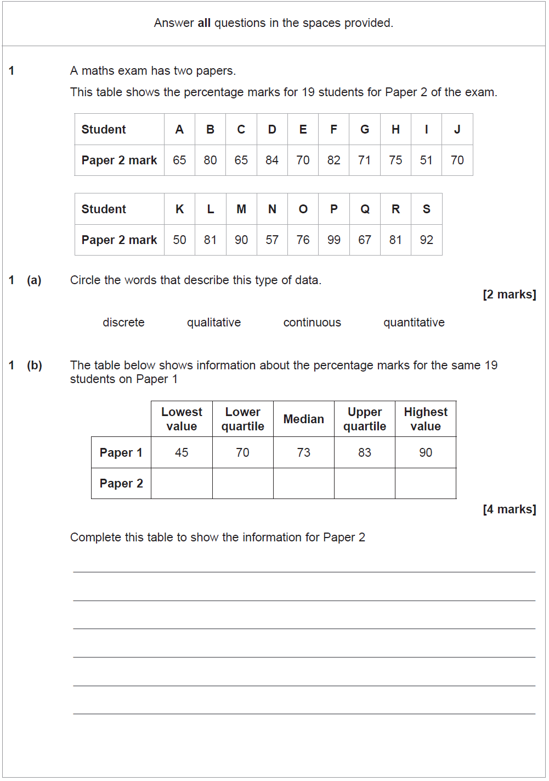
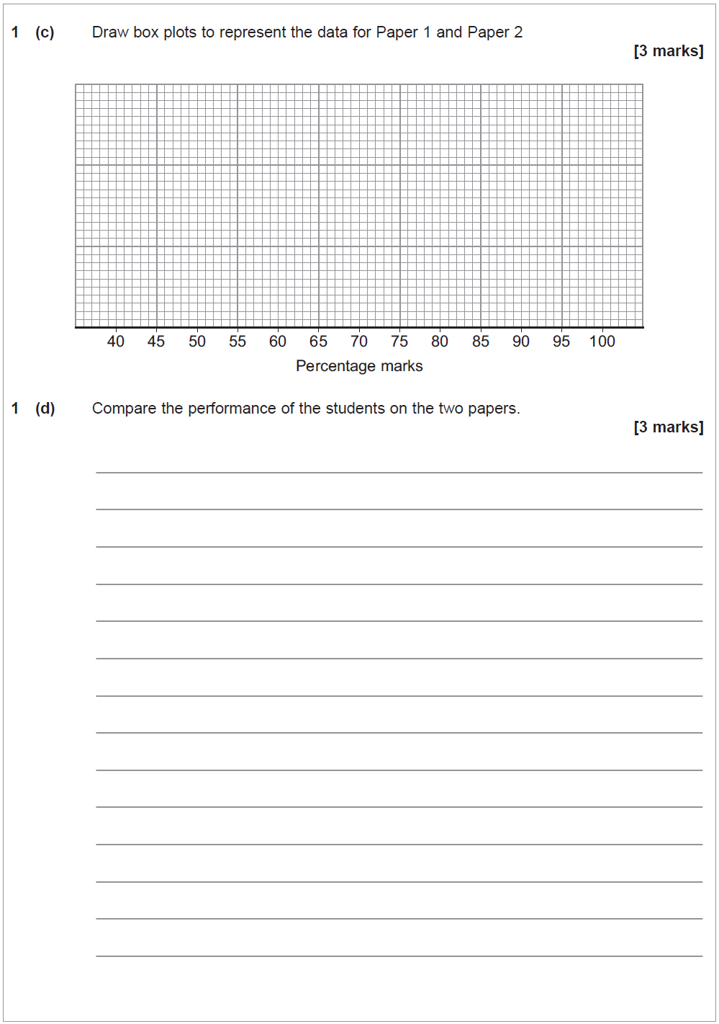

June 16 – Question 2

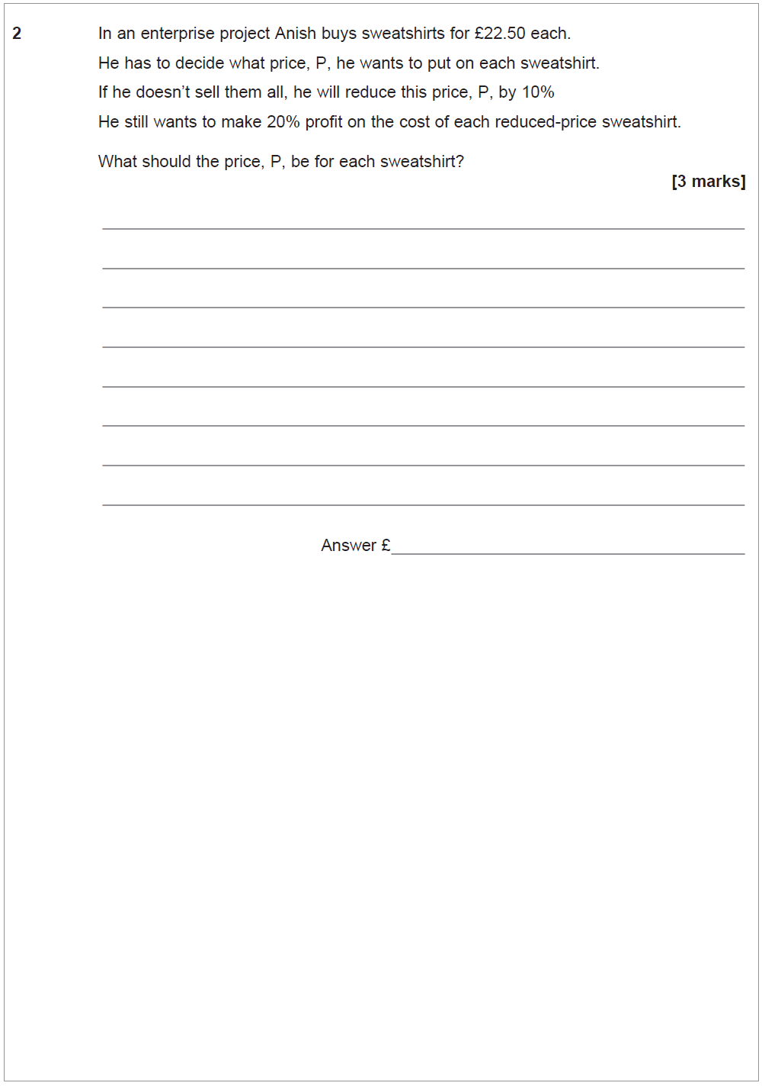

June 16 – Question 5

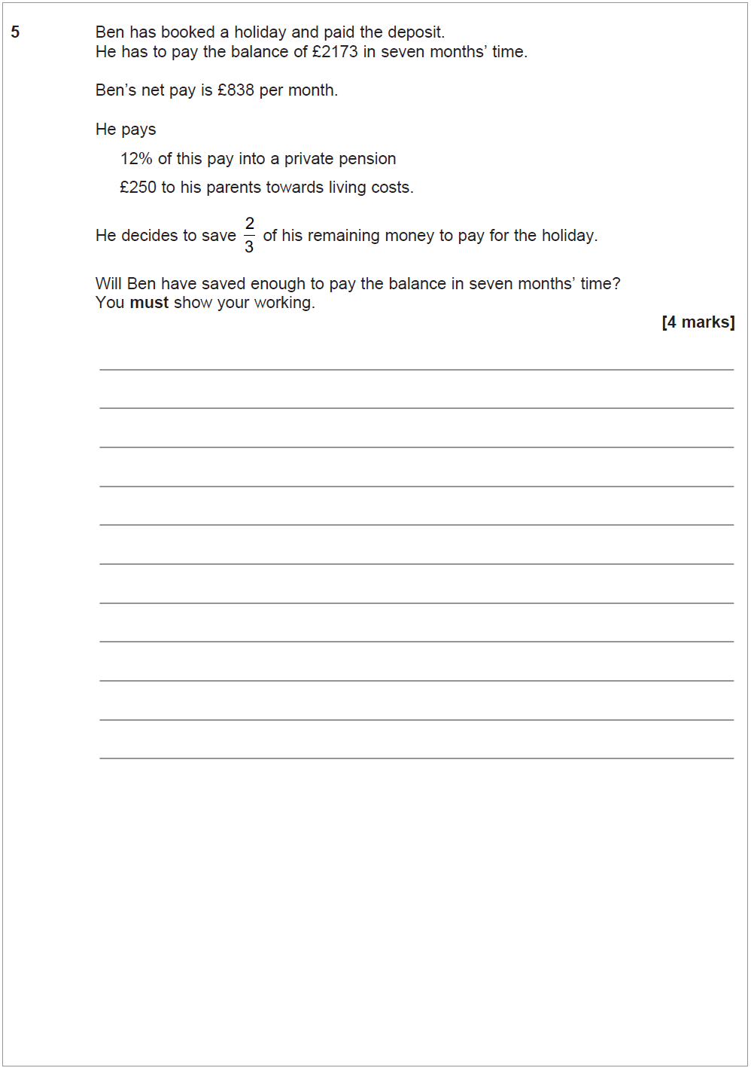

June 17 – Question 1

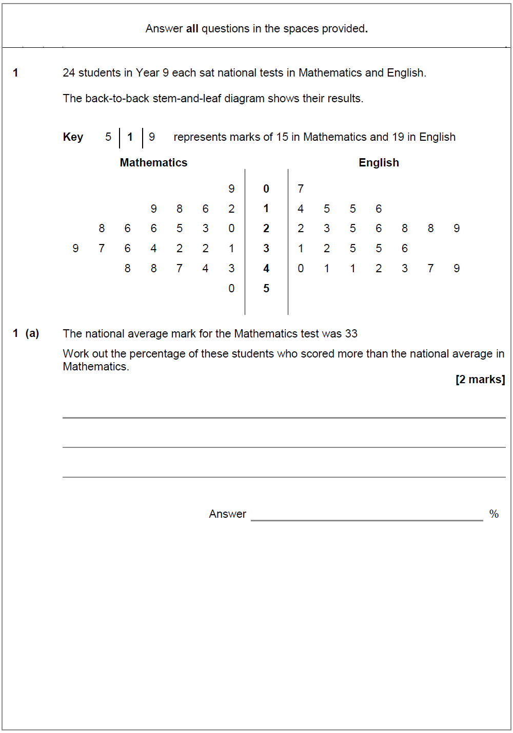

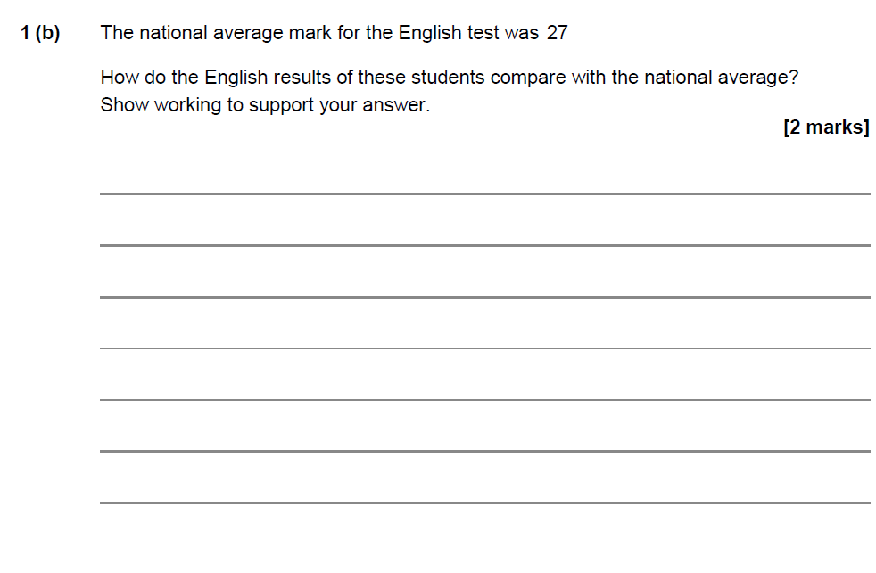

June 17 – Question 2

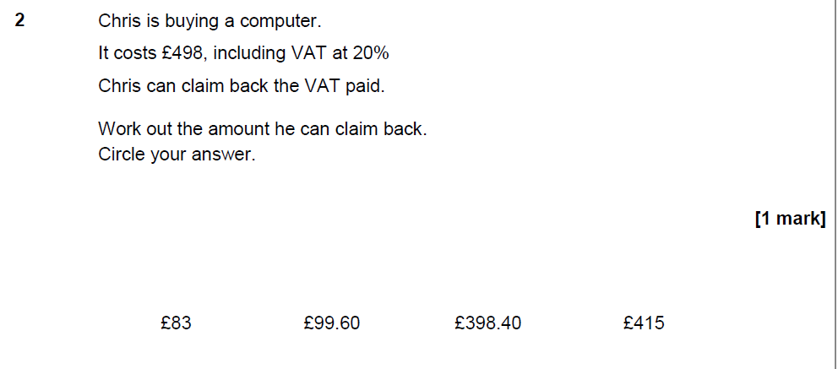

June 17 – Question 3

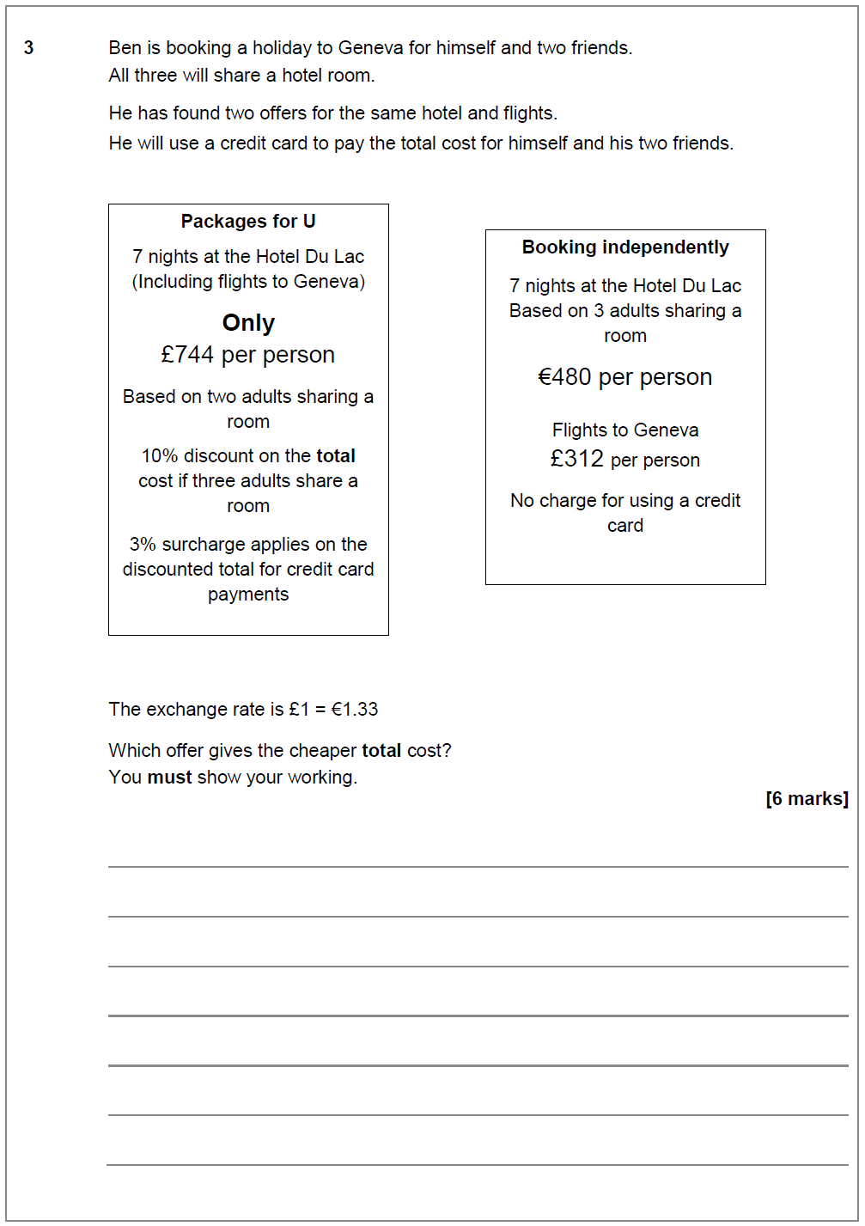

June 17 – Question 9a

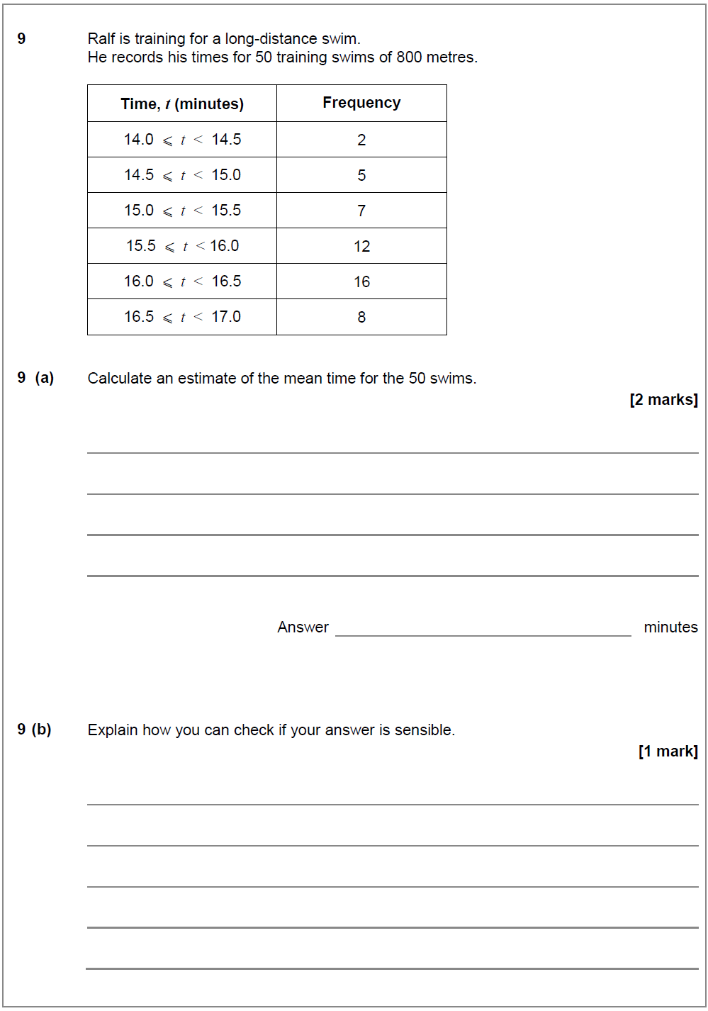

Graphical presentation of Data

Specimen – Question 4a

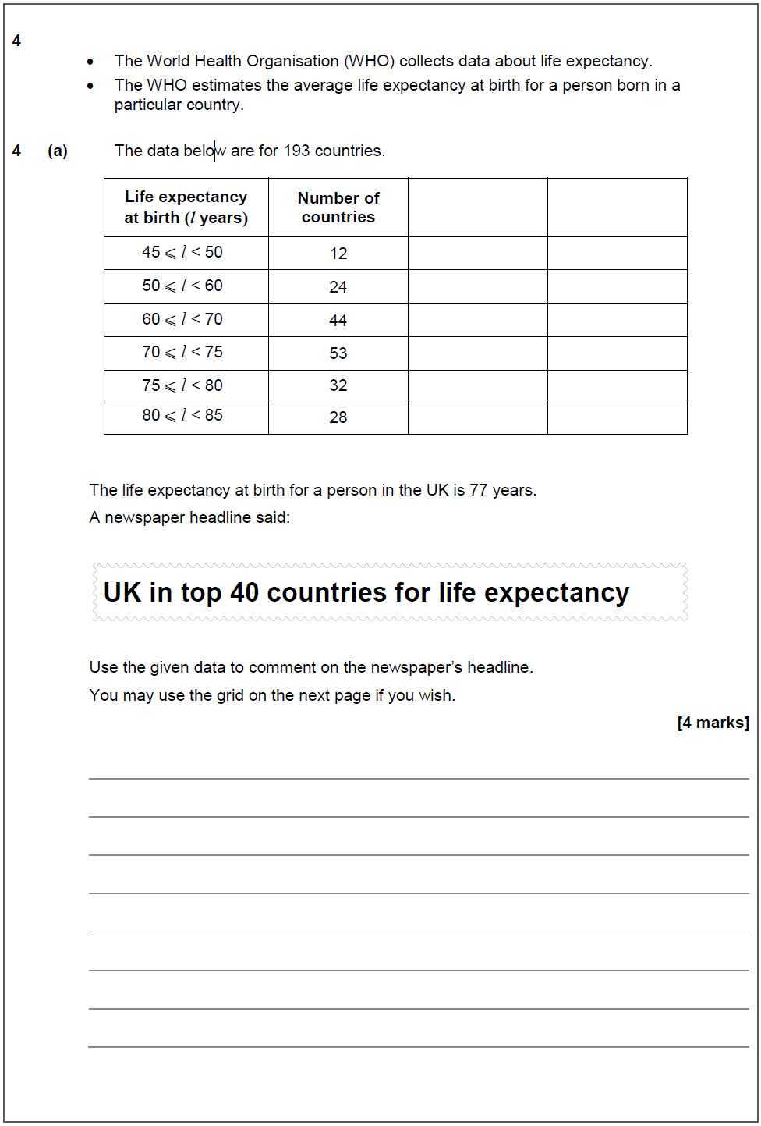

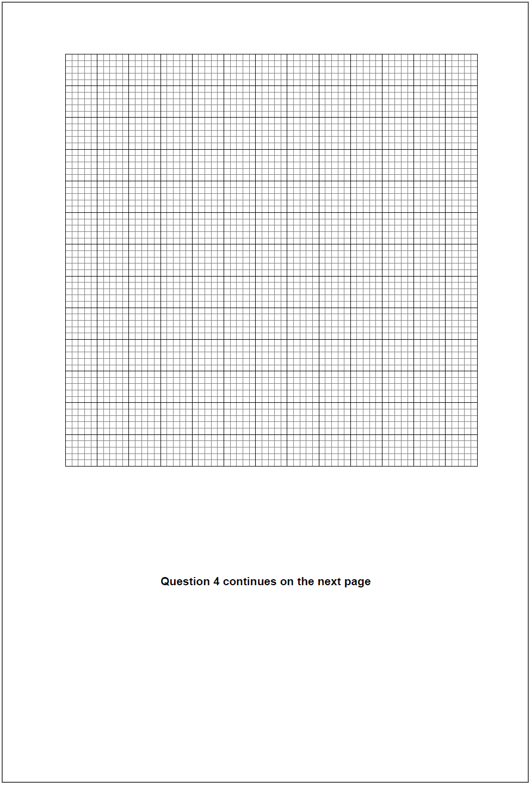

Specimen – Question 6

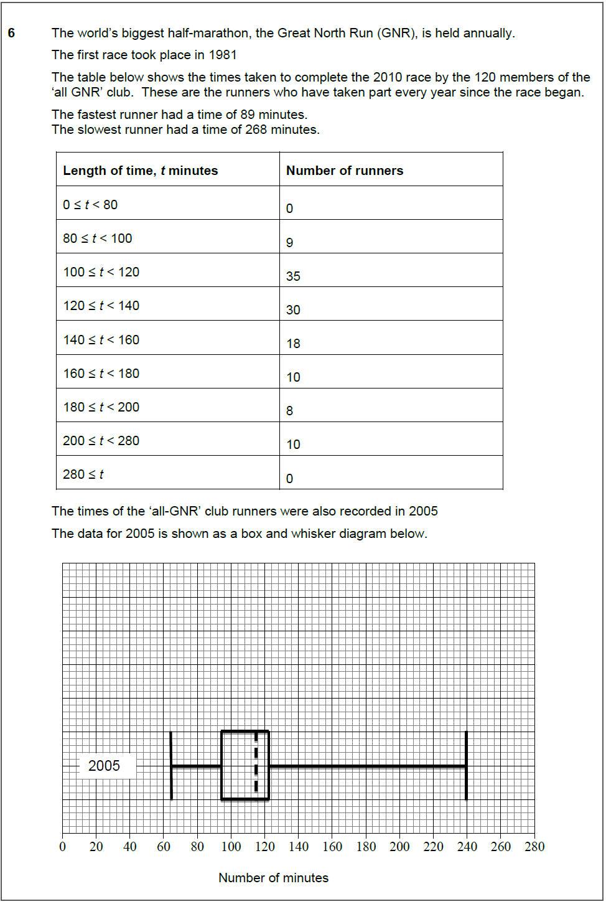

June 16 – Question 1c

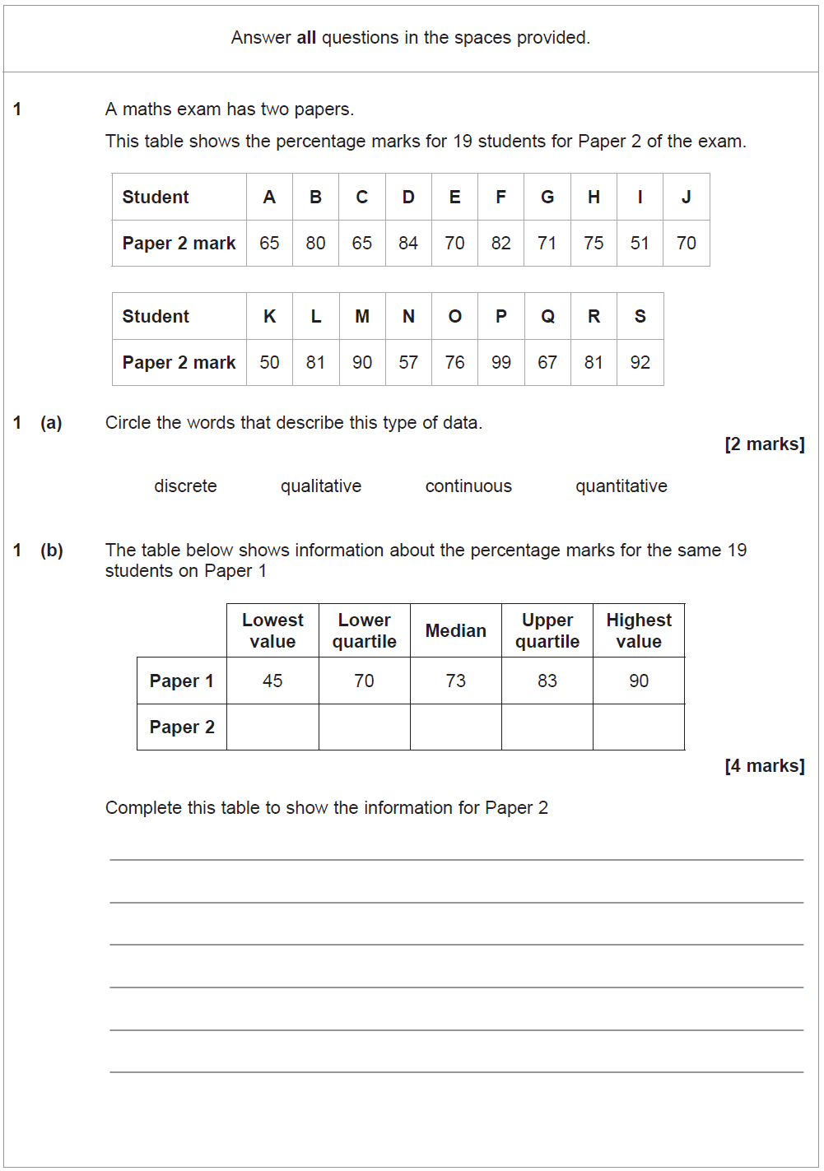
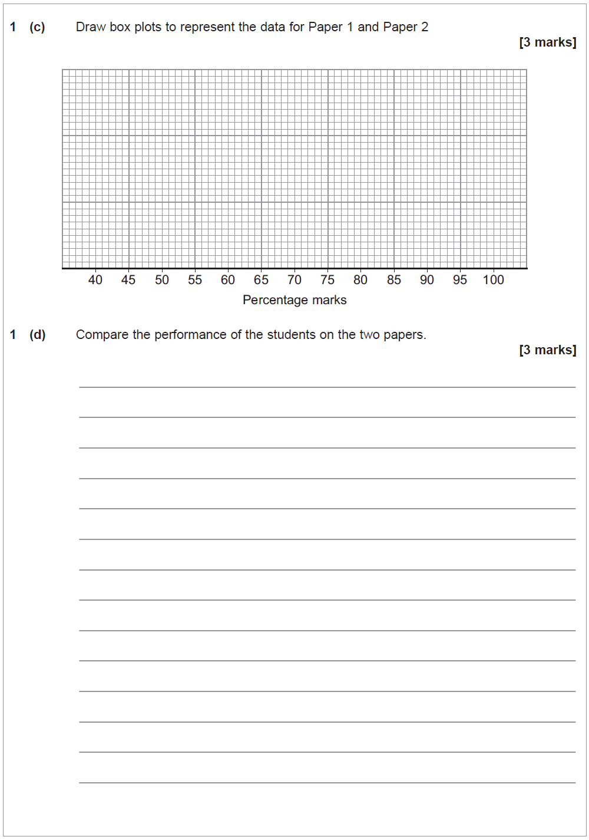

June 16 – Question 7

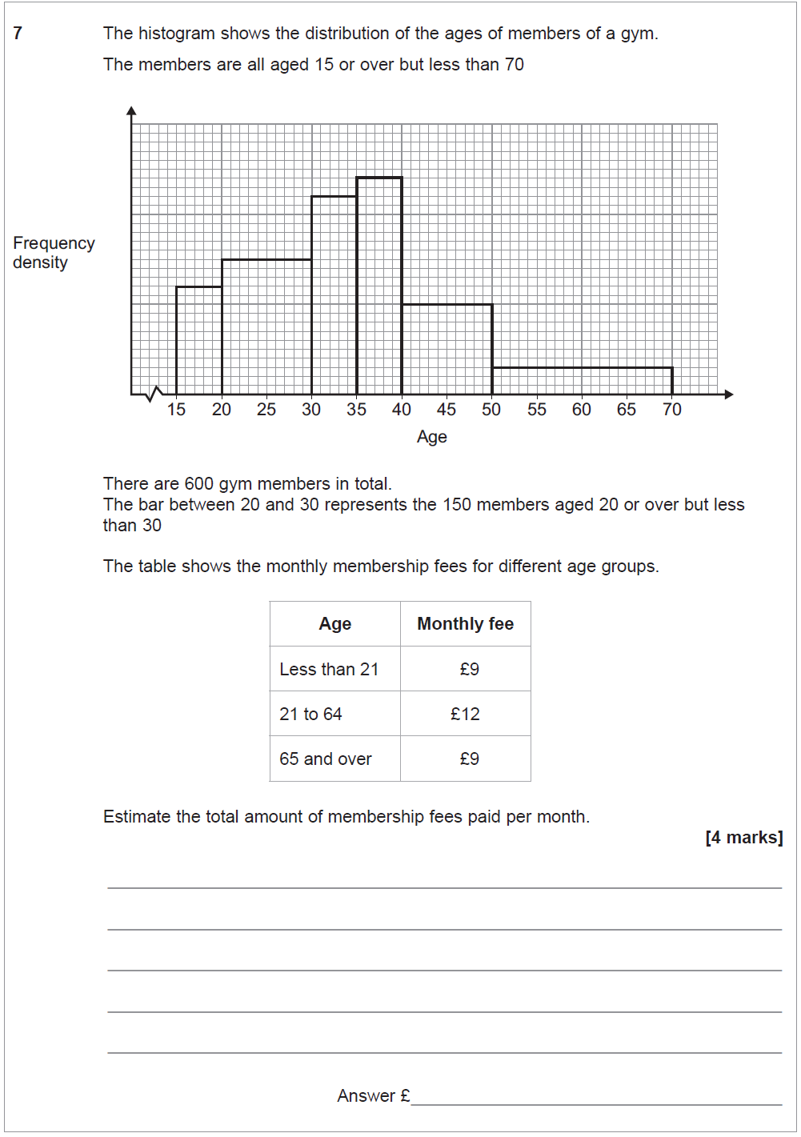

June 17 – Question 7

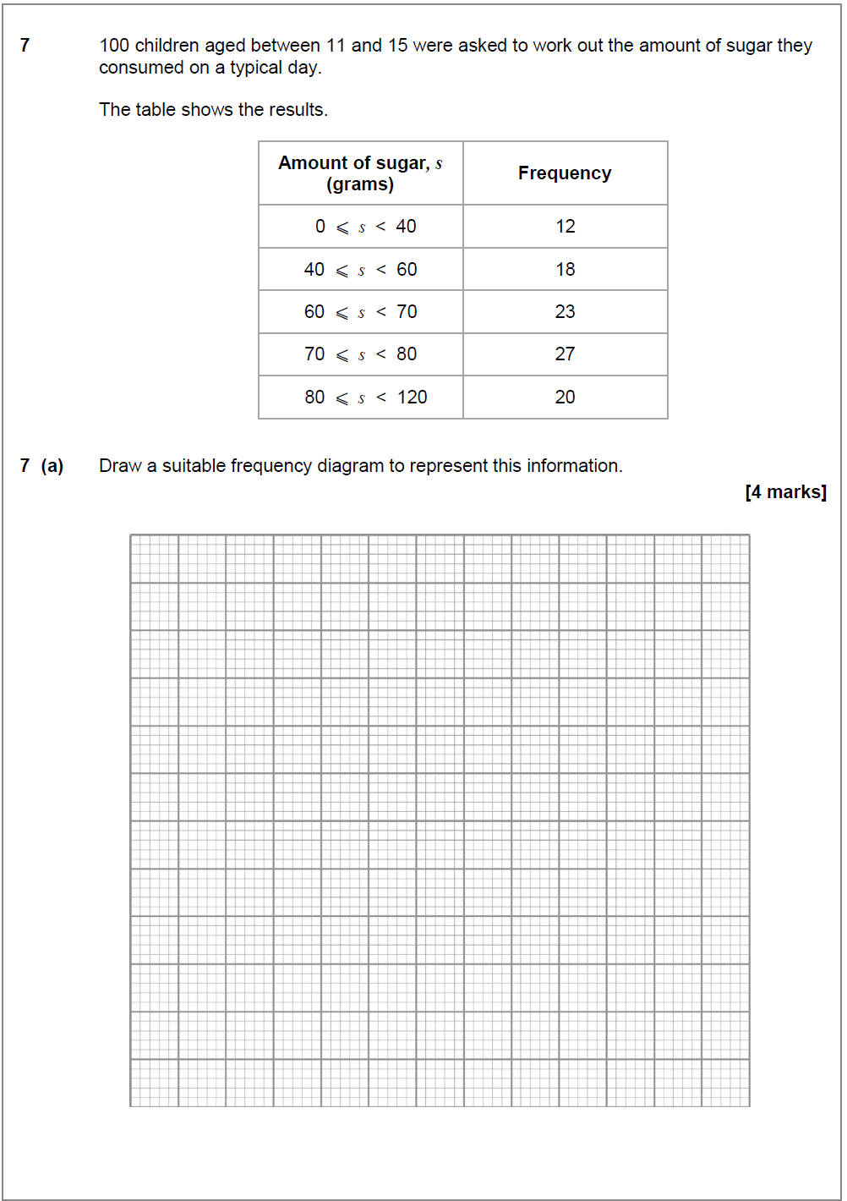

Spreadsheets

Specimen – Question 5

June 17 – Question 6a

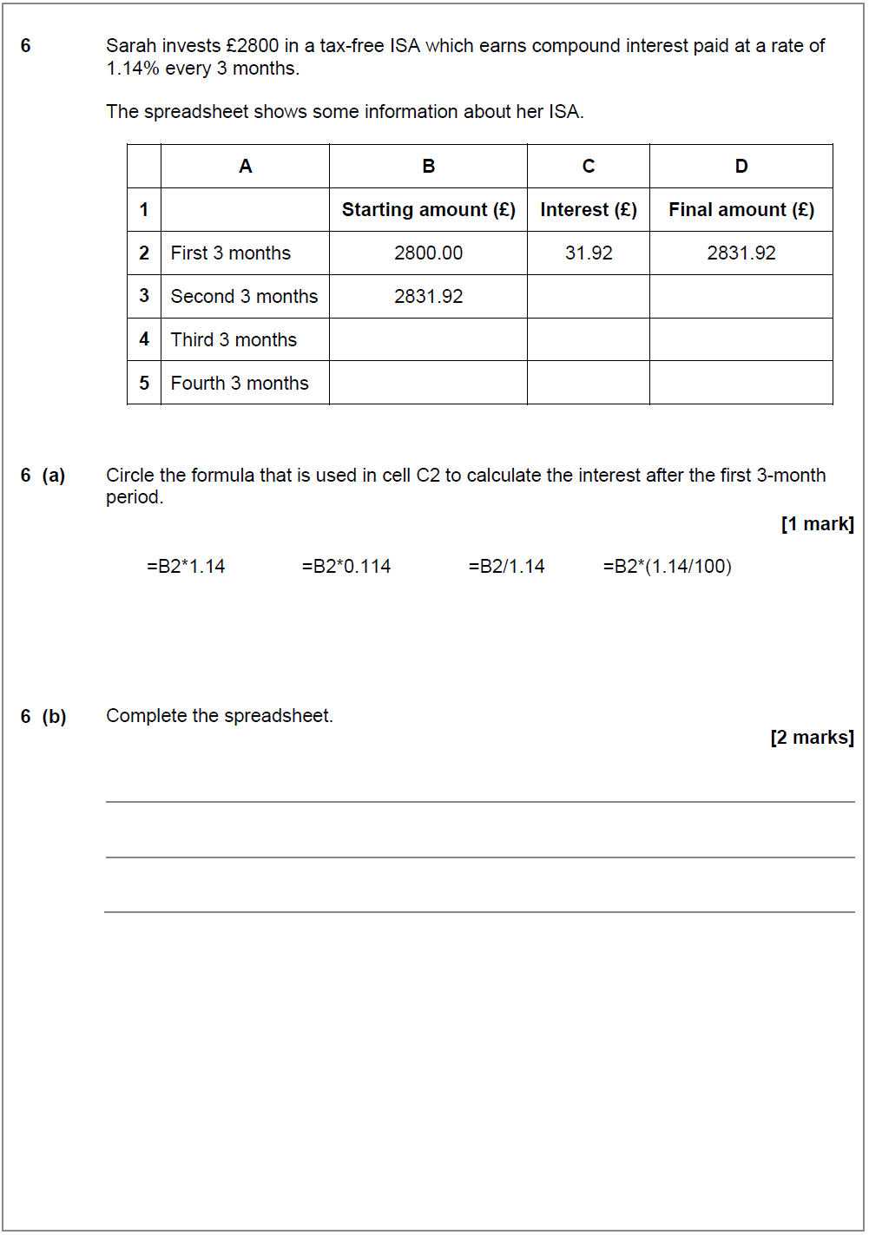

Interpretation/Analysis

Specimen – Question 4b

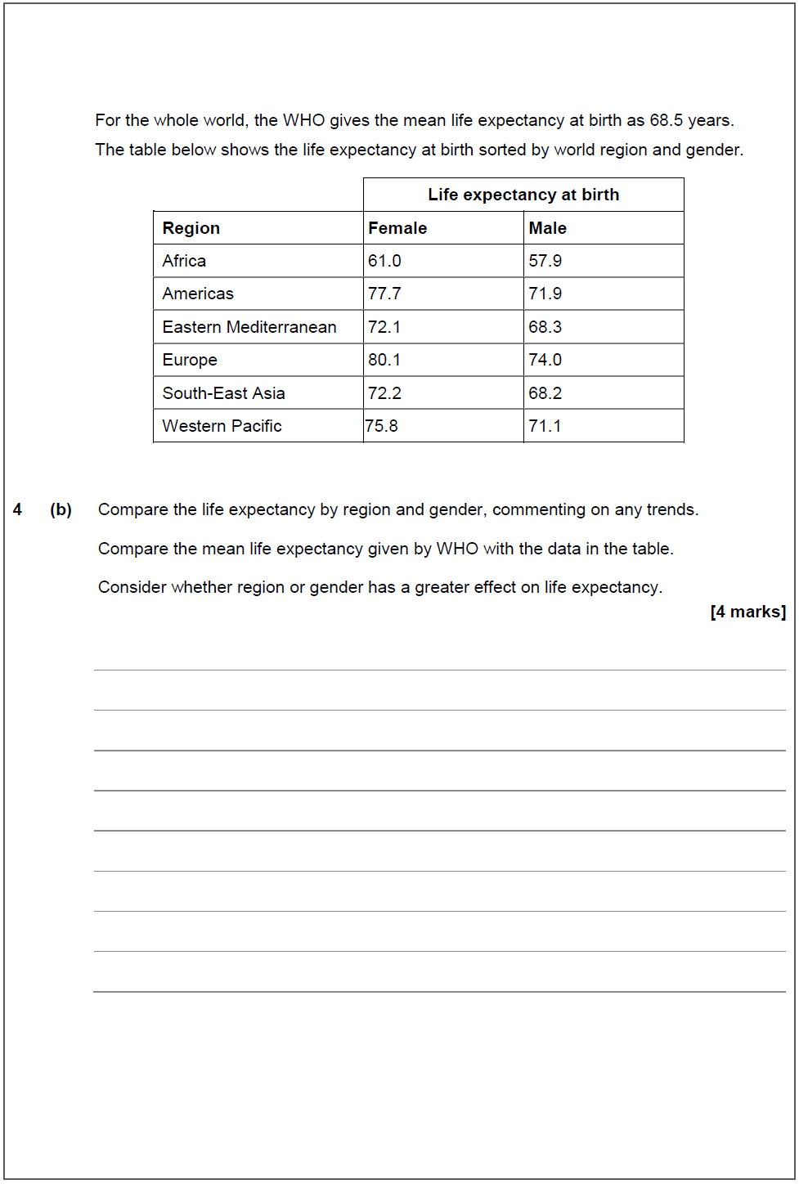

Specimen – Question 6

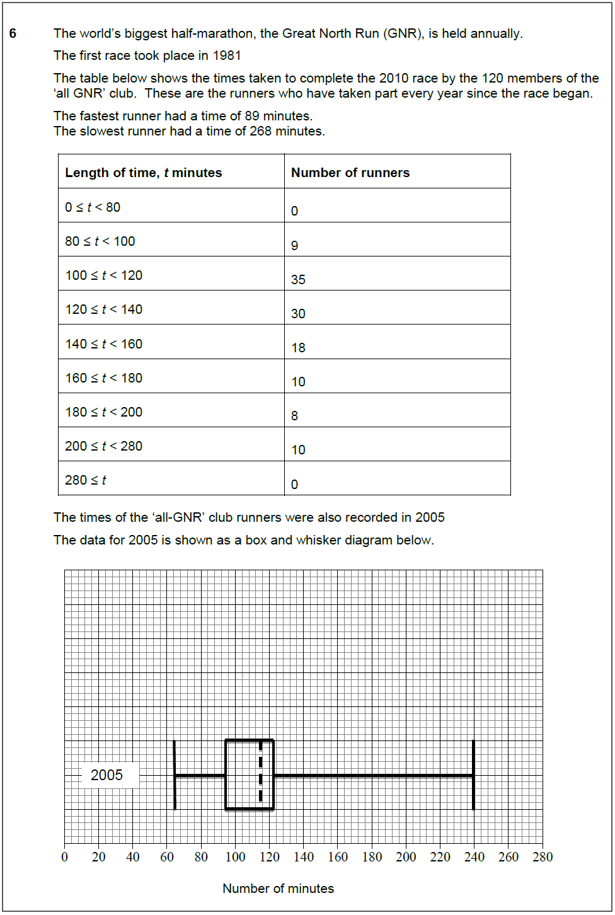

June 16 – Question 1d

June 16 – Question 3b

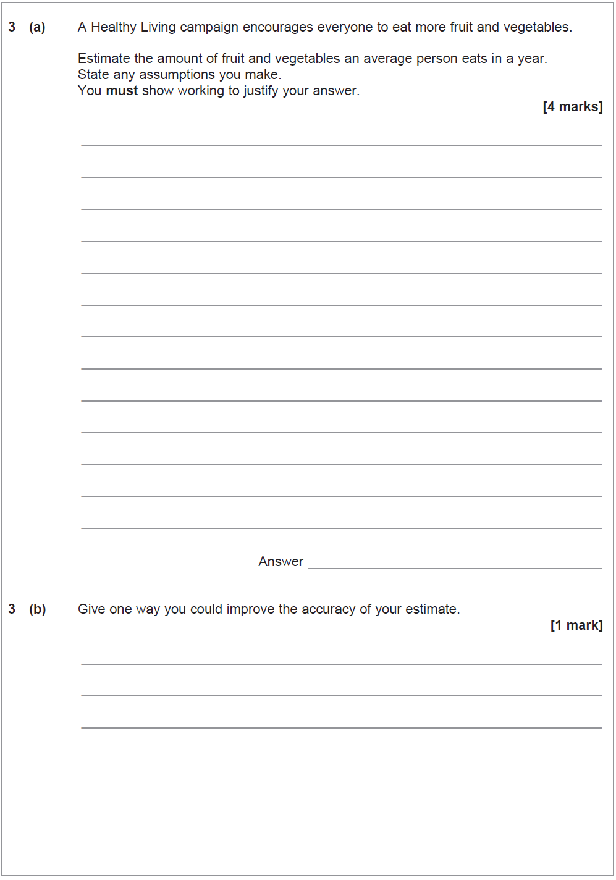

June 16 – Question 7

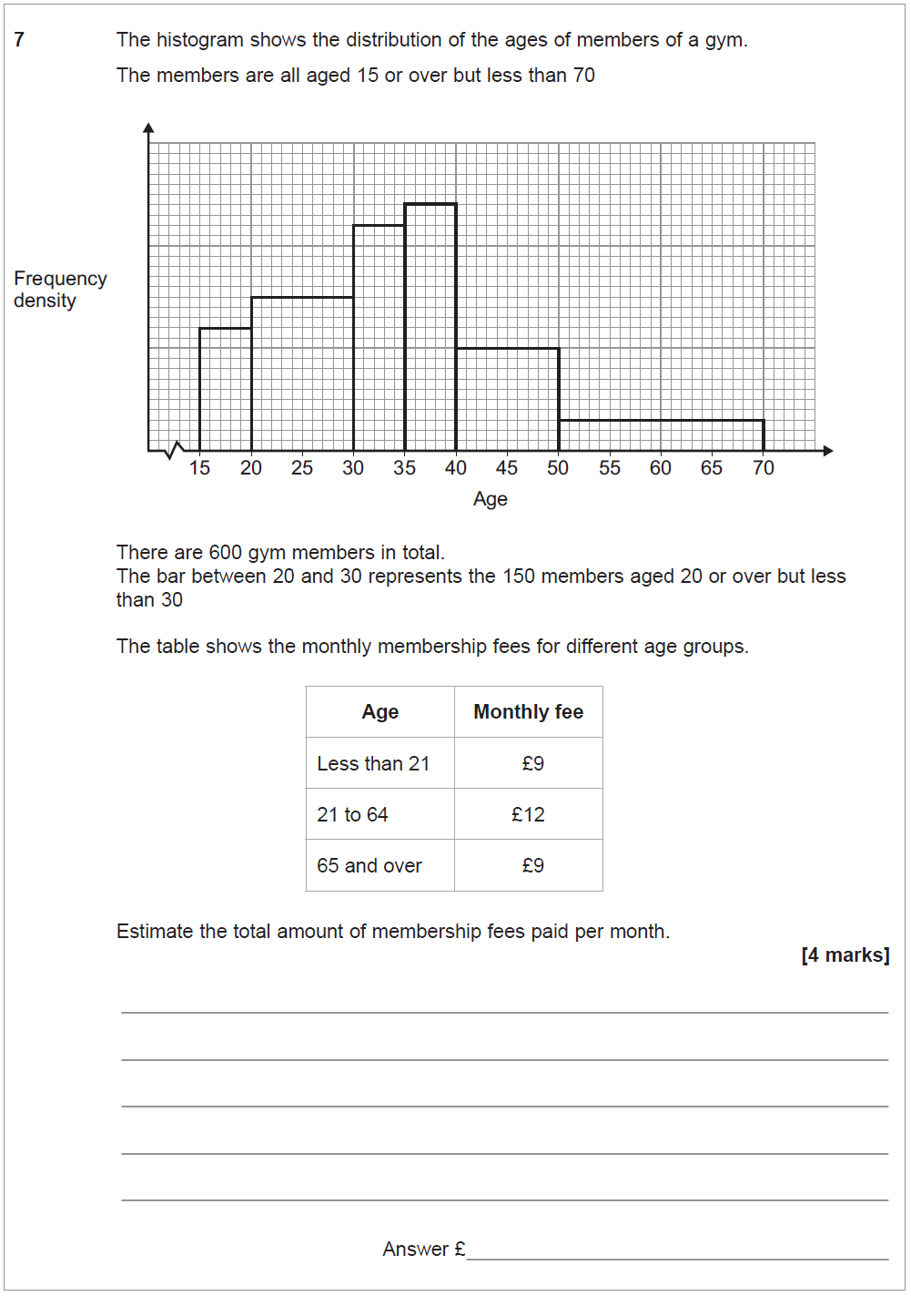

June 17 – Question 5

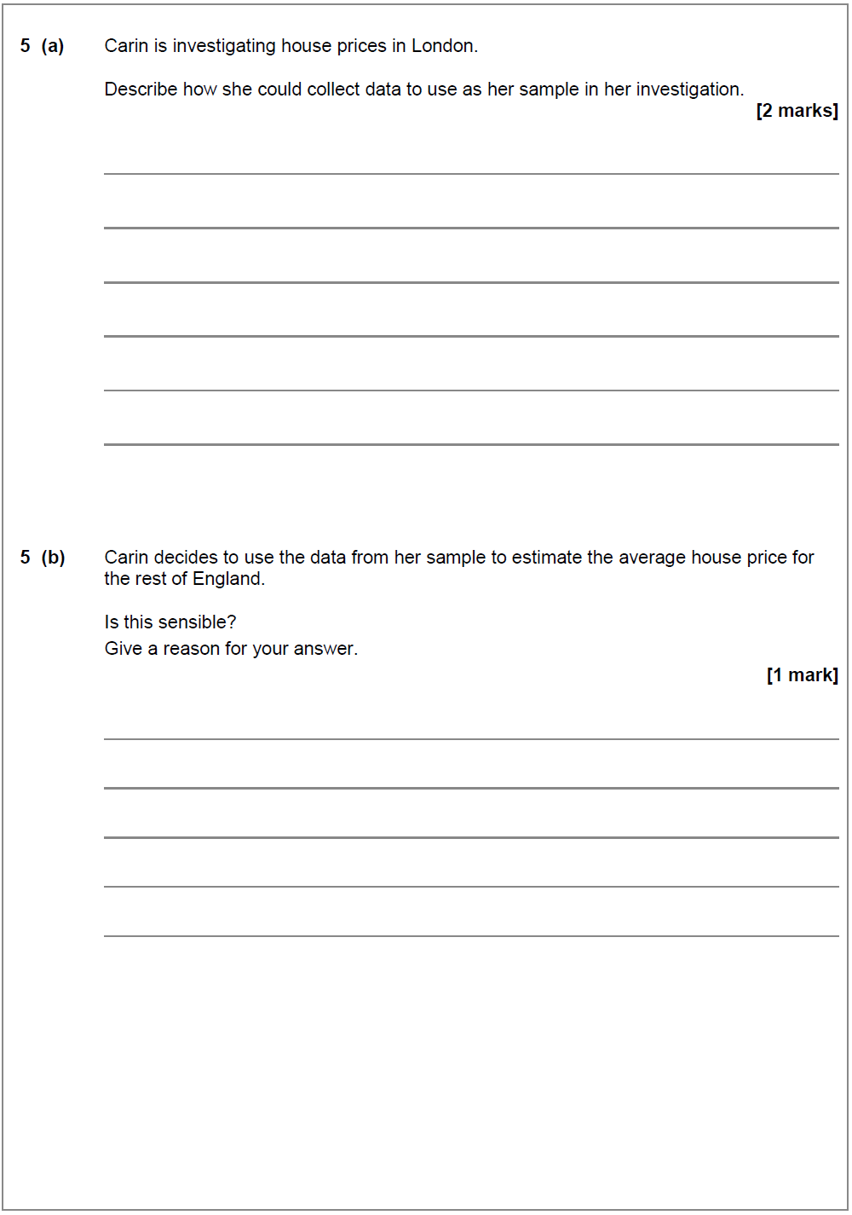

June 17 – Question 7b

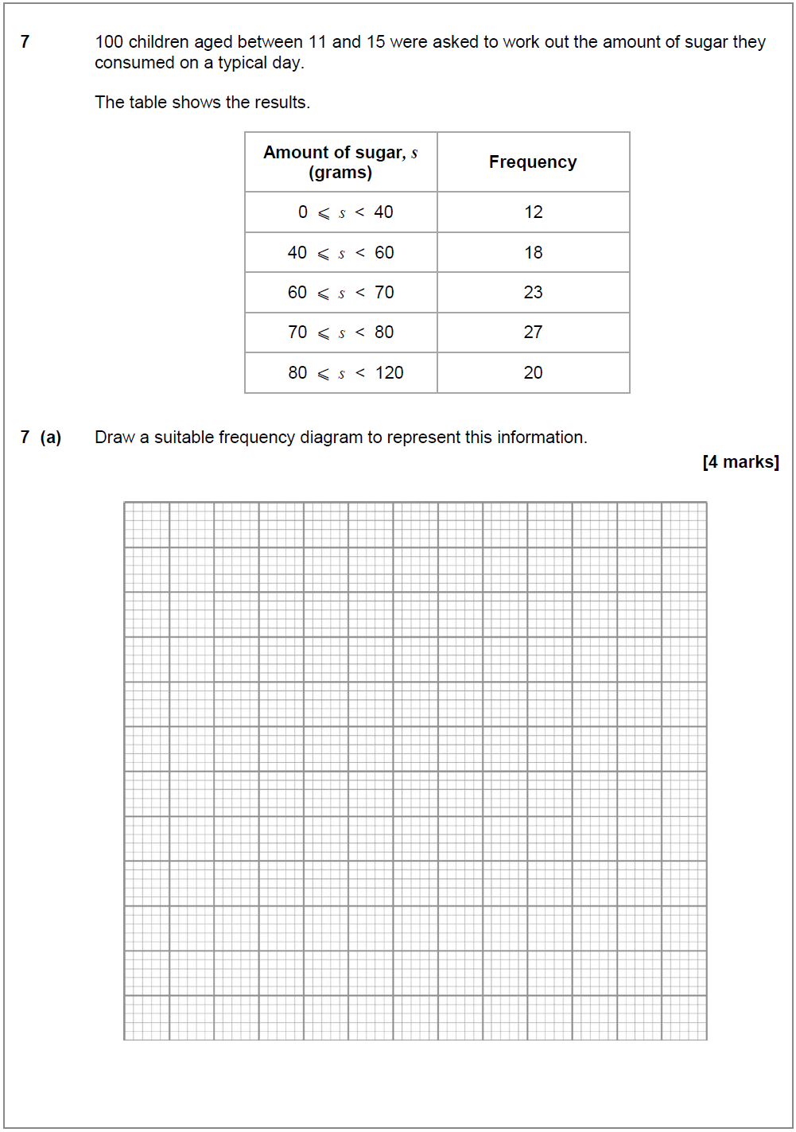
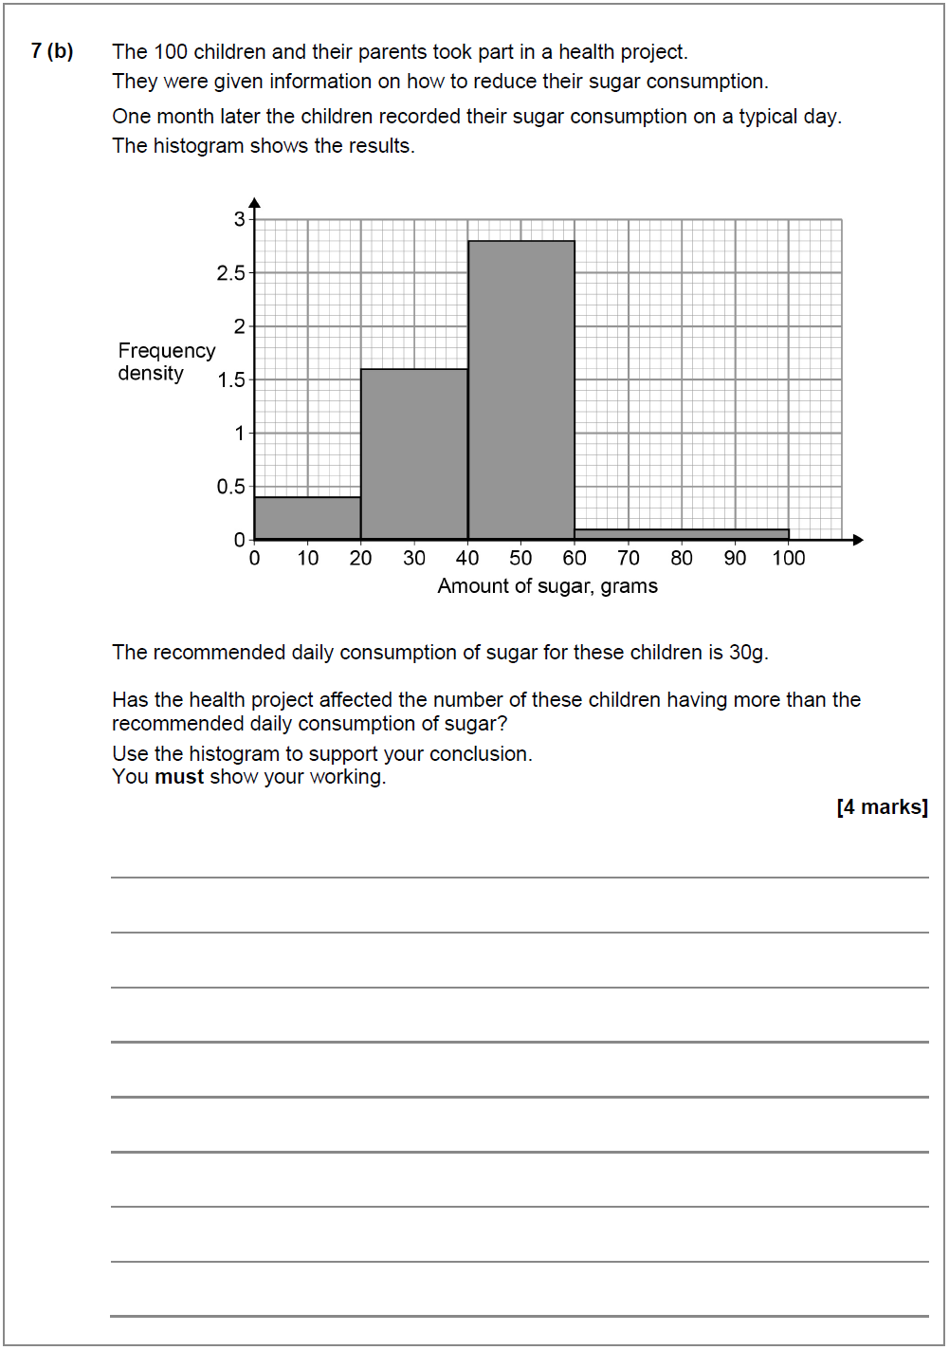

June 17 – Question 9b, 9d

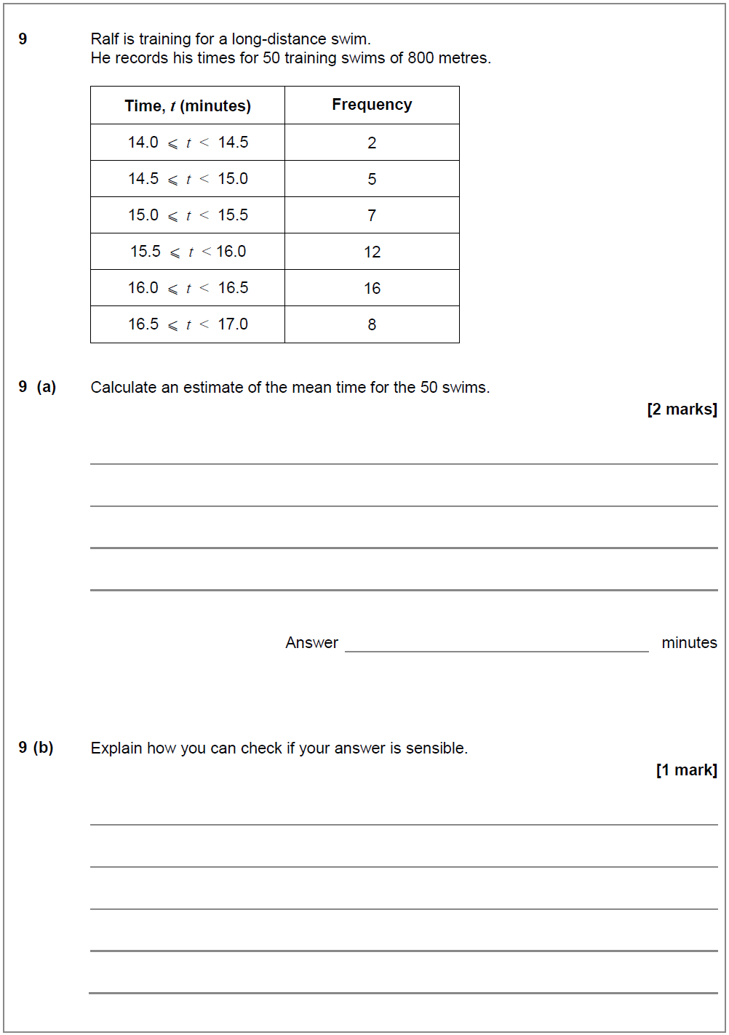

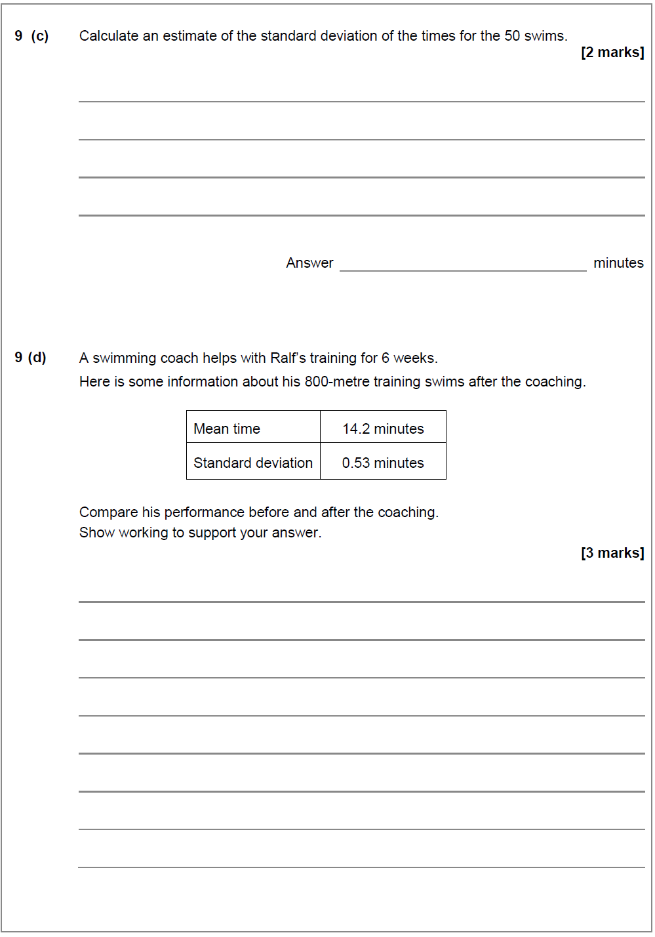

June 17 – Question 10b

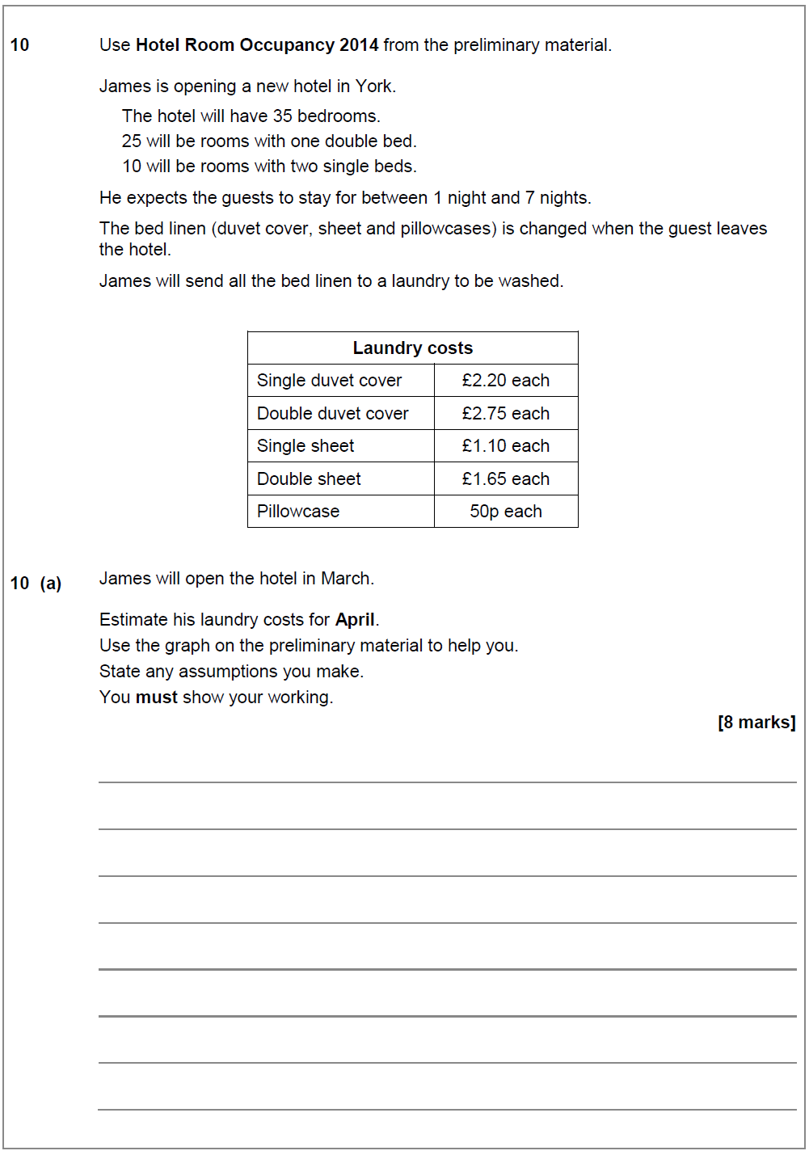

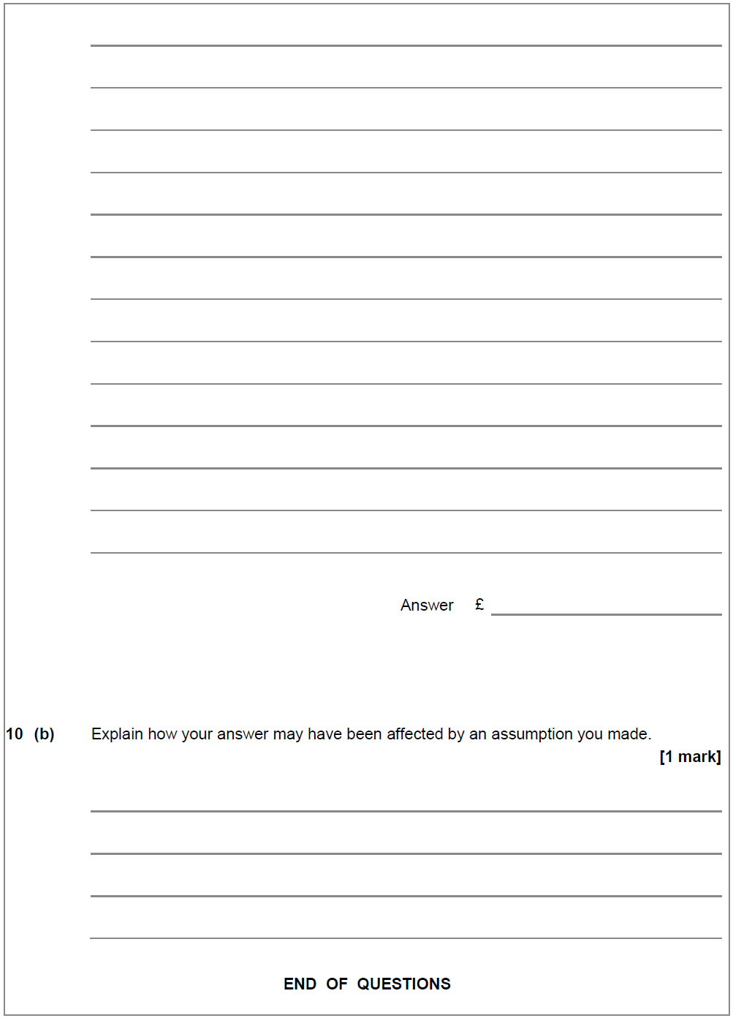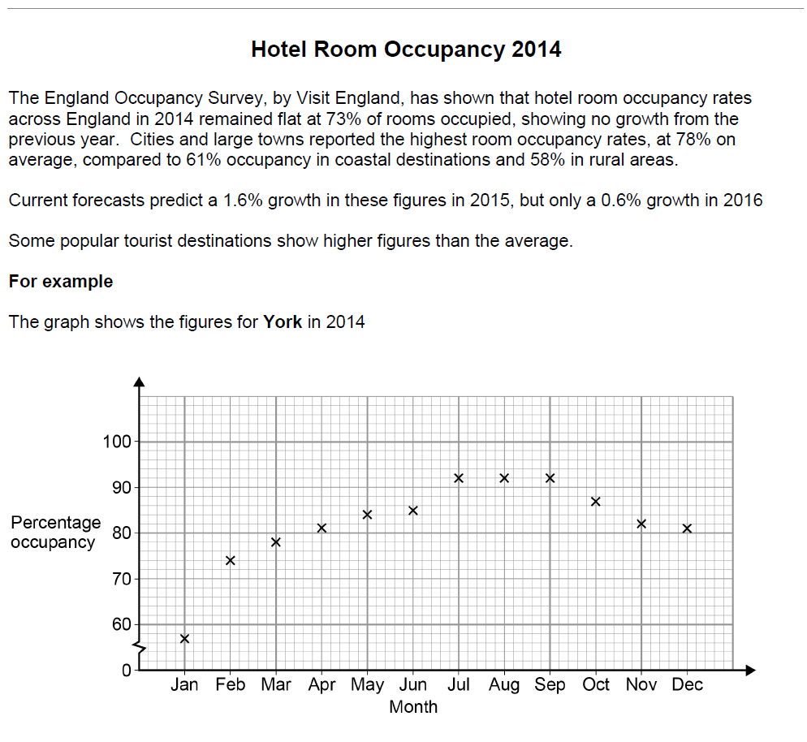

Standard Deviation

June 17 – Question 9c, 9d

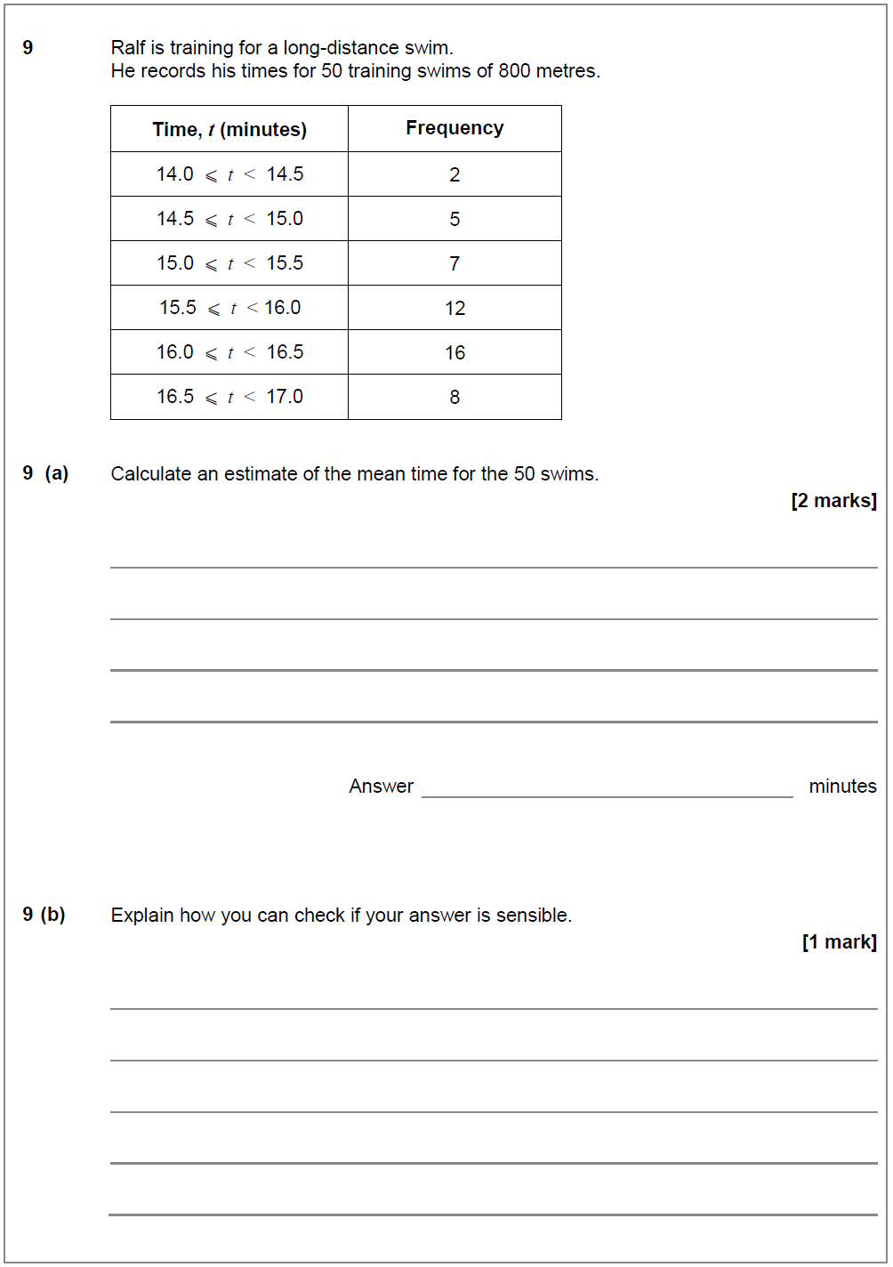

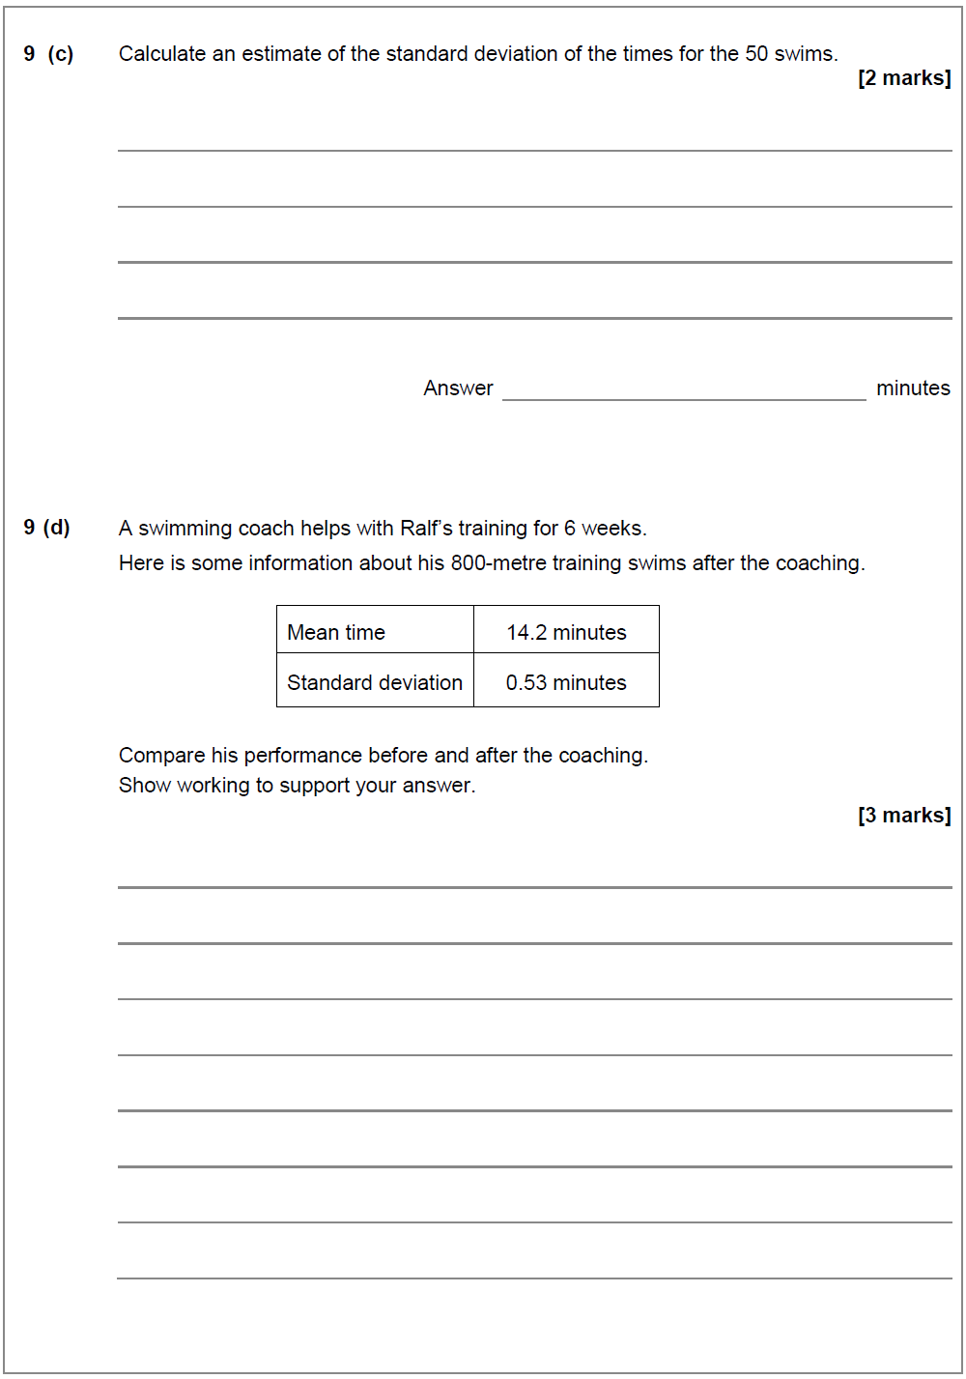

Markschemes

Specimen Paper 1 – Markscheme

Level 3 Certificate

MATHEMATICAL STUDIES

1350/1

Paper 1

Mark scheme Specimen Version 1.1

Principal Examiners have prepared these mark schemes for specimen papers. These mark schemes have not, therefore, been through the normal process of standardising that would take place for live papers.

Further copies of this Mark Scheme are available from aqa.org.uk

Glossary for Mark Schemes

Examinations are marked in such a way as to award positive achievement wherever possible. Thus, for mathematics papers, marks are awarded under various categories.

If a student uses a method which is not explicitly covered by the mark scheme the same principles of marking should be applied. Credit should be given to any valid methods. Examiners should seek advice from their senior examiner if in any doubt.

M | mark is for method
dM | mark is dependent on one or more M marks and is for method
A | mark is dependent on M or m marks and is for accuracy
B | mark is independent of M or m marks and is for method and accuracy
E | mark is for explanation
ft | follow through from previous incorrect result
CAO | correct answer only
CSO | correct solution only
AWFW | anything which falls within
AW RT | anything which rounds to
ACF | any correct form
AG | answer given
SC | special case
OE | or equivalent
A2,1 | 2 or 1 (or 0) accuracy marks
PI | possibly implied
SCA | substantially correct approach
c | candidate
sf | significant figure(s)
dp | decimal place(s)

Version 1.1 Page 3 of 16

Q | Answer | Mark | Comments

1a | sample size too small  sample not stratified / not taken in proportion to group size  may be helpful to select according to age  may be helpful to select according to length of experience  may be helpful to select according to full time/part time | B2 | oe  B1 for one reason  B2 for two distinct reasons

Alt 1  1b | sample size of at least 20 recommended | B1
 | stratified sample | B1
 | their sample size × 130  197  or  their sample size × 58  197  or  their sample size × 9  197 | M1
 | correct values for each department based on their sample size | A1 | allow rounding or truncation of any value as long as total is correct

Alt 2  1b | sample size of at least 20 recommended | B1
 | systematic sample | B1
 | explains how staff are listed | M1
 | explains that the nth person is chosen | A1 | this must result in the correct sample size

Page 4 Version 1.1

MARK SCHEME – LEVEL 3 MATHEMATICAL STUDIES – SPECIMEN PAPER - PAPER 1

Q Answer Mark Comments

Alt 3  1b | sample size of at least 20 recommended | B1
 | random sample | B1
 | explains how the staff will be individualised | M1 | eg  names written on paper and put in a box staff numbered
 | method of selection explained | A1 | eg  owner picks names from box at random random number generator used

2a | Annual Equivalent Rate | B1

Alt 1  2b | attempt at 1000 × 1.04any value | M1 | eg 1000 × 1.0410 = 1480(...)
 | attempt at value to give improved answer closer to 2000 | M1 | eg if 10 used tries number larger than 10  if first answer is more than 2000 then next trial must reduce the number of years
 | 18 (years) | A1

Alt 2  2b | 4% simple interest ⇒ 100% gain after  25 years so less than 25 years  or min £40 per year and 1000 ÷ 40 =  25 | M1
 | trial with n < 25  eg 1000 ×1.0420 =2191.(...) | M1
 | 18 (years) | A1

Alt 3  2b | 4% of 1000 = 40  so after 1 year = 1040 | M1
 | 4% of 1040 = 41.60  so after 2 years = 1081.60  …  after 17 years = [1947, 1948]  after 18 years = [2025, 2026] | M1
 | 18 (years) | A1

Version 1.1 Page 5

Q | Answer | Mark | Comments

Alt 4  2b | 1.04n = 2 | M1
 | n = log2 /log 1.04  = 17.67 | M1
 | 18 (years) | A1

Alt 1  3 | monthly income  = £21 588 = (£)1799  12 | M1 | dividing by 12
 | National Insurance  their ((£)1799 − ((£)646) × 0.12  or (£)1153 × 0.12 or (£)138.36 | M1 | finding amount of NI paid per month
 | taxable income  = (£)21588 − (£)9440 or (£)12148 | M1
 | income tax  (0.2 × (£)12148) ÷ 12 or  (£)2429.6(0) ÷ 12 or (£)202.47 | M1 | 20% tax rate
 | (£)1458.17 | A1
 | their (£)1458.17 ÷ 8 rounded correctly  to the nearest (£)10 or  (£)180 | M1
 | their (£)180 × 8 or (£)1440 | M1
 | (£)1440 and yes | A1ft | ft their monthly take-home pay

Page 6 Version 1.1

MARK SCHEME – LEVEL 3 MATHEMATICAL STUDIES – SPECIMEN PAPER - PAPER 1

Q Answer Mark Comments

Alt 2  3 | National Insurance  (£)21588 – ((£)646 ×12)  or  (£)21588 – (£)7752 or  (£)13836 | M1 | finding the amount NI is paid on each year
 | their (£)13836 × 0.12 or (£)1660.32 | M1 | NI paid per year
 | taxable income  = (£)21588 – (£)9440 or (£)12148 | M1
 | income tax  their (£)12148 × 0.2 or (£)2429.6(0) | M1 | 20% tax rate  tax paid per year  (£)17498.08 implies M4
 | (£)1458.17 | A1
 | their (£)1458.17 ÷ 8 rounded correctly to the nearest (£)10  or  (£)180 | M1
 | their (£)180 × 8 or (£)1440 | M1
 | (£)1440 and Yes | A1ft | ft their monthly take-home pay

Alt 1  4 (a) | (28 +) 32 ÷ 5 × 3 or  (28 +) 6.4 × 3 or  (28 +) 19.2 | M1 | draws cumulative frequency diagram or histogram and uses correct method to find UK’s position
 | 47.2 or 47 | A1
 | states that the newspaper is (likely to be) incorrect | E1ft | ft their 47.2
 | states that the newspaper could be correct with reason | E1ft | eg  if 11 or fewer of the 32 countries in the  UK’s band were above 77  ft their 47.2, but note that this mark cannot be awarded if the decision is unequivocal

Version 1.1 Page 7

Q | Answer | Mark | Comments

Alt 2  4 (a) | (12 + 24 + 44 + 53 +) 32 ÷ 5 × 2 or  (133 +) 6.4 × 2 or  (133 +) 12.8 or  145.8 | M1 | draws cumulative frequency diagram or histogram and uses correct method to find UK’s position
 | 47.2 or 47 | A1
 | states that the newspaper is (likely to be) incorrect | E1ft | ft their 47.2
 | states that the newspaper could be correct with reason | E1ft | eg  if 11 or fewer of the 32 countries in the  UK’s band were above 77  ft their 47.2, but note that this mark cannot be awarded if the decision is unequivocal

Page 8 Version 1.1

MARK SCHEME – LEVEL 3 MATHEMATICAL STUDIES – SPECIMEN PAPER - PAPER 1

Q Answer Mark Comments

4 (b) | makes 2 comments about trends eg in all regions the male life  expectancy is lower than the female  life expectancy  the greatest differences between male and female are in Europe and the Americas/the least differences are in Africa | B2
 | compares each gender or regions with the mean  eg only 1 region is below the mean for females whereas half the regions are below for males  or  the majority of regions are above the mean or very close to the mean | B1 | can award B2 here if B2 not gained in trends section of mark scheme
 | concludes that world region has greater effect on life expectancy and gives valid reason  eg Africa is well below the mean for both male and female  or  there are greater differences between region values than between male/ female values | E1

Version 1.1 Page 9

Q | Answer | Mark | Comments

4 (c) | oe other units throughout eg miles or steps | B1
 | years/life ≈ 68.5 | B1 | justified life span
 | reasonable starting point eg  10,000 paces per day or  km/day ≈ 6 (allow 4-10)  or  velocity of less than 4 km/hr for a reasonable number of hours per day | B1 | justified distance/time unit. Need not be based on days
 | ‘6’ × 365 (accept 365.25 or 366) | M1  A1 | calculation of scaling factor for units of  time from days (as shown) or other units of time to match other calculations
 | km/life = km/day × their days /life | M1 | scaling up to distance per year from daily, weekly or monthly distances
 | km/life ≈ 150 000 (allow 50 000 to  400 000) | A1ft | ft for correct answer to a justified method if paces have been used then final mark  can only be awarded if a realistic  conversion is made to distance (eg 1 pace  = 30 – 80 cm)  Award B1 for an answer to a sensible degree of accuracy (1 or 2 sf max)

Page 10 Version 1.1

MARK SCHEME – LEVEL 3 MATHEMATICAL STUDIES – SPECIMEN PAPER - PAPER 1

Q | Answer | Mark | Comments

5 (a) | = (B4 –16 365)*0.09 | B2 | B1 for B4 – 16 365  B1 for *0.09

5 (b) | Year Salary Repayment Outstanding  (£) (£) loan  12000 + 240 −  57.15  1 17000 57.15 = 12182.85  12182.85 +  243.66 −  2 18500 192.15 192.15  = 12234.36  12234.36 +  244.69 −  3 20000 327.15 327.15  = 12151.90  12151.90 +  243.04 −  4 21500 462.15 462.15  = 11932.79  5 | M1 | any initial value after year 1 ×  0.02 (calculate interest)
 |  | A1 | correct new loan amount at end of year 2
 |  | M1 | correct repayment of 462.15 used for 2017 (Year 4)
 |  | A1ft | all end of year values correct
 |  | B1 | after 4 years

Version 1.1 Page 11

Q | Answer | Mark | Comments

Alt 1  6 | lists cumulative frequencies of (0), 9,  44, 74, 92, 102, 110, 120 | B1
 | labels and scales axes for a cumulative frequency diagram | M1
 | plots their points correctly and joins with a smooth curve or straight lines | A1ft | ft their cumulative frequencies
 | reads off the median value at 60 runners | M1 | Lines may be drawn, but accept correct value
 | reads off the lower quartile value at  30 runners and the upper quartile value at 90 runners | M1 | Lines may be drawn, but accept correct values
 | median [130, 134] | A1ft | ft their cumulative frequency diagram this value may be shown on a box and  whisker diagram
 | Lower Quartile [112, 116]  and  Upper Quartile [156, 159] | A1ft | ft their cumulative frequency diagram this value may be shown on a box and  whisker diagram
 | correct comment made about the fastest and/or slowest times | B1 | eg  both the fastest and slowest times were slower by over 20 minutes
 | correct comment made about the average time, with evidence | B1ft | ft their results eg  they were slower on average – the median was about 16 minutes slower
 | correct comment about spread | B1ft | ft for their IQR, but not for the range eg  the range of times stayed roughly the same  the interquartile range was greater by about 16 minutes  the interquartile range had increased from  28 to 44

Page 12 Version 1.1

MARK SCHEME – LEVEL 3 MATHEMATICAL STUDIES – SPECIMEN PAPER - PAPER 1

Q | Answer | Mark | Comments

Alt 2  6 | Identifies lower quartile at 30  and  identifies upper quartile at 90 | B1
 | 21 × 20 (+ 100) or 12 (+ 100)  35 | M1
 | 16 × 20 (+ 140) or [17, 18] (+ 140)  18 | M1
 | Identifies median at 60 | B1
 | 16 × 20 (+ 120) or [10, 11]  30 | M1
 | Median is 130 or 131 | A1
 | Lower Quartile 112 and  Upper Quartile 157 or 158 | A1
 | correct comment made about the fastest and/or slowest times | B1 | eg  both the fastest and slowest times were slower by over 20 minutes
 | correct comment made about the average time, with evidence | B1ft | ft their results eg  they were slower on average – the median was about 16 minutes slower
 | correct comment about spread | B1ft | ft for their IQR, but not for the range eg  the range of times stayed roughly the same  the interquartile range was greater by about 16 minutes  the interquartile range had increased from  28 to 44

Version 1.1 Page 13

Q | Answer | Mark | Comments

7 (a) | continuous and secondary | B2 | B1 one correct and no others ticked or  continuous and primary or  discrete and secondary

7 (b) | assumptions about waste:
 | size of town/no. of households (t)  eg 20 000 | B1
 | amount of waste per household (per time period) (w)  eg 0.8 | B1 | given in cubic units for volume or Litres for capacity
 | considered or refined assumption about volume of waste produced or town size  eg less than 0.8 due to increased recycling | B1
 | calculation for volume of rubbish to be put into the landfill per year = t x w x time factor to scale to a year then x 15 for number of years  eg 20000 x 0.8 x 15 =240 000 m3 | M1  A1 | M1 for calculation that scales to 15 years  A1 for correct result
 | shape of hole used to model the site:  most likely: cube, cuboid or hemisphere but any reasonable shape to be considered  eg Cuboid 20 m deep, 120 long by  100 m wide  eg Cylinder 20 m deep, radius 62 m | M1  A1 | one dimension calculated from volume, with any additional dimensions assumed as necessary  overall dimensions clearly stated
other shapes are acceptable with correct calculations

eg waste compacted over time or recycling reduces total waste output per person

Page 14 Version 1.1

MARK SCHEME – LEVEL 3 MATHEMATICAL STUDIES – SPECIMEN PAPER - PAPER 1

 | any further or refined assumptions must be considered in the overall calculation but may be seen in earlier working eg | B2 | do not give credit for repeat of same assumptions
 | waste is compacted to increase the site capacity/volume by x amount
 | some waste will degrade to increase the capacity/volume
 | food waste is collected and disposed of separately
 | landfill site modelled as a hole with a mound on top
 | are dimensions realistic for the situation?
 | increase in proportion of recycling over time

June ‘16 – Markscheme

LEVEL 3 CERTIFICATE
Mathematical Studies
1350/1 Paper 1
Mark scheme

1350
June 2016

Version 1.0: Final Mark Scheme

Q | Answer | Mark | Comments

1a | discrete and quantitative | B2 | B1 for 1 correct word if only one word circled  or  B1 for both correct words and one other circled  or  B1 for one correct word and at most one incorrect word circled
1b | Lowest 50 and highest 99 | B1
 | Lower quartile 65 | B1
 | Median 75 | B1
 | Upper quartile 82 | B1

1c | Both fully completed box plots drawn accurately with at least one labelled | B3 ft | ±½sq  ft their values for Paper 2  B2 One fully completed box plot drawn accurately and labelled or both box plots correct but no labels  B1 one box plot fully correct with no label or  both boxes (median and quartiles box)  correctly drawn (no label needed)
 | Additional Guidance
Ignore whiskers extended into box Whiskers do not need end lines Any height of box is allowed
If boxes overlap mark to scheme if clear which is which

Q | Answer | Mark | Comments

1d | Comparing equivalent values  median, IQR/width of box, range, both quartiles, lowest value, highest value, particular parts of distribution  Eg On Paper 2 there were more students who got 90+  On Paper 2 nobody got under 50 marks but on Paper 1 one person did  On Paper 1 there were fewer students who got under 70 marks  The average was higher on Paper 2 | M1 | ft correct conclusion for their Paper 2 median  If they do not draw both boxes then they must show values for IQR and/or range
 | compares median in context  eg the median was higher on Paper 2 so on average they did better on Paper 2  eg the average mark was higher on Paper 2 so they did better on this paper | A1ft | ft correct conclusion for their medians
 | Compares spread in context  Eg the IQR was smaller so the marks were more consistent on Paper1 | A1ft | ft correct conclusion for their quartiles/width of box  They can use the IQR or the range

Additional Guidance
1d
Only award A marks for comparison of median and IQR in context.

For the comparison of spread they must mention the word consistent or variation in results/more varied etc

Eg 1 Paper 2 had a higher median M1 A0A0

Eg 2 The box was wider on paper 2 so the marks on Paper 1 were more consistent M1A1

Eg 3 The median was higher on Paper 2 so on average they did better on Paper 2. They were more consistent on Paper 1. M1A1A0 (no evidence to back up consistent)

Eg 4 The median was higher on Paper 2 so on average they did better on Paper 2. The smaller
IQR on Paper 1 shows they were more consistent on Paper 1. M1A1A1

Eg 5 They had a better success rate on paper 2 as the median was higher M1A1

Eg 6 There was a wider range of marks on Paper 2 M1A0A0

Q | Answer | Mark | Comments

2 | Alternative method 1
 | 22.5(0) × 1.2  or  20 × 22.5(0) + 22.5  100  or  10% of 22.5(0) = 2.25  and  2.25 × 2 + 22.5  or  27 seen | M1 | oe
 | their 27 ÷ 0.9 | M1 | oe
 | 30 | A1 | Not 30% SC1 29.70
 | Alternative method 2
 | 0.9 ÷ 1.2 or 0.75 | M1 | or 1.2 ÷ 0.9 or 1.33….
 | 22.5(0) ÷ their 0.75 | M1 | 22.5(0) × their 1.33…
 | 30 | A1 | Not 30%
 | Additional Guidance
If 1.3 is seen do not assume it is from 1.2 ÷ 0.9. It is more likely to be from adding 10% and
20%. In this case 22.5(0) × 1.3 = 29.25 is M0

Q | Answer | Mark | Comments

3a | Assumes an amount per day/week/month | B1 | Allow any realistic value eg 0.5 (kg) per day  3 (portions) per day  2 (pieces of) fruit and veg per day  3 (kg) per week  Allow splitting into fruit and veg separately if combined later or summer/ winter etc
 | their value per day × 365 or  their value per week × 52  or  their value per month × 12 | M1 | Allow 4 weeks in a month  Allow rounding of 365 and 52 if explained  Allow splitting into different parts of a year but must total a whole year
 | Calculates accurate answer based on their assumed amount of fruit and veg per day/week/month with units used stated | A2 | A1 Calculates accurate answer based on their assumed amount of fruit and veg per day/week/month with incorrect or no units used stated  Condone units missed off the answer line if they are seen with the total amount of fruit and veg in the body of the script  or  A1 Calculate accurate answer based on their assumed amount of just fruit or just veg with units stated  Eg 1 apple a day × 365 = 365 B0M1A0A0  Eg 1 apple a day × 365 = 365 apples  B0M1A0A1
 | Additional Guidance
If they only mention fruit or only mention veg then max 2 marks are available

Time periods must be correct

eg 6 portions per week × 365 =2190 portions per year gains M1M0A0A0

If they extend to longer than a year eg a lifespan, they can achieve M1M1A1A0 for an accurate answer with units

Q | Answer | Mark | Comments

3b | States one refinement eg  Count the portions of fruit and veg one day  Weigh the amount of fruit/veg for a week  Carry out a survey to find out how much fruit and veg people eat  Consider times when you might eat more fruit eg on holiday | B1 | B0 for  split into fruit and veg separately  Do a survey  Work out the exact amount an average person eats  Record all the fruit and veg people eat for a year

Q | Answer | Mark | Comments

4a | Full explanation eg  Yes as it takes the sample in proportion to the number of girls and boys  or  Yes as there are more girls than boys in year 12 so the sample will have more girls than boys  or  Yes as it is (more) representative of the number of girls and boys  or  Yes as it is representative of the population  or  Yes as the ratio of girls to boys in the sample is the same as in the year group | B2 | B1 partial explanation eg  Yes as there are more girls than boys  Yes as it is more representative
 | Additional Guidance
Yes may be implied , eg It is, because….. Answer of No is B0
Reference to not using other year groups is B0

Q | Answer | Mark | Comments

4b | Number the girls | B1 | Not ‘Number the girls from 1 to 34’
 | Use a random number generator/button/ tables | B1
 | Use the first 34 different numbers  (within the range)  or  Use the first 34 numbers ignoring repeats | B1 | SC2 Number each girl, put all the numbers in a hat/box etc and pick out 34 oe
 | Additional Guidance
 | Put all the girls names in a hat and pick out 34 is B0

4c | Cluster | B1 | Accept convenience

Q | Answer | Mark | Comments

5 | Alternative method 1
 | 838 × 0.88 or 737.44 or  838 × 0.12 or 100.56  and 838 – their 100.56 | M1 | oe  Full attempt to get to 88%
 | (their 737.44 – 250) × 2  3  or 487.44 × 2  3  or 324.96 | M1
 | 2173 ÷ their 324.96 or 6.6(…)  or  7 × their 324.96 or 2274.(72) | M1 | dep on 1st or 2nd M1 awarded
 | 6.6(…) and Yes or 7 and Yes  or 2274.(72) and Yes | A1 | Yes can be implied eg 2274.(72)> 2173  Allow 2275
 | Alternative method 2
 | 838 × 0.88 or 737.44 or  838 × 0.12 or 100.56  and 838 – their 100.56 | M1 | oe  Full attempt to get to 88%
 | (their 737.44 – 250) × 2  3  or 487.44 × 2  3  or 324.96 | M1
 | 2173 ÷ 7 or 310.(43) | M1
 | 324.96 and 310.(43) and Yes | A1

Q | Answer | Mark | Comments

6 | Alternative method 1
 | 31 785 + 10 600 or 42 385 | M1 | Calculating threshold for 40% tax  Condone 31 876 + 10 600 or 42 386
 | their 42 385 – 39 500 or 2885 | M1 | Calculating extra salary for 20% tax and 12% N.I
 | 43 500 – 42 385 or 1115 | M1 | Calculating amount charged at 40%  tax and 2% N.I
 | their 2885 × 0.2 + their 1115 × 0.4 or 577 + 446 or 1023 | M1 | Tax  Allow 577.20 from 31876 used
 | their 2885 × 0.12 + their 1115 ×  0.02  or 346.2(0) + 22.3(0) or 368.5(0) | M1 | N.I  Allow 346.32 from 31876 used
 | (£)1023 and (£)368.5(0)  or (£) 1023.20 and (£)368.62 or (£)1391.5(0) or (£)1391.82 | A1 | extra tax and extra N.I.
 | (43500 – 39500) – their 1023 –  their 368.5(0)  or  (£)2608.50 or (£)2608.18 | M1 | or their 1023 + their 368.5(0) + 12 ×  150 or  3191.5(0) or 3191.82
 | their (£)2608.5(0) ÷ 12 or  their (£)2608.18 ÷ 12 | M1 | 43500 – 39500 or 4000
 | 217.(..) per month and Yes or 67 extra  or  150 × 12 =1800 and 2608.5(0) and  Yes  or 4000 and 3191.(50) and Yes or 4000 and 3191.(82) and Yes | A1ft | ft their increase in net pay per month/year compared with travel costs per month/year

Additional Guidance
Allow use of 31785 or 31786 for upper tax limit
Ignoring higher tax limit and taxing all at 20% can gain max 7 marks (loses 4th M1 and 1st A1)
Ignoring higher NI or only needing to use 12% can gain max 7 marks (loses 5th M1 and 1st
A1)
Ignoring both higher limits can gain max 6 marks
For premature rounding allow all method marks
1023 or 577 + 446 implies the first 4 method marks
368.5(0) or 346.2(0) + 22.3(0) implies first 3 and 5th method marks

Q | Answer | Mark | Comments

6 | Alternative method 2
 | 43 500 – 10 600 or 32 900 | M1 | taxable income
 | (32 900 – 31786) × 0.4 + 31786 × 0.2 or 445.6(0) + 6357.2(0) or 6802.8 | M1 | calculating annual tax  Allow 31785 used giving 446 + 6357 or  6803
 | their 6802.8 ÷ 12 or 566.9(.) | M1 | monthly tax
 | 43500 ÷ 12 or 3625 | M1 | monthly gross pay
 | (their 3625 – 3532) × 0.02 or 1.86 or  (3532 – 672) × 0.12 or 343.2(0)  or 345.(..) | M1 | N.I at 2% or 12%
 | 3625 – (their 566.9(0) + their 1.86 +  their 343.2(0)) | M1 | Total tax and NI
 | 2713.(...) | A1 | calculating new net monthly salary
 | their 2713.(..) – 2495.64 or  their 2713.(...) – 150 | M1 | Increase in net pay or  subtracting 150 from their new net pay
 | 217.(..) per month and Yes or 67 extra  or 2563.(..) and Yes | A1ft | ft their increase in net pay per month/year compared with travel costs per month/year  Comparison with recalculated wrong old net pay loses this mark
 | Additional Guidance
 | Allow use of 31785 or 31786 for upper tax limit
 | Ignoring higher tax limit and taxing all at 20% can gain max 7 marks (loses 2nd M1 and 1st A1)
 | Ignoring higher NI or only needing to use 12% can gain max 7 marks (loses 5th M1as neither bracket will be correct, and 1st A1)
 | Ignoring both higher limits can gain max 6 marks
6802.8 or 6803 implies M2
566.9() implies M3
2713.(..) is the first 7 marks

Q | Answer | Mark | Comments

6 | Alternative method 3
 | 43 500 – 10 600 or 32 900 | M1 | taxable income
 | (32 900 – 31786) × 0.4 + 31786 × 0.2 or 445.6(0) + 6357.2(0) or 6802.8  or  (32 900 – 31786) × 0.6 + 31786 × 0.8 or 668.4 + 25428.8 or 26097.(..) | M1 | Allow 31785 used giving 446 + 6357 or  6803
 | (43500 – 42385) × 0.02 or 22.3 or  (42385 – 8064) × 0.12 or 4118.52  or 4140.(..) | M1 | 2% or 12% NI
 | their 6802.8 +their 22.3 + their  4118.52 or 10943.82  or  their 26097.(..) – their 22.3 – their  4118.52 or 21956.38 | M1 | or their 6802.8 + their 4140.82 their total tax + NI  Must be consistent time periods
 | 43500 – their 10943.82  or their 21956.38 + 10600 | M1 | Gross salary – (tax +NI)  Must be consistent time periods or  43500 – 10943.82 - 1800
 | 32556.(18) | A1 | or 30756.(18) (only if 12 × 150) deducted
 | their 32556.(18) ÷ 12 or 2713.(..)  or 2495.64 × 12 or 29947.(68)  and 12 × 150 (if not included at some other point | M1 | their 30756.18 ÷ 12 or 2563.(..)  or 2495.64 × 12 or 29947.(68)
 | their 2713.(..) – 2495.64 or  their 32556.(..) – their 29947.68 | M1 | For 1800 subtracted earlier, answer of  30756.(..) and 29947.(..) and Yes or 2563.(..) and Yes  implies final M1and A1as no subtraction is required

 | 217.(..) per month and Yes or 67 extra  or 2563.(…) and Yes  or 30756.(..) and 29947.(..) and Yes | A1ft | 2563.(..) and Yes  ft their increase in net pay per month/year compared with travel costs per month/year  Comparison with recalculated wrong old net pay loses this mark
 | Additional Guidance
 | Allow use of 31785 or 31786 for upper tax limit
 | Ignoring higher tax limit and taxing all at 20% can gain max 7 marks (loses 2nd M1 and 1st A1)
 | Ignoring higher NI or only needing to use 12% can gain max 7 marks (loses 3rd M1as neither bracket will be correct, and 1st A1)
 | Ignoring both higher limits can gain max 6 marks
 | For premature rounding allow all method marks
6802.8 or 6803 implies M2

566.9() implies M3

2173.(..) is first 7 marks

Q | Answer | Mark | Comments

7 | Scale 1 cm2 = 25 people or 24 cm2 = 600  or 1 small square = 1 person  or frequency density scale labelled in  5’s every cm  or one other bar shown with correct frequency | M1
 | [(5 × 12) + (1 × 15)] × 9 or 75 × 9 or 675  and  5 × 3 × 9 or 15 × 9 or 135 or  (75 + 15) × 9 or 810 | M1 | Correct method for either end implies correct scale so 1st M1
 | [600 – their (75 +15)] ×12 or  [(9 ×15) + (5 × 22) + (5 × 24) + (10 × 10) + (15 × 3)] × 12  or 510 × 12 or 6120 | M1 | their 75 + 15 must be from use of correct scale  Condone 1 error when adding all the other bars/ages  (must include all of bar up to 65)
 | (£)6930 | A1
 | Additional Guidance
 | 6975 or 6921 may imply M2 from combining 20-21 within the £12 or 64 -65 within the £9

Q | Method | Mark | Comments
8 | 9300 – 6200 or 3100 | M1 | calculates loan amount
 | their 3100 × 1.055 or 3270.5 | M1 | oe
 | (56 700 – 21 000) ÷ 12 or 2975 | M1 | or (56700 – 21000) × 0.09 or 3213
 | their 2975 × 0.09 or 267.75 | M1 | their 3213 ÷ 12 or 267.75
 | 10 × their 267.75 or 2677.50 | M1
 | their 3270.5 – their 2677.5 | M1dep | dep on previous M1  their 3270.5 can be 3100
 | 593 | A1 | SC5 318.(..) for use of repayment plan 1 if no working seen
 | Additional guidance
The 3rd and 4th method marks can be in either order or combined

So (56700 – 21000) × 0.09 ÷ 12 gains 3rd and 4th method marks

If students use repayment plan 1 and show working then they can achieve
B1,M1,M0,M1,M1,M1,A0 eg gets 3270.5 M2
(56700 – 17335) × 0.09 =3542.85 M0

3542.85 ÷ 12 = 295.(..) M1

10 × 295. (..) = 2952.(..) M1

3270.5 – 2952.(..) M1

318.(..) A0

If no working is seen award SC5 for the correct answer of £318.(..)

Failing to subtract 21000 loses 3rd M1 and A1 so can gain 5 marks

Q | Answer | Mark | Comments

9 | Alternative method 1
 | Makes an assumption for average number of people in 3 or 4 bedroom homes  eg 3 or 4 bedroom family homes average 4 people per home  or  Makes an assumption for average number of people in 1 or 2 bedroom homes  eg 1 or 2 bedroom homes average 2 people per home | B1
 | Uses [134,191] (cubic metres) for the family homes | B1
 | Uses [54,134] (cubic metres) for the 1 or 2 bedroom homes | B1
 | 240 × their usage for 3 or 4 bed homes  eg  240 × 164 or 39 360 or approx.  39 000 | M1 | Allow any rounded or unrounded answer eg 240 × 164 is approx. 40 000 or 39 500
 | 80 × their usage for 1 or 2 bed homes eg 80 × 101 or 8080 or approx.8000 | M1 | Allow any rounded or unrounded answer
 | 30 × 54 or 1620 or approx. 1600 | M1 | water usage for retirement flats must use 54 for annual use  or per day [145, 150] litres or [0.14, 0.15]  cubic metres  Allow rounding to 1 or 2 sf
 | their 40 000 + their 1600 + their 9000 | M1 | sum of their 3 rounded or unrounded answers
 | Correct answer for their values | A1 | All method marks must be scored
 | their answer ÷ 365 (×1000)  or their answer ÷ 52 ÷ 7 (×1000) | M1 | Condone ÷ 12 ÷ 31
 | Correct division of their total per year to give value per day and conversion to litres | A1 | Must convert to litres  Penalise decimal answers

9 | Alternative method 2-working on daily values
 | Makes an assumption for average number of people in 3 or 4 bedroom homes  eg 3 or 4 bedroom family homes average 4 people per home  or  Makes an assumption for average number of people in 1 or 2 bedroom homes  eg 1 or 2 bedroom homes average 2 people per home | B1
 | Any water usage ÷ 365 (×1000) | B1 | Implied by figures within the ranges of the values used for each size of home
 | For the 3-4 bed homes, uses  [360, 530] litres or [0.36, 0.53] cubic metres | B1
 | For the 1 or 2 bedroom homes, uses  [145, 360] litres or [0.145, 0.36] | B1
 | 240 × their usage for 3 or 4 bed homes  eg  240 × 450 or 108 000 or approx.  110 000 | M1 | Allow any rounded or unrounded answer  Allow rounding to 1 or 2 sf
 | 80 × their usage for 1 or 2 bed homes eg 80 × 367 or 29 360  or approx. 29 000 | M1 | Allow any rounded or unrounded answer eg 80 × 0.367 = 29.36 or 29.4 or 29 or 30  Allow rounding to 1 or 2 sf
 | 30 × 148 or 4440 or approx. 4500  or 30 × 0.148 or 4.44 or approx. 4.5 | M1 | Water usage for retirement flats  per day [145,150] litres or [0.14,0.15]  cubic metres  Allow rounding to 1 or 2 sf
 | their 110 000 + their 29000 + their  4500 | M1 | Sum of their 3 rounded or unrounded answers
 | Correct answer for their values (in litres or cubic metres) | A1 | All method marks must be scored
 | Answer given with correct evaluations of division by 365 (changing to per day) seen earlier | A1 | Penalise decimal answers

Additional Guidance
All values can be rounded at any point.
Example for final mark

138000 given as their answer (first A mark)is incorrect A0

In their working they divided their water usages correctly by 365

Their answer is in litres and no decimals so final A1 is awarded

(Note the M1 for dividing water usage by 365 is for one seen-whereas the A1ft is for dividing all water usages accurately)

June ‘17 – Markscheme

Level 3 Certificate
Mathematical Studies
1350/1 Paper 1
Final Mark Scheme

1350
June 2017

Version/Stage: v1.0

Q | Answer | Mark | Comments

1(a) | 10  (× 100)  24 | M1 | OE
 | 41 or 42 or 41.6(…) or 41.7 | A1
 | Additional Guidance
 | Sight of 0.41(6…) |  |  | M1
 | 5  seen  12 |  |  | M1
 | Beware 42.6 comes from the average of the ten scores over 33

1(b) | Alternative method 1
 | Median or mean = 30 | B1
 | In general the students in this class/they performed better than the national average | E1ft | OE  correct comment for their median or mean
 | Alternative method 2
 | 15 out of 24/more than half the students scored more than the national average  or  9 out of 24/ less than half the students scored below the national average | B1 | OE eg 62.5% scored more than the national average
 | In general the students in this class/they performed better than the national average | E1ft | OE  correct comment for their proportion/values
 | Additional Guidance
Do not accept ‘The median was higher’ for the E mark

However ‘they got higher marks than the national average/ on average they got higher marks’ would score E1
 | In general students were above the national average |  |  | E0

Q | Answer | Mark | Comments

2 | £83 | B1

Q | Answer | Mark | Comments

3 | Alternative method 1
 | Package  744 × 3 × 0.9 or (£)2008.8(0) | M1 | OE | Award M2 for  744 × 3 × 0.9 ×1.03 in any order  Award M1 for any 3 of these values multiplied in any  order
 | their (£)2008.(..) × 1.03 or (£)2069.(..) | M1 | OE
 | Independent  Hotel 480 ÷ 1.33 × 3 or 360.9(0) × 3  or (£)1082.(..) | M1 | or 480 ÷ 1.33 + 312 or (£)672.90
 | Total cost  Their (£)1082.(..) + 312 × 3 or (£)2018.(..) | M1 | their (£)672.90 × 3
 | (£)2069.(…) and (£)2018.(…) and  independent is cheaper or  independent is 50.35 cheaper/over £50 cheaper | A2 | A1 for two values with one correct and correct ft conclusion  or  A1 for both values correct but incorrect or no conclusion
 | Additional Guidance
If there is evidence of multiplying by 3 people at some point then use alt 1 (in pounds) or alt 3 (in euros)

If there is no evidence of multiplying by 3 then use alt 2 (in pounds) or alt 4 (in euros) Do not swap between alts for a response
Example (using alt 1)

744 × 3 × 0.9 × 1.03 = 2069.06 M2

480 ÷ 1.33 = 360.90

360.90 + 312 = 672.90 M1 (in comment box)

independent is cheaper A1 (one correct value – 2069- and correct ft conclusion)

So although both values are correct on different alts they should have multiplied 672.9 by 3 or divided 2069 by 3 to be consistent so treat as incorrect method

(marking on alt 2 would give the same total of 4 marks –M1M0M1M1A1)
Accept alternative ways of subtracting 10% and/or adding 3%
Multiplying by an incorrect percentage can still score one of the first 2 method marks

Examples

744 × 3 × 0.1 × 1.03 or 229.(…) scores M0M1 (3 correct values multiplied)

744 × 3 × 1.1 × 1.03 or 2528.(…) scores M0M1 (3 correct values multiplied)

744 × 3 × 0.9 × 0.97 or 1948.(..) scores M0M1 (3 correct values multiplied)

744 × 3 × 0.1 × 0.97 scores M0M0

These are only examples.
They must compare using consistent units example
£2069 and €2685 and packages 4 u are cheaper does not gain the A1 for one value correct and correct ft conclusion. This would gain maximum M2 for either 2069 or 2685

3 | Alternative method 2
 | Package per person  744 × 0.9 or (£)669.(..) | M1 | OE | Award M2 for  744 × 0.9 ×1.03 in any order  Award M1 for any 2 of these values multiplied in any order
 | their (£)669.(..) × 1.03 or (£)689.(..) | M1 | OE
 | Independent per person  Hotel 480 ÷ 1.33 or (£)360.(9..) | M1
 | Their (£)360.(9..) + 312 or 672.(..) | M1
 | (£)689.(…) and (£)672.(…) and  independent is cheaper per person or  independent is (£)17 cheaper per person  or  total cost is (£)51 cheaper for independent | A2 | A1 for two values with one correct and correct ft conclusion  or  A1 for both values correct but incorrect or no conclusion
 | Additional Guidance

Accept alternative ways of subtracting 10% and/or adding 3%
Multiplying by an incorrect percentage can still score one of the first 2 method marks

Examples

744 × 0.1 × 1.03 or 76.(…) scores M0M1 (2 correct values multiplied)

744 × 1.1 × 1.03 or 842.(…) scores M0M1 (2 correct values multiplied)

744 × 0.9 × 0.97 or 649.(..) scores M0M1 (2 correct values multiplied)

744 × 0.1 × 0.97 scores M0M0

These are only examples.
They must compare using consistent units

Q | Answer | Mark | Comments

3 | Alternative method 3
 | Package  744 × 1.33 × 0.9 or (€)890.5(..) | M1 | OE | Award M2 for  744 × 1.33 × 0.9 ×1.03 × 3 in any order  Award M1 for any 3 of these values multiplied in any order
 | their (€)890.56 × 1.03 × 3 or (€)2751.(..) | M1 | OE
 | Independent  Hotel 312 × 1.33 × 3 or (€)1244.88 | M1 | or 312 × 1.33 + 480 or (€)894.96
 | Total cost  Their (€)1244.88 + 480 × 3 or (€)2684.(88) | M1 | their (€)894.96 × 3
 | (€)2751.(...) and €2684.(88) and  independent is cheaper | A2 | Deduct one mark if € signs are missing from their answer  A1 for two values with one correct and correct ft conclusion  or  A1 for both values correct but incorrect or no conclusion
 | Additional Guidance
 | Accept alternative ways of subtracting 10% and/or adding 3%
 | Multiplying by an incorrect percentage can still score one of the first 2 method

marks

Examples

744 ×1.33 × 0.1 × 1.03 × 3 or 305.(…) scores M0M1 (at least 3 correct values multiplied)

744 × 1.33 × 0.1 × 1.03 or 101.(…) scores M0M1 (3 correct values multiplied)

These are only examples.

3 | Alternative method 4
 | Package  744 × 1.33 × 0.9 or (€)890.5(..) | M1 | OE | Award M2 for  744 × 1.33 × 0.9 ×1.03 in any order  Award M1 for any 3 of these values multiplied in any order
 | their (€)890.56 × 1.03 or (€)917.(..) | M1 | OE
 | Independent  Flight 312 × 1.33 or (€)414.(..) or 415 | M1
 | Total cost  Their (€)414.(..) + 480 or (€)894.(..) or (€)895 | M1
 | (€) 917.(...) and (€)894.(..) and  independent is cheaper | A2 | A1 for two values with one correct and correct ft conclusion  or  A1 for both values correct but incorrect or no conclusion
 | Additional Guidance
 | Accept alternative ways of subtracting 10% and/or adding 3%
Multiplying by an incorrect percentage can still score one of the first 2 method marks

Examples

744 ×1.33 × 0.1 × 1.03 or 98.(…) scores M0M1 (at least 3 correct values multiplied)

744 × 1.33 × 0.9 × 0.97 or 863.(…) scores M0M1 (3 correct values multiplied)

These are only examples.

Q | Answer | Mark | Comments

4 | Makes an assumption about number of litres per person per day in the range 1 litre to 10 litres (or ml equivalents)  and  assumes a number of days in a month in the range 28 to 31  and  Makes an assumption about number of people in a small town in the range  1000 to 100000 | B3 | Must state units  eg Minimum for B3  (Assume) 5 litres, 28 days,15000 people or  B2 for 2 correct assumptions (one missing or not in range)  eg (Assume) 3 litres, 30 days, 300000 people  or  B2 for all 3 values within range but not stated as assumptions  eg 4 × 30 × 10000 seen gets B2 M1 or  B1 Any one correct assumption stated eg drink about 3 litres per day  or  Multiplication of 3 values with 2 in range and no units  eg  12 × 31 × 20000
 | Multiplies their 3 values together | M1 | This may be done in two steps
 | Accurate answer to their calculation | A1ft | ft their 3 values  May be rounded
 | Additional Guidance
 | Ignore any calculations to get the number of litres per day eg 4 × 300ml glass is 1.5 litres scores B1 for 1.5 litres (even though arithmetic is wrong)
 | The amount of liquid they multiply by must be per person not per household
28 to 31 days can come from various calculations eg 7 days × 4 weeks,

365(.25) ÷ 12 Again just award the B1 for a number of days within the range

they could use households to estimate population eg small town 2000 houses
× 4 people = 8000 population
If working in ml they can still gain the method mark but they must convert to litres for the accuracy mark
The three values may be multiplied in 2 steps

eg litres per day × days in month at one point in their working, then this answer × number of people
If they just state a number of litres per month eg 65 litres per month they do not score the marks for assumptions but can score M1 and A1 for multiplying this correctly by their population
Allow rounding at any point eg
uses 7 litres and 31 days in a month, 7 × 31 = 217 and rounds to 200 or 220
Final answer must be an integer

Q | Answer | Mark | Comments

5(a) | Collect prices from estate agents/websites for house prices/ recent house sales/newspapers  and  across different areas of London | E2 | E1 Partial explanation (only one of the comments)
 | Additional Guidance
 | For different area allow different suburbs/estates/streets

5(b) | (No,) London prices may not be representative of the whole country  or  London prices are likely to be higher/different than some other parts of the country | B1
 | Additional Guidance
 | No may be implied eg It would not be sensible
 | Ignore other non-contradictory comments eg sample size too small
 | Its London/it’s the capital |  |  | B0

5(c) | Alternative method 1
 | 2009 157 to 165  and  2014 188 to 192 | B1 | condone 000’s added eg 158000
 | 180 000 ÷ their [157,165]  or  [1090,1147] | M1 | 180 000 × their[188,192] implies M2  their [157,165]
 | their [1090,1147] × their [188,192] | M1
 | (£) [204 900,220 200] | A1ft | ft their values for 2009 and 2014  Answer must be to nearest £100
 | Alternative method 2
 | 2009 157 to 165  and  2014 188 to 192 | B1 | condone 000’s added eg 158000
 | their[188,192] − their[157,165] (  their[157,165]  ×100)  or [13.9,22.3]  or [0.139,0223] | M1
 | their [0.139,0223] × 180 000 | M1
 | (£) [204 900,220 200] | A1ft | ft their values for 2009 and 2014  Answer must be to nearest £100

 | A | B | C | D
1 |  | Starting amount (£) | Interest (£) | Final amount  (£)
2 | First 3 months | 2800.00 | 31.92 | 2831.92
3 | Second 3 months | 2831.92 | 32.28 | 2864.20
4 | Third 3 months | 2864.20 | 32.65 | 2896.85
5 | Fourth 3 months | 2896.85 | 33.02 | 2929.87

Q | Answer | Mark | Comments

6(a) | =B2*(1.14/100) | B1
 | Additional Guidance

6(b) | Fully correct | B2 | B1 for one error with correct ft calculations
 | Additional Guidance
Note these figures are worked out on rounding to 2 dp each year

If more dp are used in calculations then D4 may be 2896.86 and D5 would be 2929.88 so 2929.87 or 2929.88 in cell D5 scores B2

Q | Answer | Mark | Comments

6(c) | Alternative method 1
 | 4 × 1.14 or 4.56(%) or 0.0456 | M1 | (1 + 0.0114)4- 1 gains M2
 | 4   their 0.0456    1+  − 1   4   or 0.04638(…) | M1
 | 4.638(…)  4.64 | A1
 | Alternative method 2
 | their 2929.87 – 2800 or 129.87 | M1 | ft their 2929.87 from part (b)
 | their 129.87  × 100  2800 | M1
 | 4.638(…)  4.64 | A1ft | ft their total interest from part (b)
 | Alternative method 3
 | their 2929.87 ×100 or 104.64  2800 | M1 | ft their 2929.87 from part (b)
 | their 104.64.. – 100 | M1
 | 4.63(…)  4.64 | A1 | ft their total interest from part (b)
 | Additional Guidance
 | Alt 1 uses the AER formula from the formula sheet
4
Note �1 + 0.0114� − 1 is a common incorrect substitution. Scores M0M1A0
4
 | For Alt 2 and Alt 3 If their 2929.87 is a different value the check to see it matches their final value in the spreadsheet (use full screen view)
Beware the use of 3 instead of 4 for the months
3
This leads to �1 + 0.0456� − 1 = 0.04629 or 4.63 scores M1M0A0
3

Q | Answer | Mark | Comments

7(a) | Alternative method 1
 | Histogram chosen | B1 | vertical scale labelled frequency density implies density  unequal bar widths implies histogram unless values are cumulative
 | Both axes scales appropriate with correct labelling | B1 | Vertical scale must be labelled frequency density (or fd) not just frequency  Horizontal scale minimum label is sugar, g
 | Fully correct histogram  0-40 height 0.3  40-60 height 0.9  60-70 height 2.3  70-80 height 2.7  80-120 height 0.5 | B2 | B1 At least 3 bars correct or at least 3 correct frequency densities seen  Heights ± ½ square  Check table for frequency densities
 | Additional Guidance
 | if a bar goes above the graph paper (eg used 5cm to 1) penalise B1 for an inappropriate scale but allow heights for final B marks

less than 40 | 12
less than 60 | 30
less than 70 | 53
less than 80 | 80
less than 120 | 100

7(a) | Alternative method 2
 | Cumulative frequency graph chosen | B1 | cf scale or heights plotted at cf values implies cf graph
 | Both axes scales appropriate with correct labelling | B1 | Vertical axis must be cumulative frequency  (or cf) not just frequency  Horizontal scale minimum label is sugar, g horizontal axis must start from 0 (no  broken axis)
 | Fully correct cumulative frequency graph joined with lines or smooth curve | B2 | ± ½ square  B1 All heights correct and joined with line/curve but plotted at incorrect horizontal position  or  Plotted at upper class values and joined with line or curve with at least 3 heights correct  or  All points correct but no line/ curve or poor line/curve
 | Additional Guidance
 | Can be joined to (0,0)
If heights are incorrect check if they have shown their cf values and follow through 1 error eg they show their cf values as 12,20,43,70,90 and then plot these values accurately award
B1 of the final B2

Just seeing the cf values does not gain the first B1 –they must attempt the graph!

Some are working out cf values and plotting at these heights but as cf ‘bars’ not single points eg a sort of ‘cumulative frequency histogram’
Award B1 for choosing cf graph and B1 if scales are appropriate and labelled correctly
 | Deduct 1 mark if end of curve drops down.
 | The tolerance of ½ sq applies to horizontal position, heights and the curve/line going through the points.
 | A ‘poor’ curve is ‘feathered’ and/or misses the points by more than ½ square

7(a)  cont | Alternative method 3
 | Frequency polygon chosen | B1
 | Both axes scales appropriate with correct labelling | B1 | vertical scale must be frequency  Horizontal scale minimum label is sugar, g
 | Fully correct frequency polygon plotted at mid class intervals, with all heights correct and joined with straight lines | B2 | ± ½ square  B1 All heights correct and joined with straight lines but plotted at incorrect horizontal position  or  Plotted at mid-class values with 3 or 4 heights correct, and joined  Ignore lines before first point and after last point  or  All points correct but no line or poor line
 | Additional Guidance
In Alt 2, the points can be joined by straight lines or a smooth curve

Lines must be ‘straight’ not curved or ‘wiggly’.
 | Non-linear scale on the horizontal axis loses the 2nd B1 but can access the last two B marks for plotting at their correct positions
 | The tolerance of ½ sq applies to horizontal position, heights and the line going through the points.

Q | Answer | Mark | Comments

7(b) | Alternative method 1 - working out number above 30g
 | (Before =) 91 | B1
 | 10 × 1.6 or 16 or  20 × 2.8 or 56 or  40 × 0.1 or 4 or  20 × 0.4 or 8 | M1 | These can be written on the bars of the histogram  Ignore any units
 | (After =) 76 | A1
 | Yes, the number/percentage of children consuming more than the recommended amount had decreased (by 15(%))  or  Yes it was 91(%) before and now it’s only 76(%) | B1ft | ft their values if M1 awarded and a value seen for both before and after
 | Alternative method 2 - working out number below 30g
 | (Before =) 9 | B1
 | 20 × 0.4 or 8 or  10 × 1.6 or 16 | M1 | Ignore any units
 | (After =) 24 | A1
 | Yes, the number/percentage of children consuming below the recommended amount had increased (by 15(%)) | B1ft | ft their values if M1 awarded and a value seen for both before and after
 | Additional Guidance
 | check histogram for values

Q | Answer | Mark | Comments

8 | Alternative method 1
 | 40 × 50p  or 40 × 0.5  or 40 × 7.2(0) – 40 × 6.7(0)  or 288 – 268 or (£)20 | M1 | extra gross pay per week
 | their 20 × 0.2 or (£)4 | M1 | OE extra tax paid per week
 | their 20 × 0.12 or (£)2.40 | M1 | OE extra N.I paid per week
 | their 20 – (their 4 + their 2.40) or  13.6(0) | M1
 | their 13.6(0) ÷ 40 or 0.34 | M1 | or 35 × 40 or 1400(p) or (£)14
 | £0.34 or 34(p) and Yes or  13.60 and 14 and Yes | A1 | If leave 34p in pounds must show £ sign condone £0.34p
 | Alternative method 2
 | 7.2(0) – 6.7(0) or 50 (p) | M1 | extra gross pay per hour
 | their 50 × 0.2 or 10 (p) | M1 | OE extra tax paid per hour
 | their 50 × 0.12 or 6 (p) | M1 | OE extra NI paid per hour
 | their 10 + their 6 or 16 | M1
 | 50 – their 16 | M1
 | 34p and Yes | A1

8 (cont) | Alternative method 3
 | 40 × 7.2(0) × 52 or 14 976 | M1
 | (their 14 976 – 11 000) × 0.2 or 3976 × 0.2  or 795.2(0) | M1 | OE Tax  their 14976 cannot come from 6.7 × 40 ×  52 (= 13936) (using the current salary)
 | (their 14 976 – 8060) × 0.12 or 6916 × 0.12  or 829.92 | M1 | OE NI
 | their 14 976 – (their 795.2(0) + their  829.92)  or 13350.88 | M1 | Annual net pay
 | their 13350.88  � -243.15� ÷40 or 0.34  52 | M1 | or their 13350.88 -243.15� or 13.6(0)  �  52  and  35(p) × 40 or 1400 or (£)14  new and old weekly pay can be divided by  40 separately- leads to 6.42 – 6.08
 | £0.34 or 34(p) and Yes or  13.6(0) and 14 and Yes | A1 | If leave 34p in pounds must show £ sign condone £0.34p
 | Additional Guidance
 | Allow truncated values for all method marks but answer must be 34p
 | 14180.8(0) comes from 14976 – the tax and scores M1M1
795.2(0) or 829.92 scores M2

795.2(0) and 829.92 scores M3

13350.88 scores M4
 | Penalise the use of 48 weeks in a year (from 4 weeks × 12)
 | Working out tax and national insurance for their current wage of 6.70 gains no marks. (the net pay is given) Please ignore any work using this 6.70

8 (cont) | Alternative method 4
 | 40 × 7.2(0) or 288 | M1 | New gross pay per week
 | 11000  (their 288 – ) × 0.2  52  or (their 288 – their 211.54) × 0.2 or 76.46 × 0.2  or 15.29 | M1 | OE Tax per week  their 288 cannot be 268 (from 40 × 6.70)
 | (their 288 –155) × 0.12 or 15.96 | M1 | OE NI per week Condone 155.01 used
 | their 288 – (their 15.29 + their 15.96)  or 256.75 | M1
 | (their 256.75 – 243.15) ÷ 40 or 13.6(0) ÷ 40 or 0.34  or their 256.75 – 243.15 and 35(p) ×  40 | M1 | or 256.75 − 243.15  40 40  or 6.42 – 6.08 or 6.08 + 0.35
 | £0.34 or 34(p) and Yes or  13.6(0) and 14 and Yes or  6.43 and 6.42 and Yes | A1 | If leave 34p in pounds must show £ sign condone £0.34p
 | Additional Guidance
 | Allow truncated values for all method marks but answer must be 34p
13.60 scores M4

256.75 scores M4

15.29 or 15.96 scores M2

15.29 and 15.96 scores M3
 | Working out tax and national insurance for their current wage of 6.70 gains no marks. (the net pay is given) Please ignore any work using this 6.70

Q | Answer | Mark | Comments

9(a) | 15.8(4) | B2 | B1 for ∑fx = 792 seen  SC1 15.59 or 15.6 or 16.09 or 16.1 (using lower or upper class boundaries)
 | Additional Guidance
 | If 15.84 is seen then ignore any attempt to change to minutes and seconds
 | Ignore further rounding eg to 16 after 3 or 4 sf answer seen

9(b) | The answer is within the range of the data/ close to the intervals with the highest frequencies/in/near the  modal class  or  work out the median and check its similar/compare with the mean | B1 | OE
 | Additional Guidance

9(c) | 0.6759(…) or 0.676  or 0.6828(…) or 0.683 or 0.68 | B2 | B1 for ∑fx2 = 12568.125
 | Additional Guidance
 | If correct sd is seen then ignore any attempt to change to minutes and seconds But penalise by one mark any invalid further working after correct sd seen example  sd = 0.68  0.68 × 50 = 34 |  |  | B1

9(d) | Correct evaluation of difference between the mean before and after training | B1ft | ft their (a) and (c)  1.6(4) if their 9a is correct
 | Correct comparison in context about the means  eg after training he was faster/ he’s swimming quicker/his times have decreased | B1 ft | ft their (a) and (c)
 | Correct comparison of sd’s in context eg he is now more consistent/ his  times are less varied | B1ft | ft their (a) and (c)
 | Additional Guidance
 | If there are no values for their part a and/or c then they must state the mean and/sd they are using
 | eg He decreased his average time by 1.6(4) minutes and his times were minutes more consistent |  |  | B3
 | eg He decreased his average time by 1.6(4) minutes |  |  | B2
 | eg After coaching he was faster and more consistent |  |  | B2
 | He was faster after training |  |  | B1
 | After training he had a lower mean time |  |  | B0
 | After training his mean was lower by about 1.6 seconds and he was more consistent |  |  | B1B0B1

Q | Answer | Mark | Comments

10(a) | Alternative method 1
 | Occupancy rate of 70% to 85% used eg 0.8 × 25 = 20 rooms with 1 bed  eg 0.7 × 10 = 7 rooms with 2 beds | B1 | Can be for all 35 rooms eg 0.8 × 35 = 28 rooms
 | Makes assumption about average number of sheet changes per room  eg 4 times a week  20 times per month  guests stay on average 4 days so about 7 times per month | B1 | Accept 2 – 6 changes per week or  6 – 26 changes per month  Must be changes –not number of nights stayed
 | Works out total number of sheet changes per month for double rooms  eg their 20 × their 4 per week × 4 weeks  or  their 20 rooms × their 20 times | M1 | Answers may be rounded eg to nearest 10 costs per room may be worked out first and  then multiplied by number of sheet  changes  Working out total costs for all their rooms and then multiplying by their number of sheet changes gains M2
 | Works out total number of sheet changes per month for single bed(s) rooms  ( can use 1 or 2 beds consistently)  eg their 8 × 2 × their 3 per week × 4 weeks (double occupancy)  eg assuming only one bed used their 8 × their 7 changes per month | M1
 | Room with double bed costs (£)5.40 or (£)6.40 | B1 | 2 pillowcases or 4 pillowcases used  can be implied by their total cost for their number of rooms  eg 20 double rooms costs £108 implies 20  × 5.40
 | Room with 2 single beds costs  (£)7.60 or (£)8.60  or  room with one single bed used costs  (£) 3.8(0) or (£)4.3(0) | B1 | 2 pillowcases or 4 pillowcases used can be implied by their total cost for a  single room

 | x sheet changes with double bed × their cost per room + y sheet changes with (two) single bed(s) × their cost per room | M1
 | Correct answer for their calculations  (may be rounded) | A1 | Answers must be rounded to the nearest pound
 | Additional Guidance
 | students may carry out the above stages of calculation in a different order
 | Accept sensible rounding for any stage of their calculations eg estimates on average bed linen is £6 per set (double bed)
10(a)  cont | Omitting to consider/ use a number of sheet changes per month gains a maximum of 3 marks – 1 for using an occupancy rate and 2 for each of the correct costs per set of double room linen or single room linen  Example  0.81 × 25 = 21 double rooms  0.81 × 10 = 8 single rooms  21 × 2.75 + 21 × 1.65 + 21 × 2 × 0.5 =113.40 113.4 implies 5.40  8 × 2.20 + 8 × 1.10 + 8 × 1= 34.40 34.4 implies 4.30  113.40 + 34.40 = 147.80  no further marks are possible as number of sheet changes has not been considered |  |  | B1  B1  B1  M0
 | costs may be used in parts with numbers of rooms and then totalled example  assume occupancy rate of 81%  double rooms  0.81 × 25 = 20.25 so assume 20 double rooms used  20 × 2.75 = 55  20 × 1.65 = 33  4 pillows cost £2 so 20 × £2 = 40  55 + 33 + 40 =128 (cost for 20 double rooms for 1 sheet change-implies 20 ×  6.40)  assumes stay is on average 2 nights so 15 changes per month  128 × 15 =1920  rooms with single beds  0.81 × 10 = 8 rooms  8 × 2.20 + 8 ×1.10 + 8 × £1 = 34.40 (2 pillowcases used)  34.40 × 15 = 516  1920 + 516 = 2436 |  |  | B1  B1  B1  M1  B1  M1  M1A1

10(a)  cont | Alternative method 2 –works on full occupancy first
 | Room with double bed costs (£)5.40 or (£)6.40 | B1 | 2 pillowcases or 4 pillowcases used implied by totals of a particular number of  rooms  eg (£)135 is 25 rooms at (£)5.40
 | Room with 2 single beds costs  (£)7.60 or (£)8.60  or  room with one single bed used costs  (£) 3.8(0) or (£)4.3(0) | B1 | 2 pillowcases or 4 pillowcases used implied by totals of a particular number of  rooms  eg (£)134.40 is 8 rooms at (£)4.30
 | 25 × their 5.40 + 10 × their 7.60 | M1 | finds total cost of laundry for one change
 | Makes assumption about average number of sheet changes per room  eg 4 times a week  20 times per month  guests stay on average 4 days so about 7 times per month | B1 | Accept 2 – 6 changes per week or  6 – 26 changes per month  Must be changes –not number of nights stayed
 | Works out total cost of sheet changes per month for all rooms  eg their total cost per change × their  4 per week × 4 weeks  eg their total cost per change × their  20 times | M1 | Answers may be rounded eg to nearest 10
 | Occupancy rate of 70% to 85% used | B1
 | Their cost per month × their occupancy rate | M1 | their cost per month must include multiplication by the number of sheet changes
 | Correct answer for their calculations  (may be rounded) | A1 | Answers must be rounded to the nearest pound
 | Additional Guidance
Accept sensible rounding for any stage of their calculations

eg estimates on average bed linen for double room is £6 per set
 | Answers may follow part of each alt eg works out occupancy rate first then finds cost of laundry for all rooms per night

Q | Answer | Mark | Comments

10(b) | Occupancy rate may be (a lot) lower as it’s a new hotel  or  Number of sheet changes may be different as guests may stay longer/ shorter period than estimated  or  In rooms with two single beds only one bed may need to be changed  or  Instead of 4 pillows for a double bed there may be only 2 pillows (or vice versa) | E1 | OE
 | Additional Guidance
 | Just restating their assumptions gains no credit eg I assumed there were 2 pillows per room |  |  | B0

